NOTE – first HTML file should always be index.html if you want your website to be produced or hosted. (because of the predefined rules)

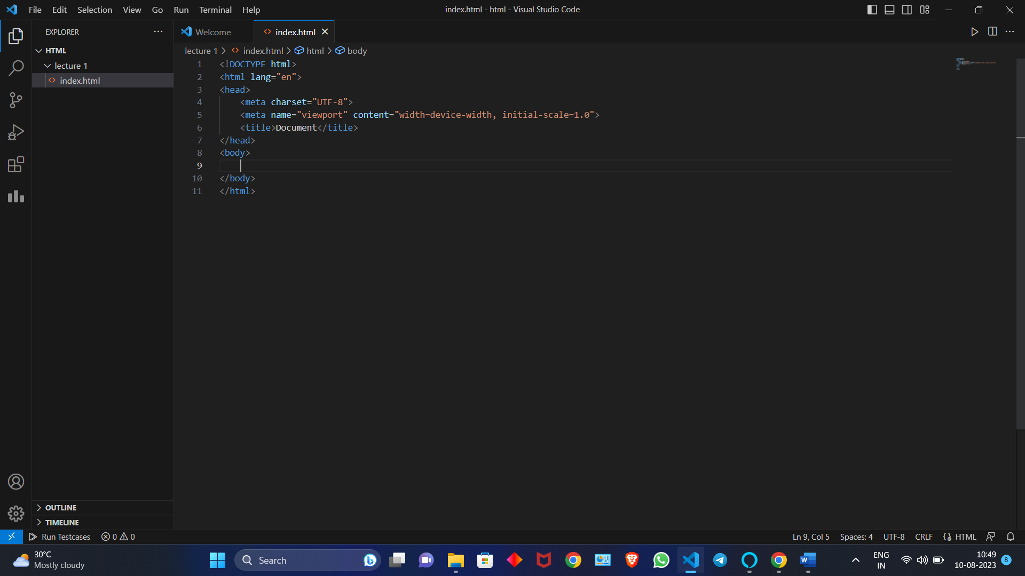

After writing html 5 in this file this code comes – this code is called boilerplate code

Boiler plate – it is the basic level of codes which defines about the **HTML STRUCTURE**

Emmet – they are the prewritten chunk of code which can be autocompleted using emmet.

EXPLAINING BOILER PLATE

<!DOCTYPE html>

This defines that you are using the latest version of HTML. That is html 5

<html lang="en">

It dignifies the code which your are writing will be accepted in English language

In line number 2 “<html>” this sign dignifies the opening tab of html

<head>

Opening tab of head -> this tag includes all the information which I don’t want my user to see(accept title)

<meta charset="UTF-8">

# uses of meta tag

1.meta tag are also used to increase the search engine optimization by adding some specific important keywords

2.meta tags are information carriers i.e they help carrying out the data in a optimized and ethical way

<meta name="viewport" content="width=device-width, initial-scale=1.0">

View port means white colour

Content “width = device-width” it shows that the screen is set according to different users screen

Initial scale= is magnification

<title>Document</title>

It gives the title

LECTURE 2

1. LOREM

In paragraph when we want to write a dubbing text just type lorem(no of words you want in paragraph) – it will give the dummy text

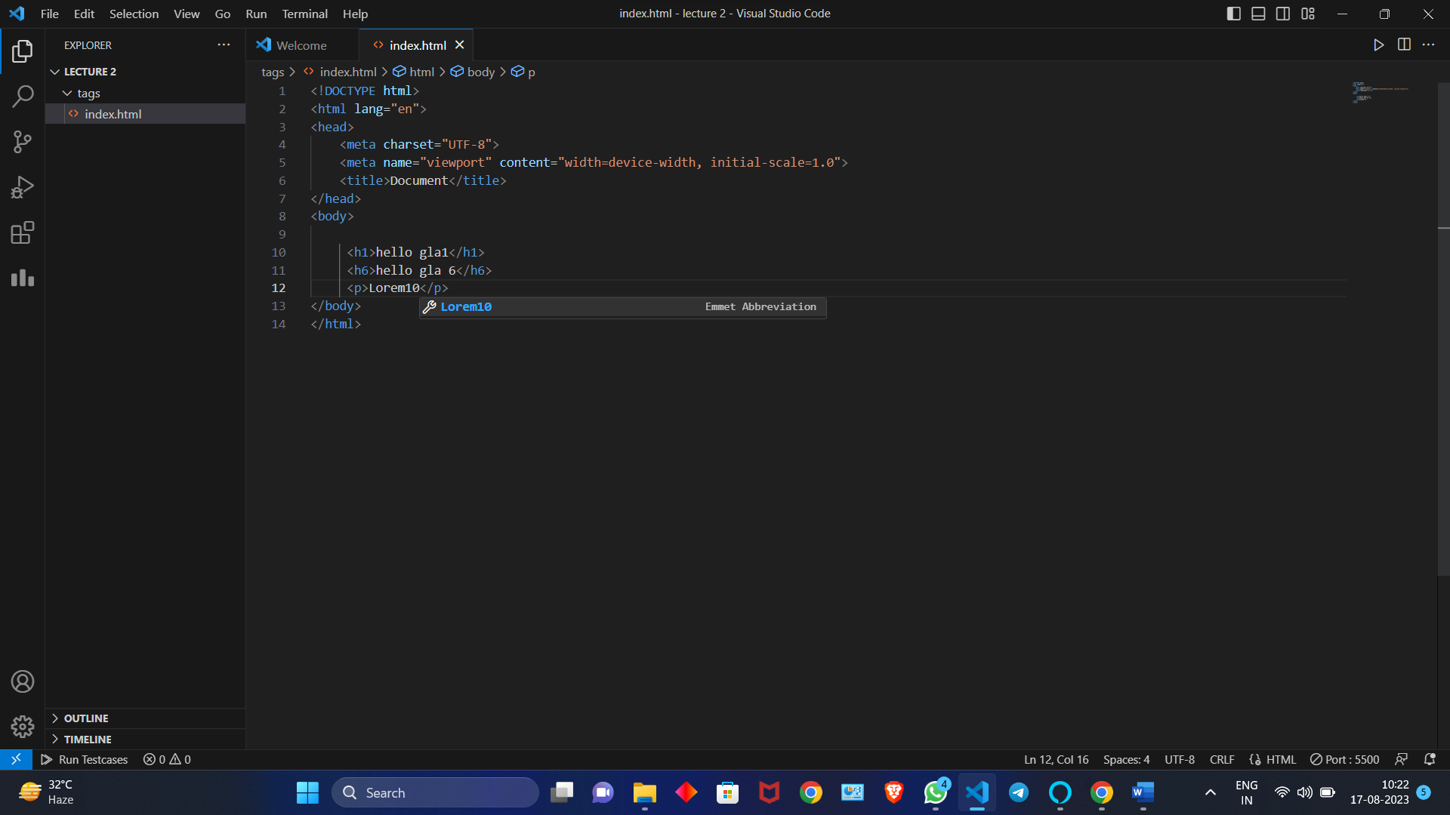

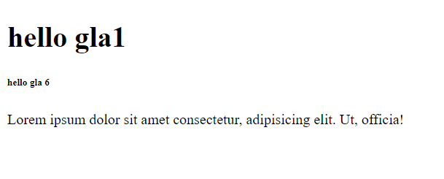

2. inline elements

NOTE- the elements that adjust in a single line are called inline elements.

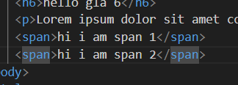

Span is a inline element example,<em>,<b>,<strong>

Teacher def – inline elements are the elements which does not occupy the entire space that is they only takes up the space which is necessary to display that particular content

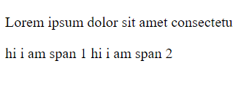

3.block elements

These are those elements which occupies the entire space irrespective the amount of text to be written

Examples all h1- h6 , paragraph<p> , <div>

DIFFERENT TAGS

1. Em(empahsise tag) do give italic tag

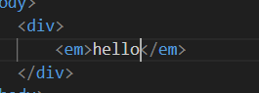

It is an inline element

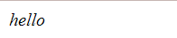

1. b (bold)

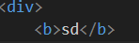



Give bolded text

It is an inline tag

1. i (idomatic tag)

give italisize tag

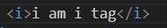



Looks same as em tag

It is an inline tag

1. strong tag(works same as bold)



It is also an inline tag

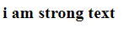

Difference between strong and b AND em and i

The difference is for developer if I just want to content to be bolder I will use b tag and if I want to emphasis the tag I will use strong tag (simply – b Is just used as a jewel to make text beautiful strong is used to highlight important text but both works the same ways)

Same goes with em and I tag em is used to emphasise on a specific thing and I tag is just only for decorative text

1. br (break) tag

used to break a particular line

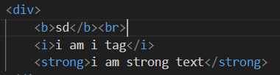

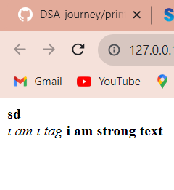

ENTITIES

1. for (<) than sign

To display a less than sign (<) we must write: **&lt;** or **&#60;**

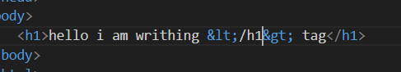



1. for (>) sign

to display greater than sign use &gt; or &#62;

1. &hearts;

Used to print heat on screen

1. &copy;

For copyright symbol

1. For &

&amp;

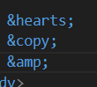

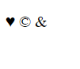

1. &nbsp; (no break space)

One &nbsp give one space

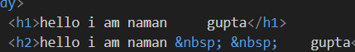

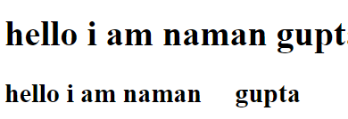

**LIST**

There are two types of list

1. Ordered list – use <ol>

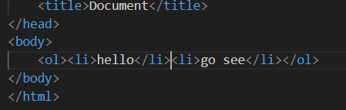

Use <li>tag to get the element in the list in ordered list the counting comes in it ordered list

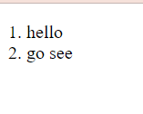

1. Unordered list – uses <uo> tag and same <li> tag for the list elements

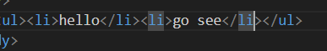

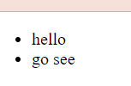

**Q-what are attributes?**

**Attributes are the extra information which we provide to our browser about that particular / specific element**

**Attributes are provided inside the element only in opening side**

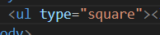

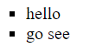

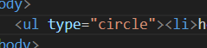

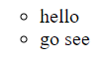

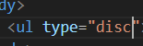

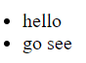

**These are different types of the tags for the unordered list by default it is disc but we can change it to square to circle**

**NOW ATTRIBUTES FOR OL (ordered list)**

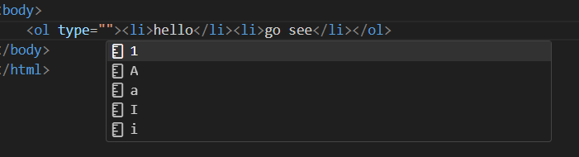

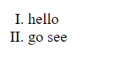

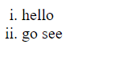

**By default it is 1 2 3 4 5 6 7………………………**

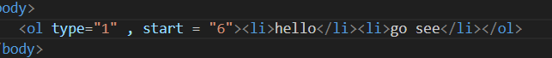

**Another attribute is start from where we start**

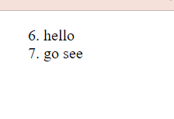

**START CAN WORK WITH DIFFERENT DATA ON TYPE ATRRIBUTE**

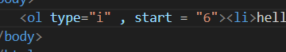

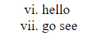

**We can also start with negative number**

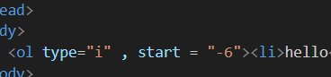

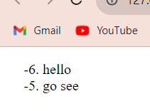

**FOR NEGATIVE VALUE OF START** – till o negative numbers will be used and after 0 the iteratable item is used

Example for start = “-3”

-3

-2

-1

0

a/I

b/II

INT ALPHABET the alphabet after the range givens aa ab ac ad ae af ag ai

REVERSED ATTRIBUTE – reverse the order of the counting

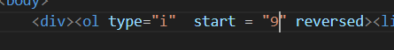

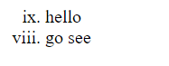

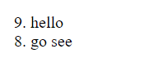

Reverse is the Boolean attribute by default its values is false

**MEDIA TAGS**

**Image tag**

. = . means one level up in your directory

/ = / means one level down

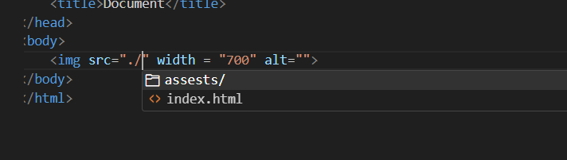

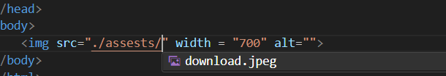

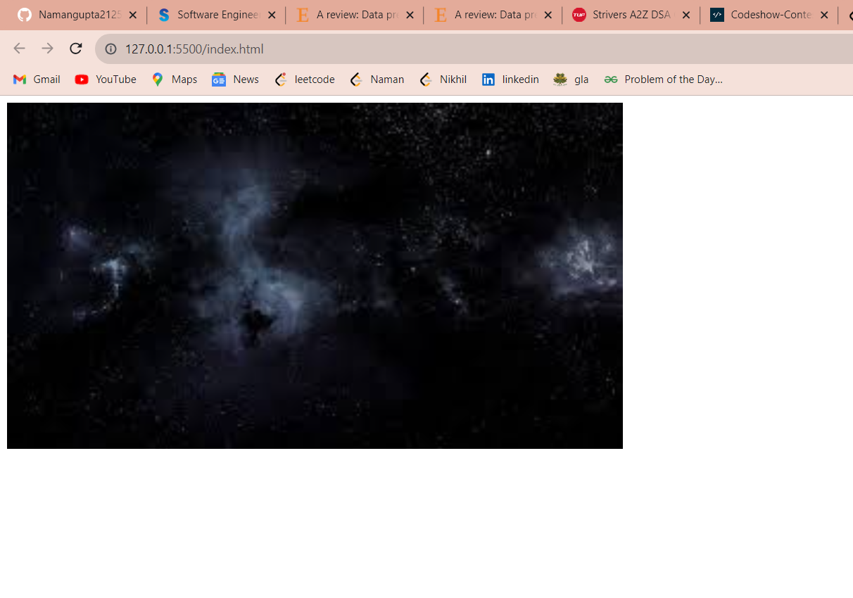

More than two dots (.)are not valid

More than single (/) at a time is not valid

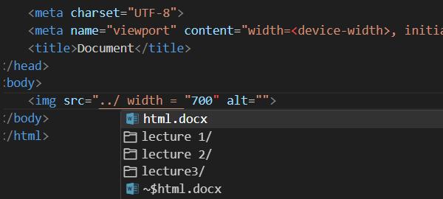

DOT (.) IS FOR ONE DIRECTORY OUT AND YOU CAN ONLY COME TWO DIRECTORY UP AT A TIME

FOR (/) FOR DOWN DIRECTORY OR GOING INSIDE THE FOLDER OR DIRECTOR

______________________

/ ______________

/ ________

._______________

._____________________

AT A TIME WE CAN ONLY USE TWO DOTS AND ONLY SINGLE /

SRC – src tag is used to et the directory or source directory of image

Alt – alt is used to set alternative image when real image is not present at the moment

**Audio tag**

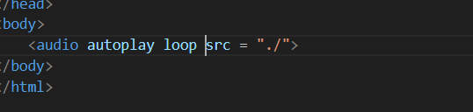

Src is used to check the source

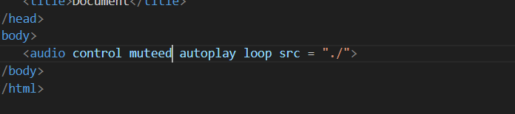

CONTROLS – GIVES THE CONTROL OF AUDIO

MUTED – MUTE THE SONG

AUTOPLAY – PLAYS THE AUDIO WHEN YOU REFRESH YOU RSITE

LOOP -LOOPS THE AUDIO AFTER ITS END THE ONE TIME

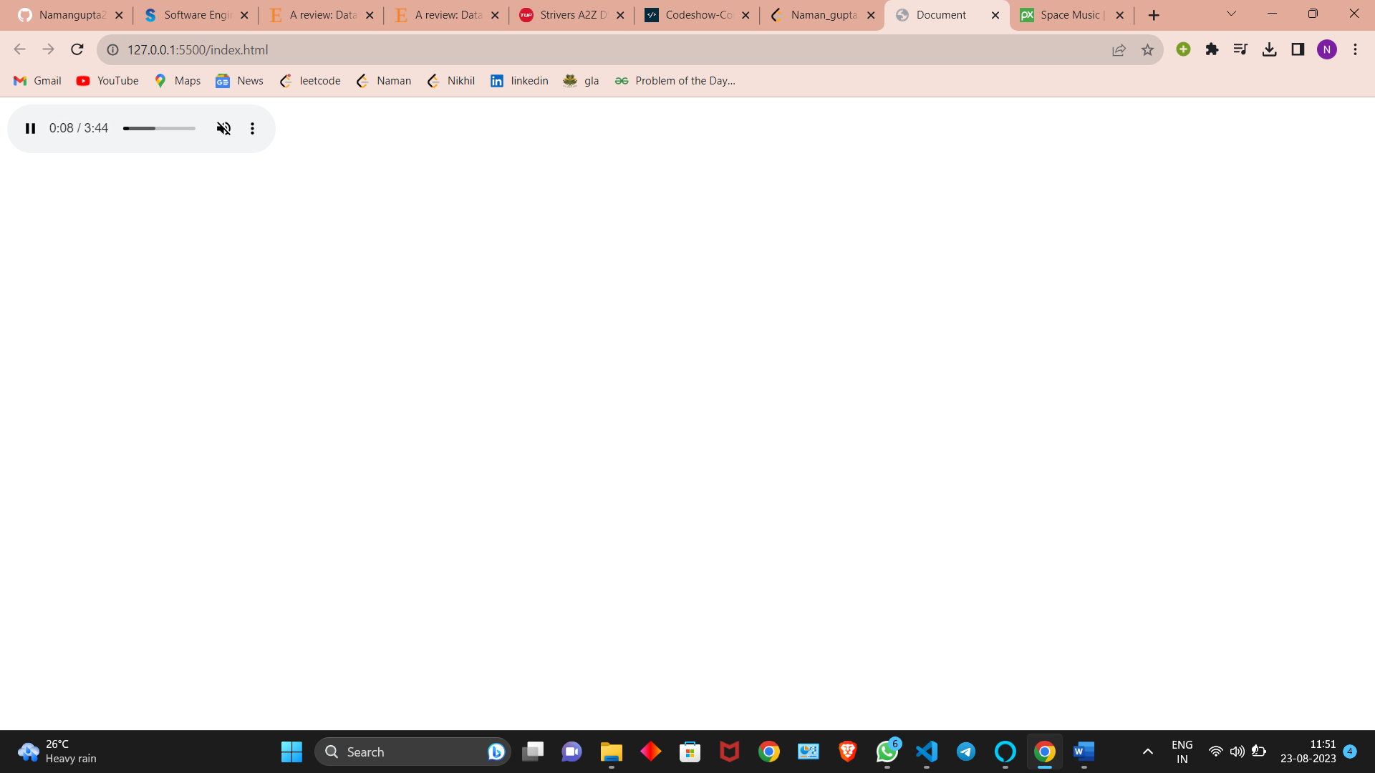

**Controls are absolutely needed for the**

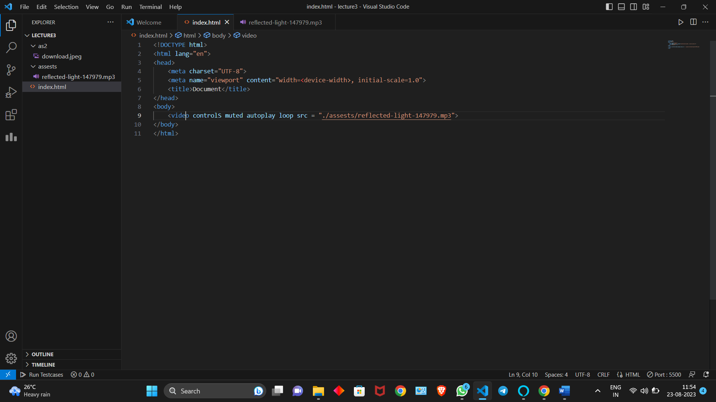

**TABLE**

Table has three parts head, body and foot.

FIRST TABLE HEAD

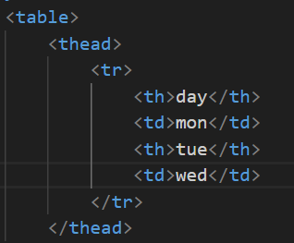

<tr> is used to define the column

In tr we have two tags <th> - used for bold

<td> used for non bold

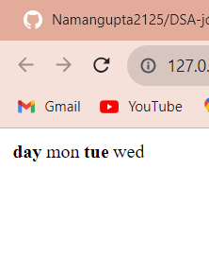

<tr> table rows

<th> table heading

<td> table data

TBODY DEFINING <Tbody>

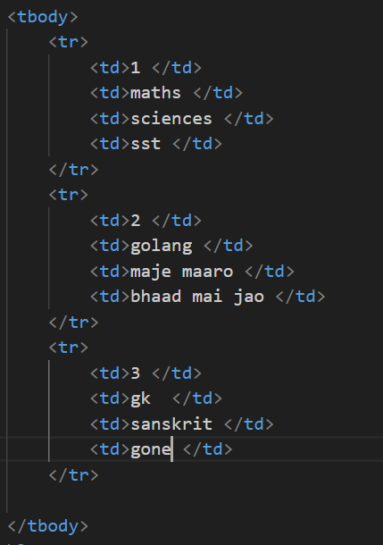

<tbody> tag used for defining table body

<td> define tag is used for table data

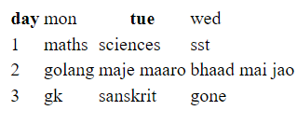

For making line we need to add attribute at table starting tag <table>

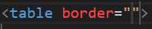

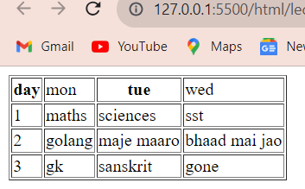

<th> gives the data bolded and centrally aligned

We can give number in border attribute

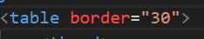

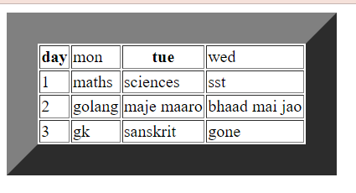

**STARTING CSS STYLING**

We have to add attribute style then we have to add style to the attribute then add attribute and its parameter to the attribute you defined

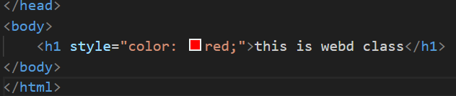

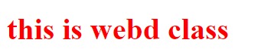

We can multiple styles after semicolon

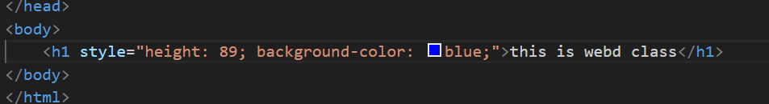



This type of change is called inline change

But it has drawback that is too change a small change we have to change each an every attribute to each and every tag

INTERNAL TAG

We have to create a tag named <style> in head tag

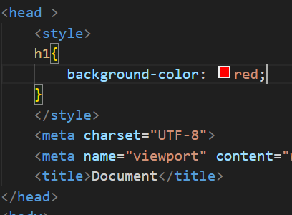

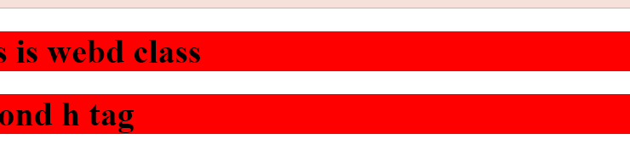

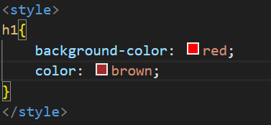

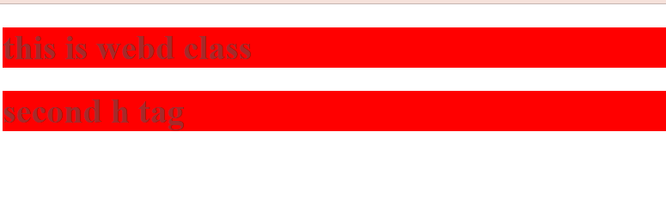

In every h1 tag the change reflect on the screen

Third way is external that is creating a separate file with extension.css and then linking it.

for commenting used we use<!-- -- > tag

separation concern css ka code alag and html ka code alag likhna hai ethical

focus on <link> tag

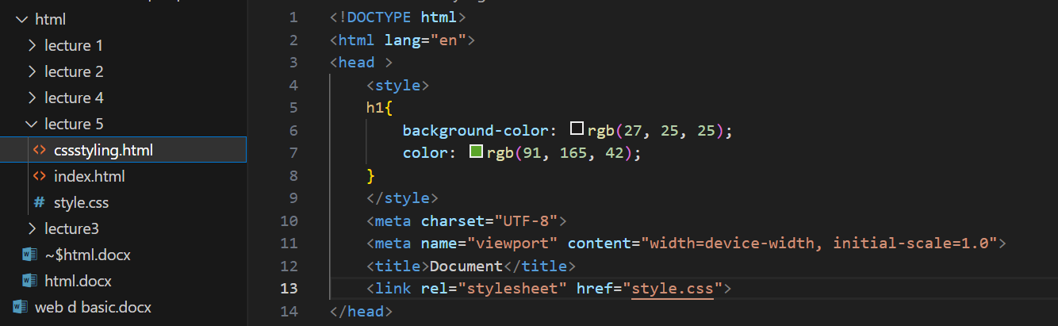

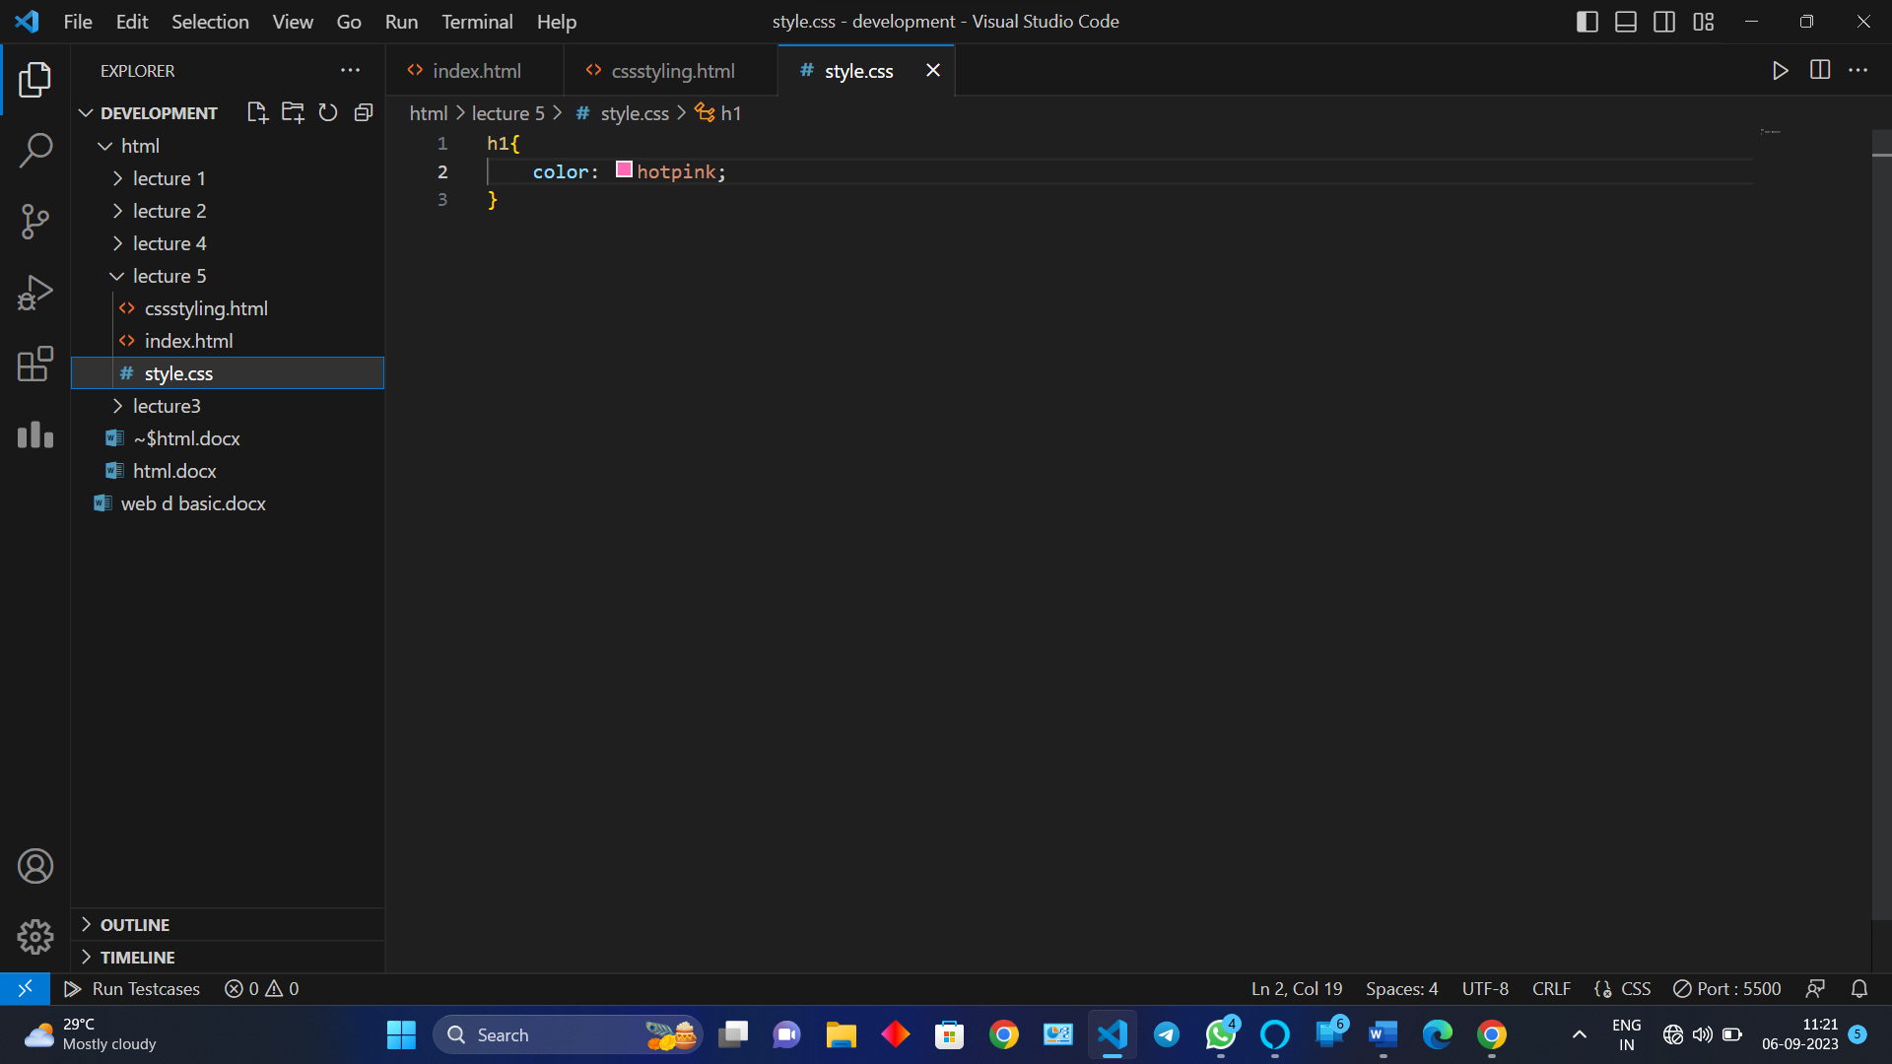

Specificity of inline internal or external (also called priority check of css styling)

1.inline

2.internal

3. external

NOTE - if one feature is not given in more priority attribute then the lower specificity tag also works but only for that feature that is not present in more priority tag

Specificity is only for same property not for different properties.

Use of rowspan and colspan can be done

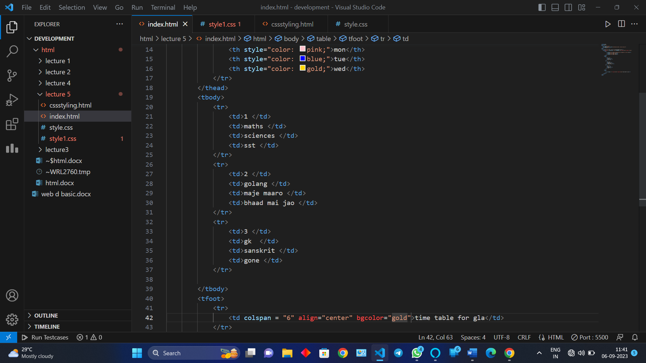

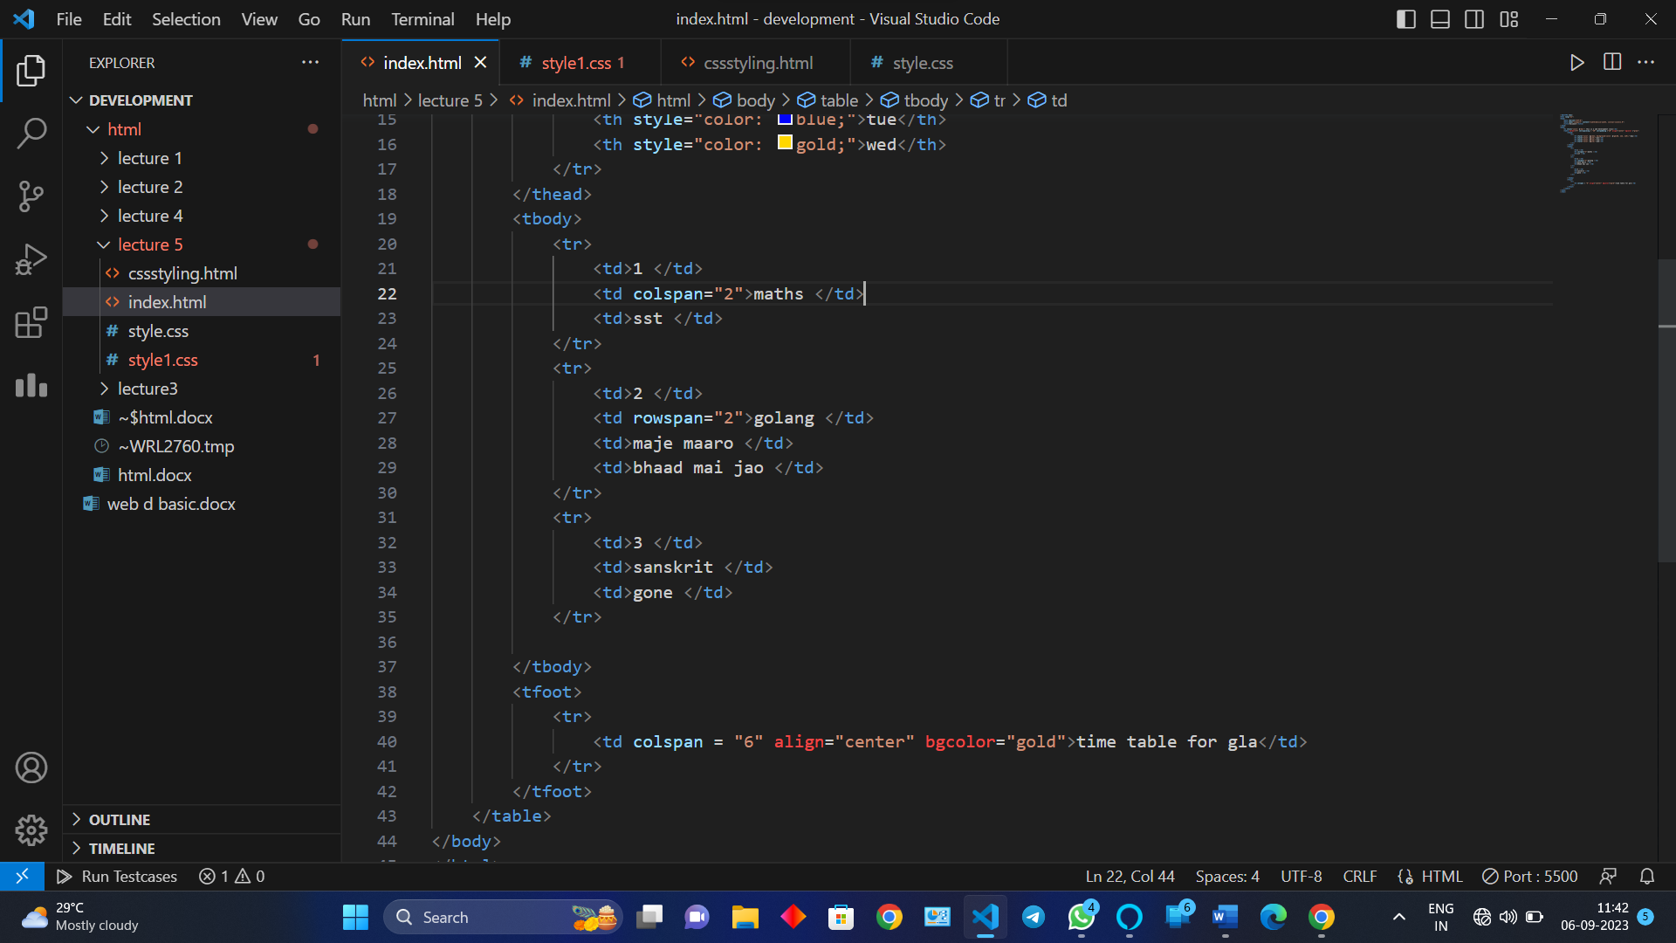

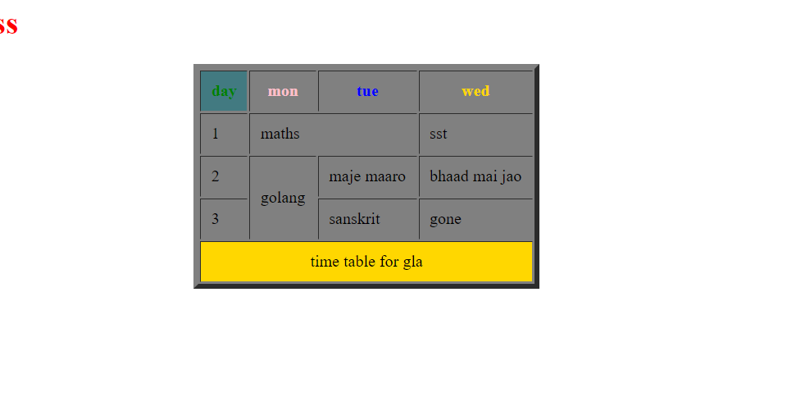

***CSS***

Types of css file

1.inline

2.internal

3.external

Most influention is inline but most used is external file

SELECTERS

HOW TO ID AN ELEMENT IN CSS

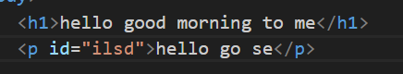

FOR USING ID IN CSS STYLE SHEET USE #

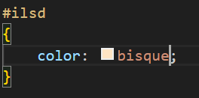

We can give same ids to an element but it should be unique

How to use class selecter

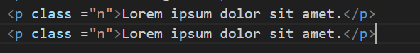

How to use classes in css style sheet with the help of(.)

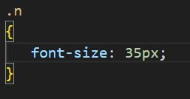

Output

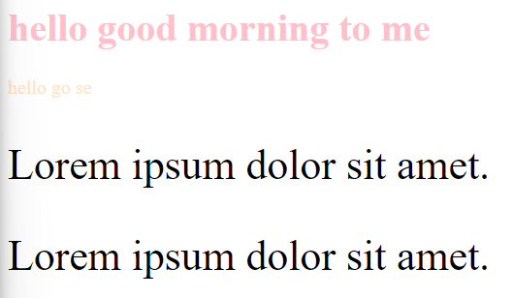

We can use it on multiple elements

INPUTS

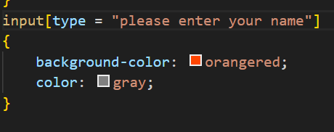

Input css style

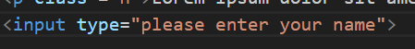

Output

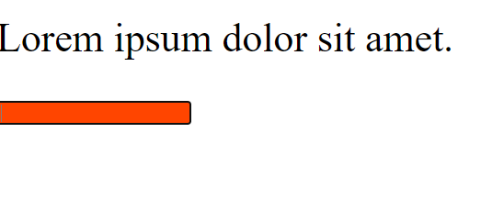

<input type = “our text whatever we want to live”>

Used to input something from user

Input[type = “our text we use to define”]

{  
it is used to styple text box

}

UNIVERSAL TAG

It is used add the css style to every element present in html

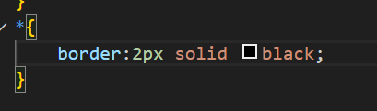

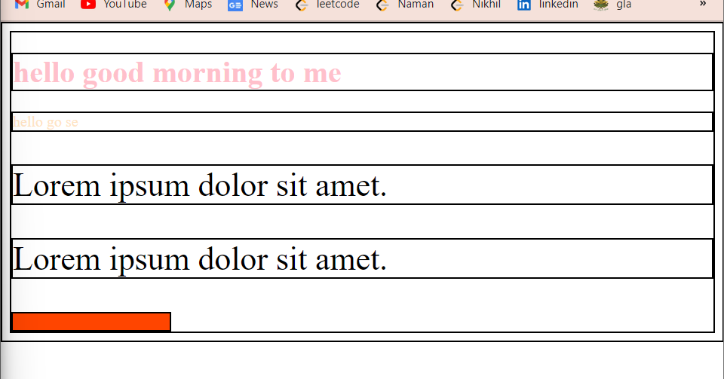

Border to all the things have been applied to use universal selecter we use “*”

Filed set intput and legender

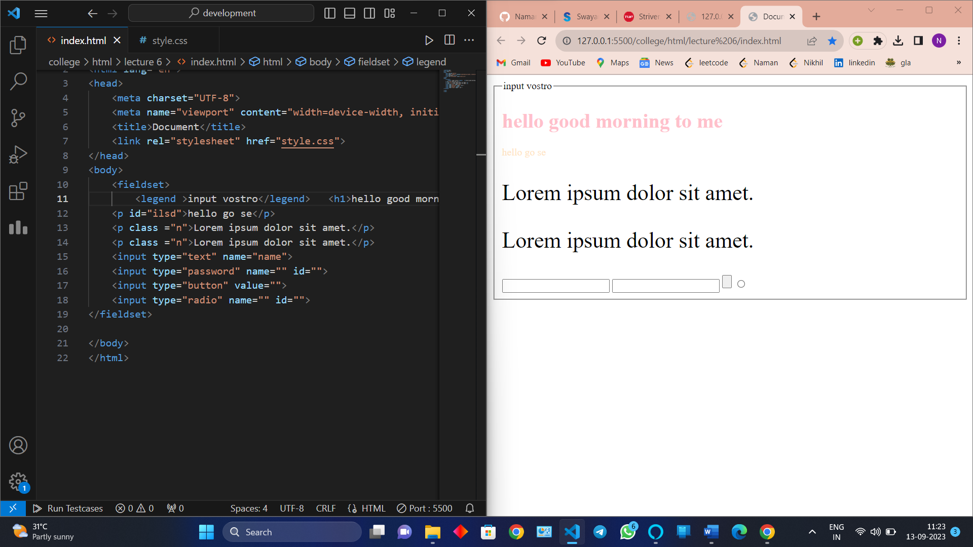

Form

Has two attribute action and method

Method has two actions

1.Get

2.post

By default method is get

Teacher def – forms have two major attribute

First is action which specifies the path that where the action is being performed

Second is method

Methods in the case of form are of two types

1.get

2.post

By default if no method is specified its value is get

In form we can use input and a tag

Name <button type =” ”><button/>

The type is by default submit

And we have options for

Type is

Menu \

Button

Reset

Submit

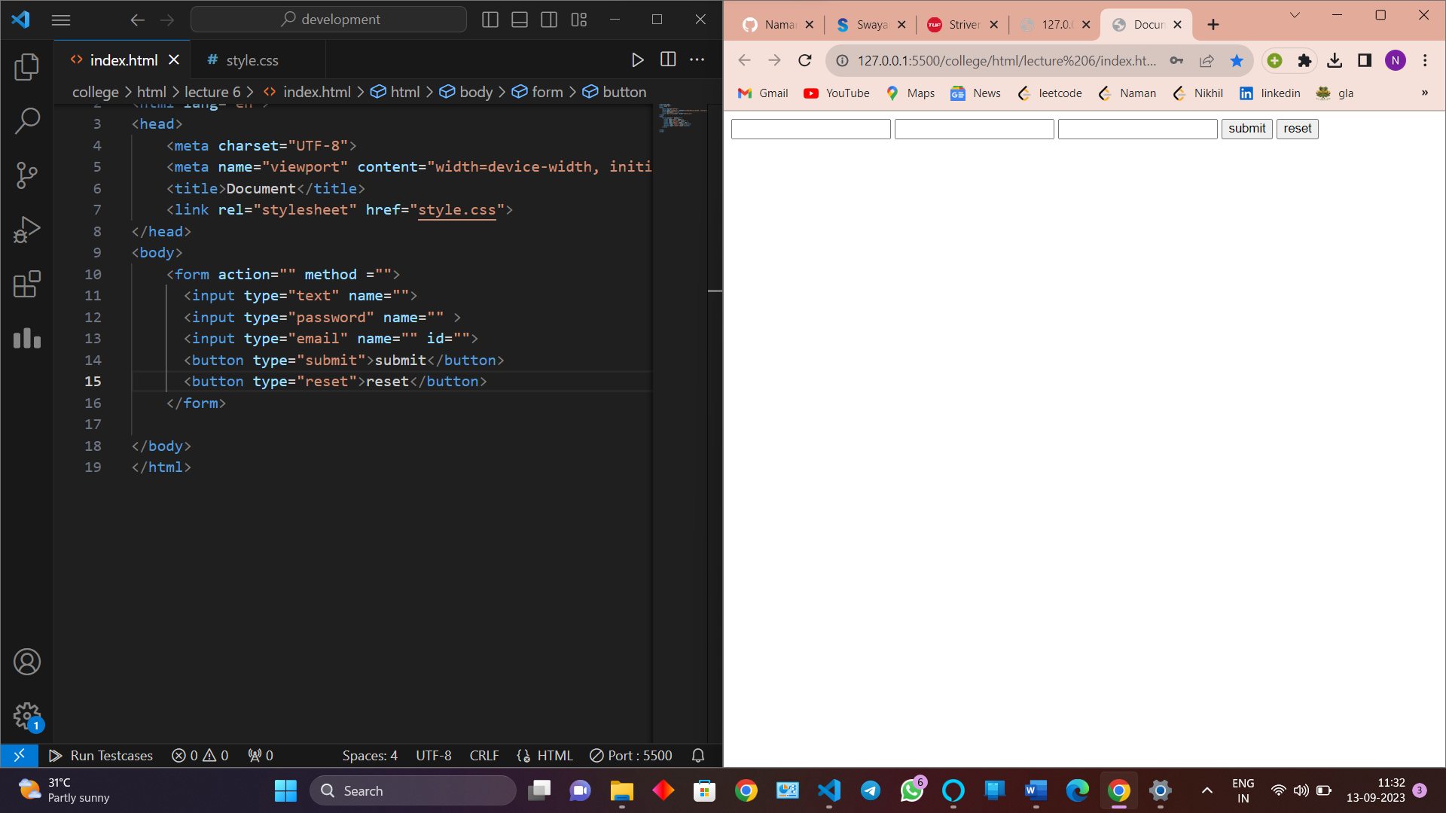

Whenever we send a get request all my sensitive information that was a part of my form appears in the main url (provided you should have mentioned the name attribute)

In case of post (method) the password is not visible in url 6

Id and class take extra memory

ADVANCED SELECTOR

1.combinators selectors – when you use two or more tags

a. descendant

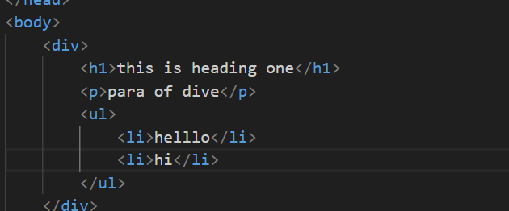

Any level down

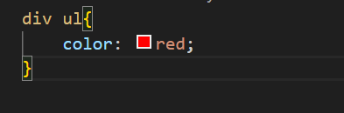

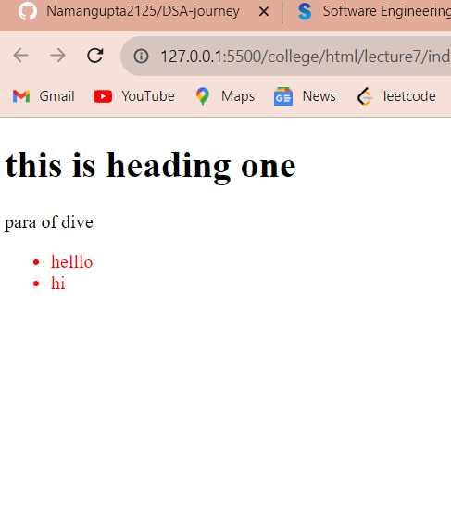

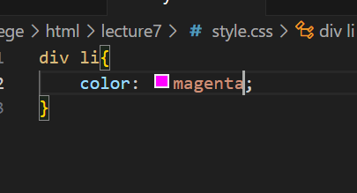

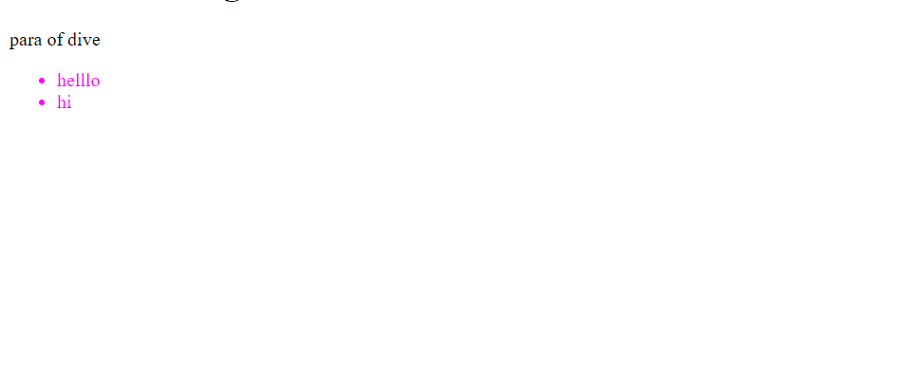

b. child

only 1 level down

for child we use the symbol >

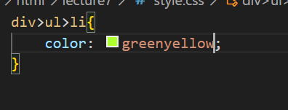

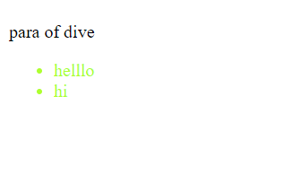

Note - We can take only one jump in descendant we can take any number of jump and we can also use both together

c. adjacent sibling

sign is +

flow of code is from top to bottom and left to right

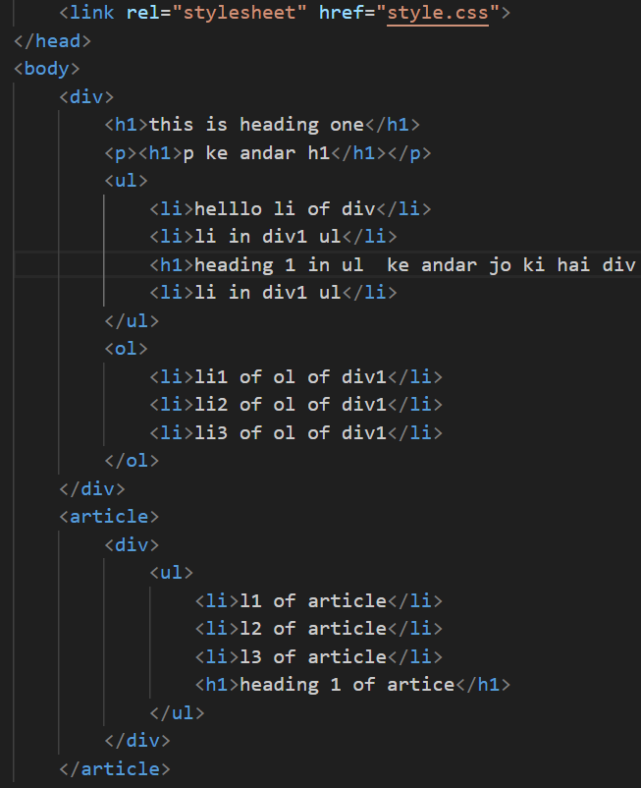

In this case we can’t choose li directly from div class because there are two div ,ul int article as well as in body so we choose div>ul>h1 and the we choose adjacent sibling

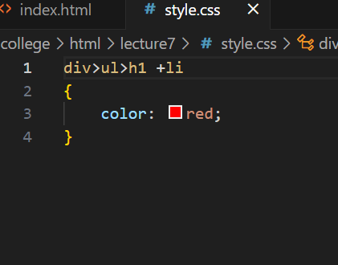

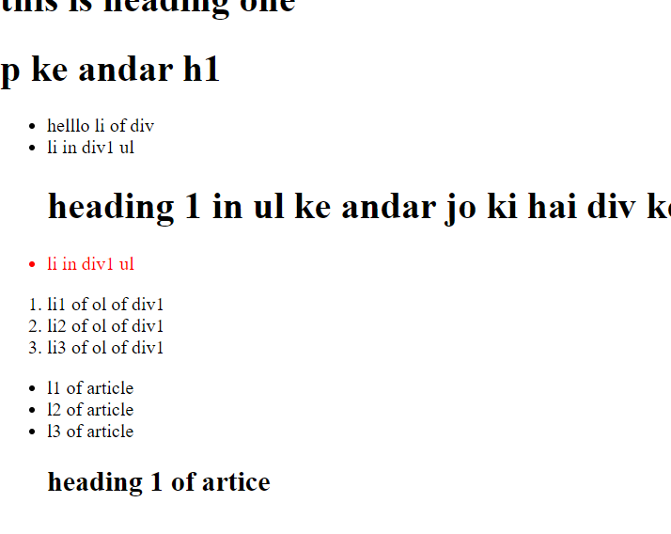

We only get adjacent sibling on right not on leftGenerally used when there is no way ki aap koi element choose

d. general sibling

for general sibling we use the sign ~ tild

general matlab saare element jo bhi right mai hai code flow from left to right

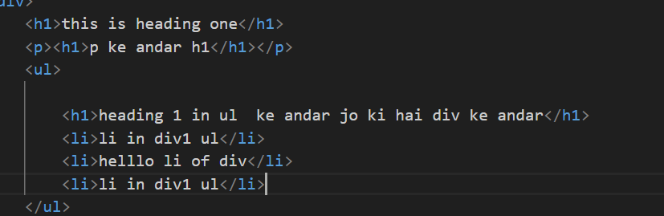

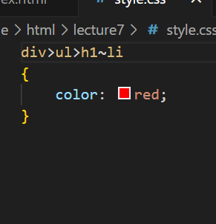

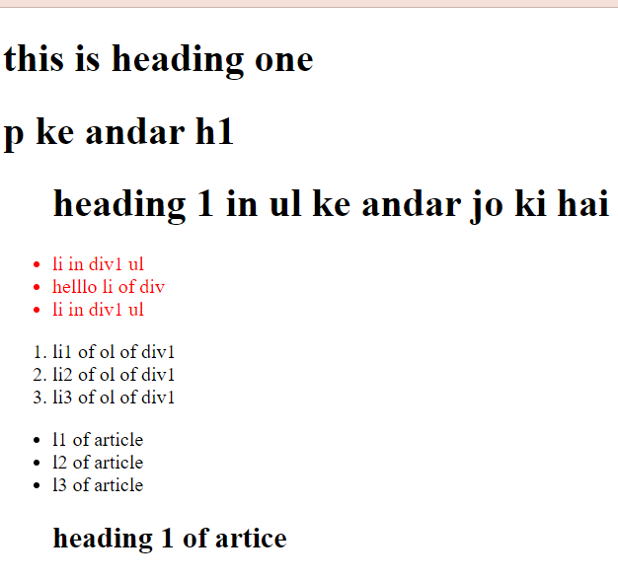

1. pseudo classes

all the elements in pseudo class used : in front of there name

1. :hover state

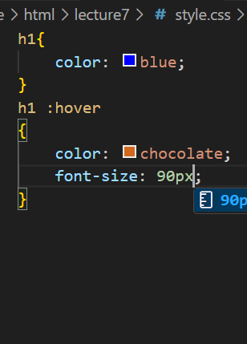

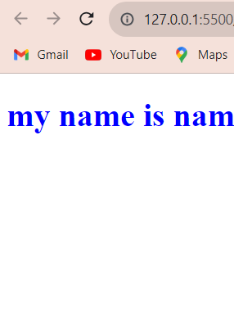

Now hover state



Note – do not give state like h1 :hover it will not work

It should be h1:hover

1. :focus

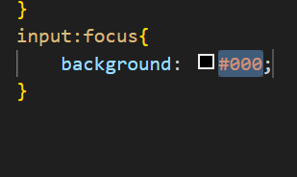

When not in foucus normal other wise different

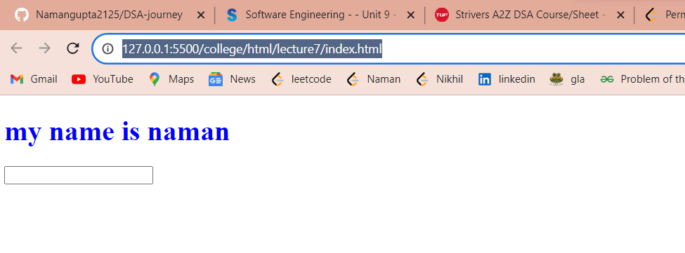

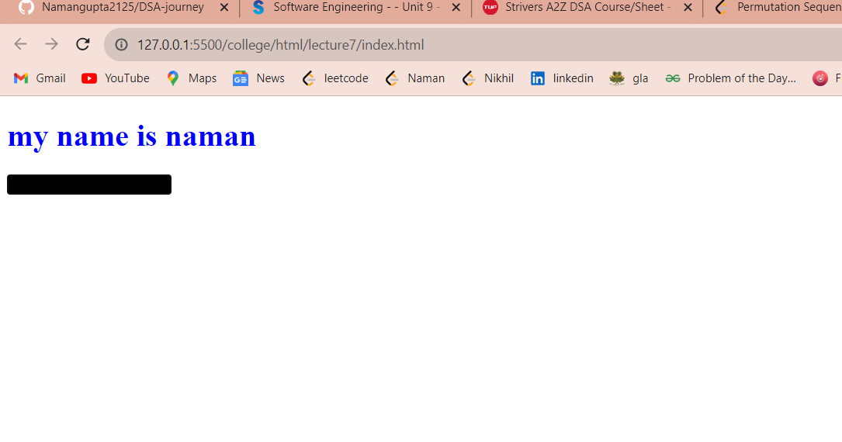

1. Active

Generally used with anchor tag when clicked on url change the color

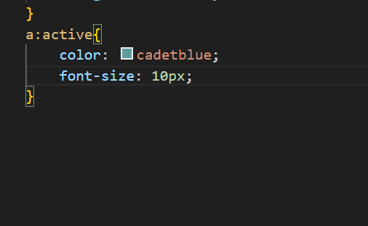

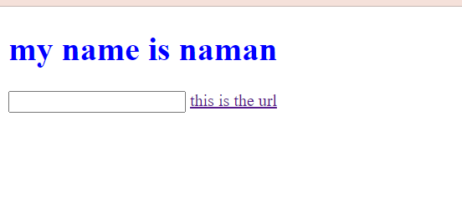

Now active state

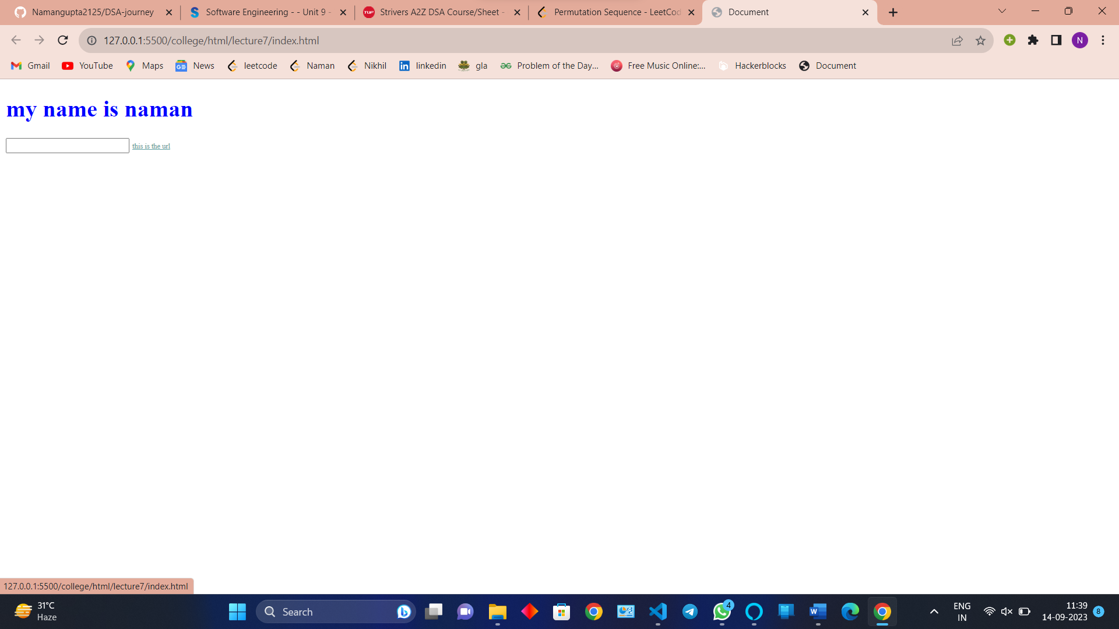

1. Visited

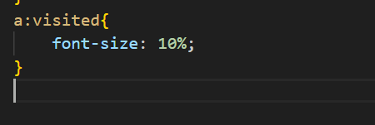

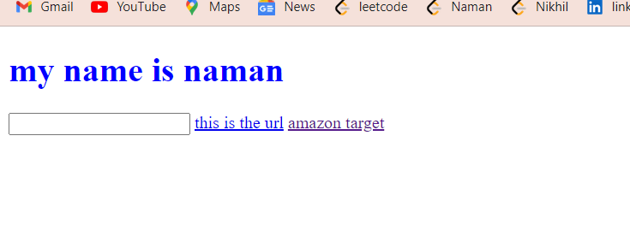

**POSITION ARGUMENT**

Offset

Offset are used to set position properties

Types of position properties

1. Static – offset does not work on static we avoid using it
2. Relative – offset does work
3. Absolute – when we give the absolute element come one level up and the third element takes it place

Offset depends upon recent parent if we do not give the position to recent parent then the offset will set according to the more upper parent if not available then it give according to body

Offset work according to recently positioned parent

1. Fixed

Direct take offset according to body do not move from the screen

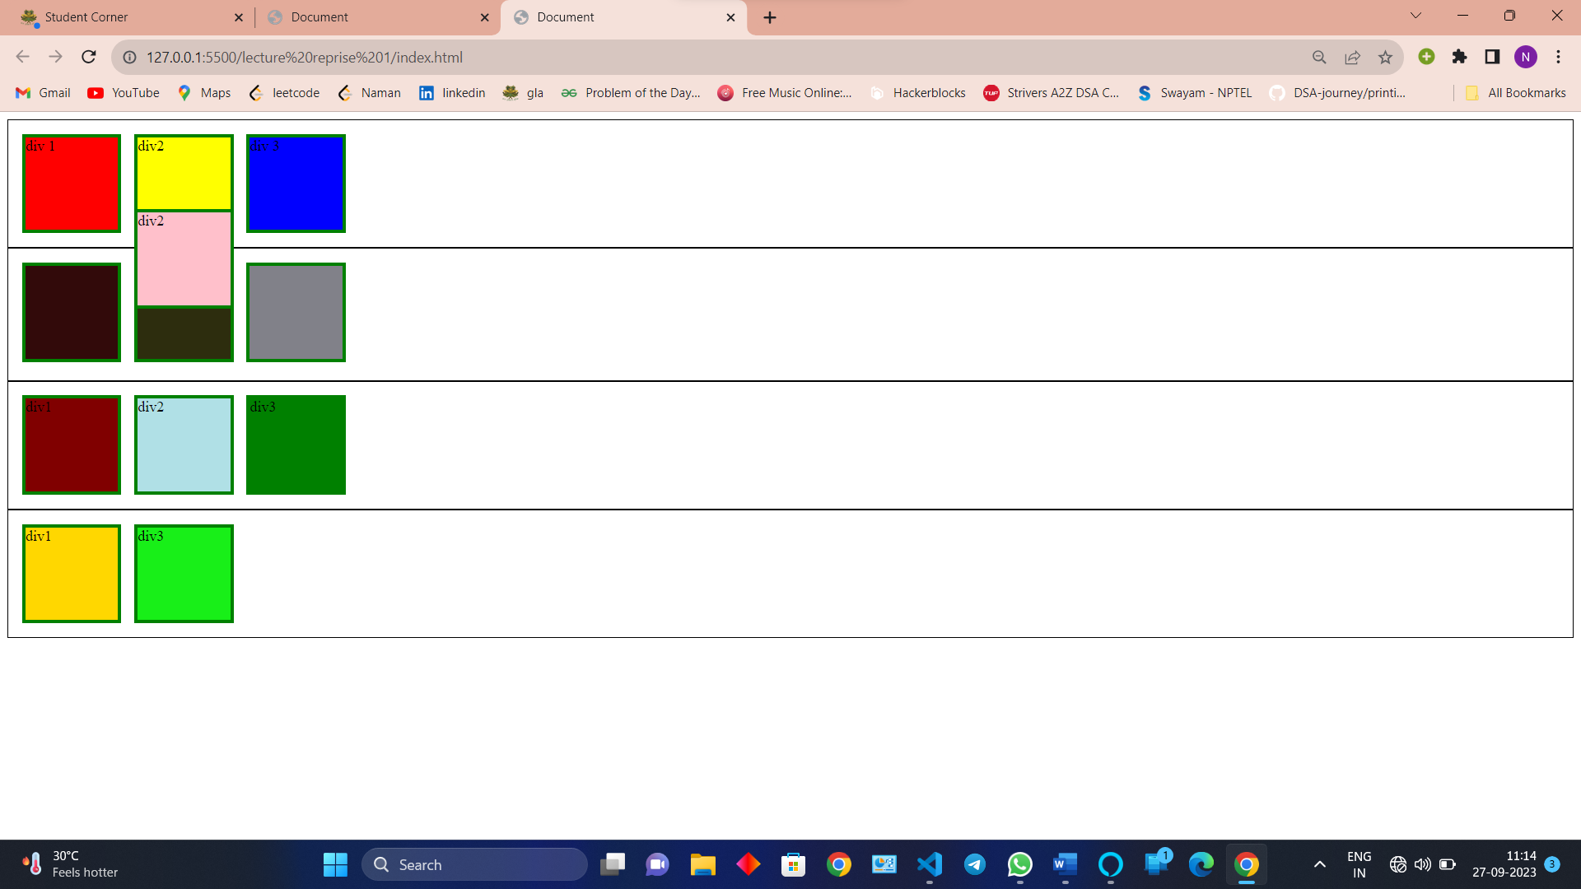

1. Sitcky

Only fixed till the height width of the parent

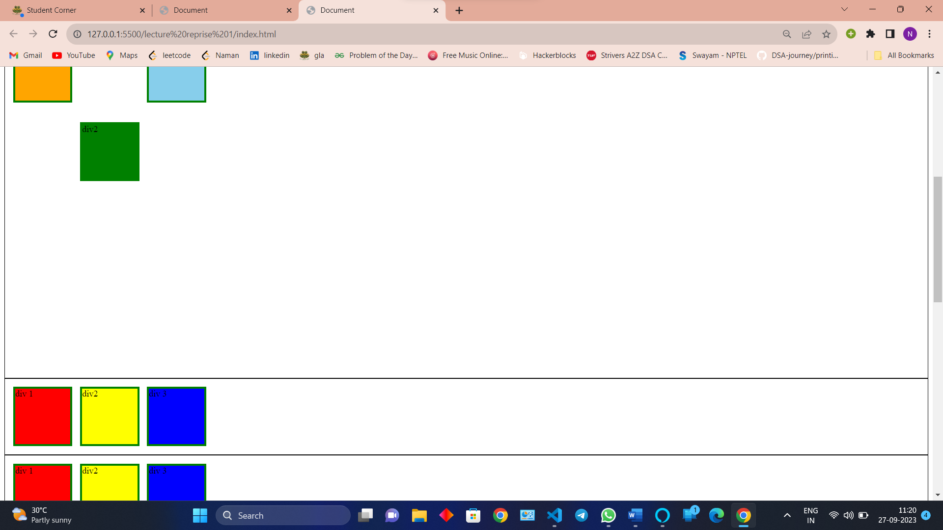

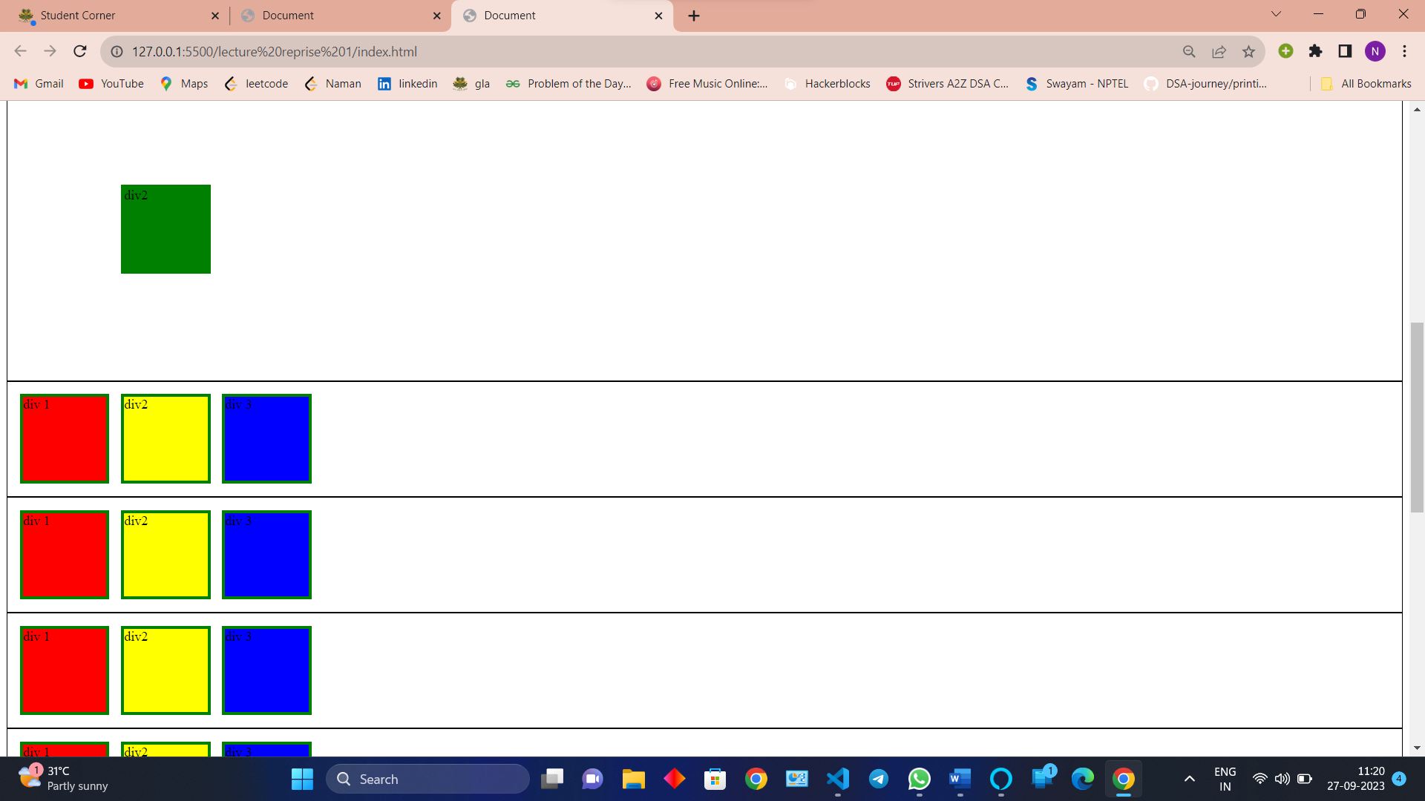

It is the mixture of relative and fixed

Inside parent acts like fixed and after that relative nature work

**LIST PROPERTIES**

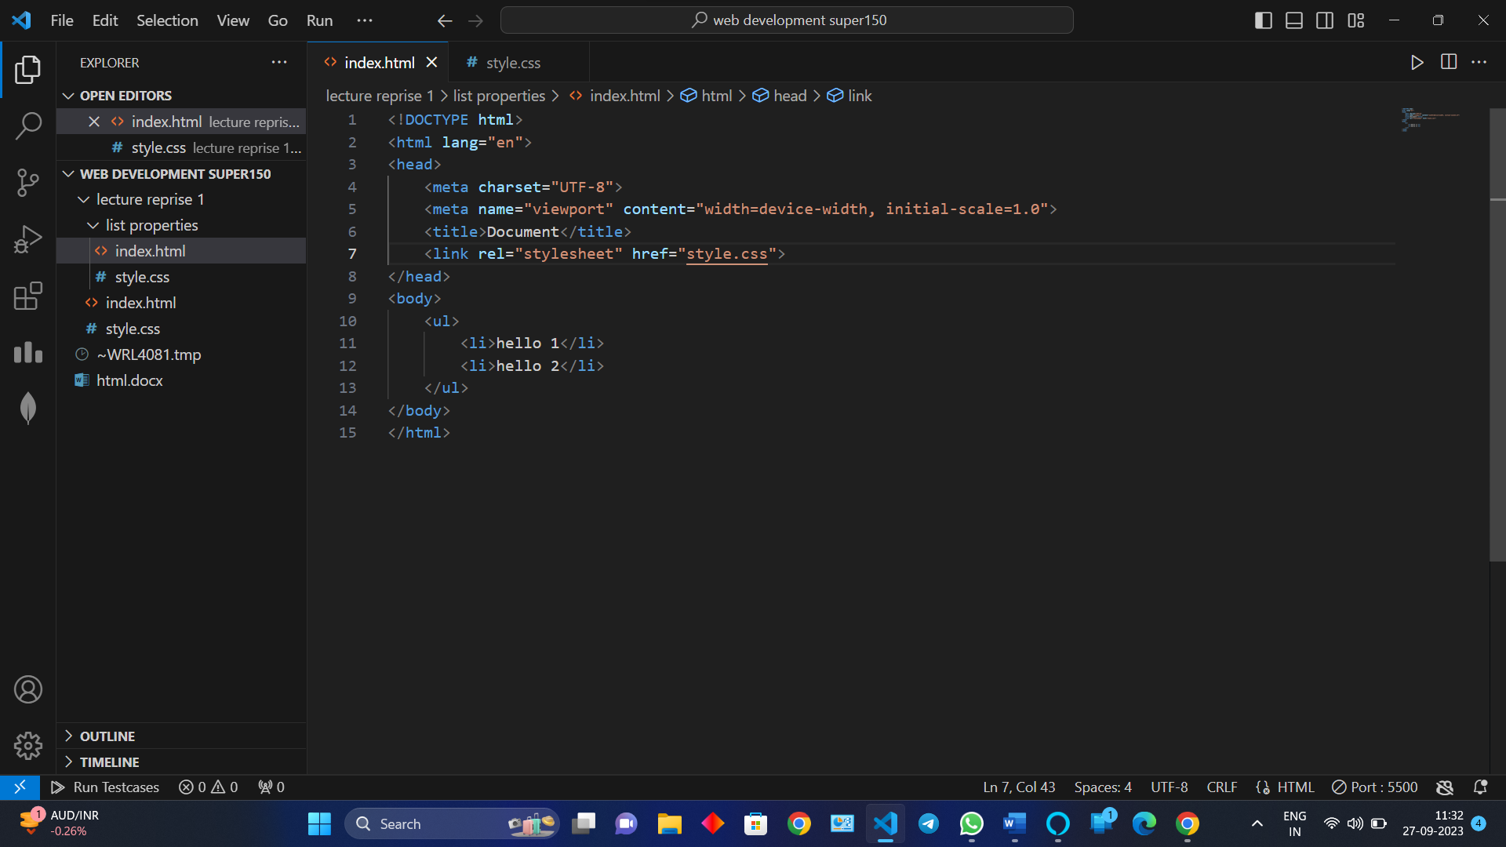

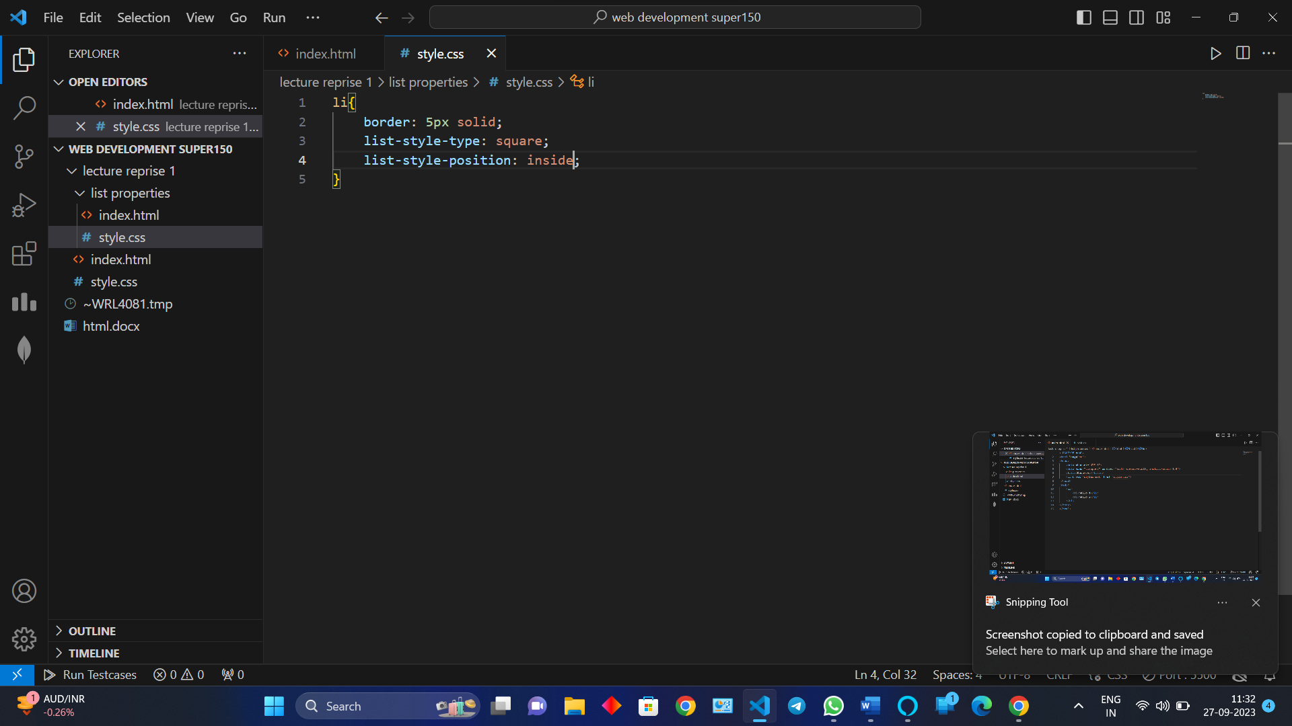

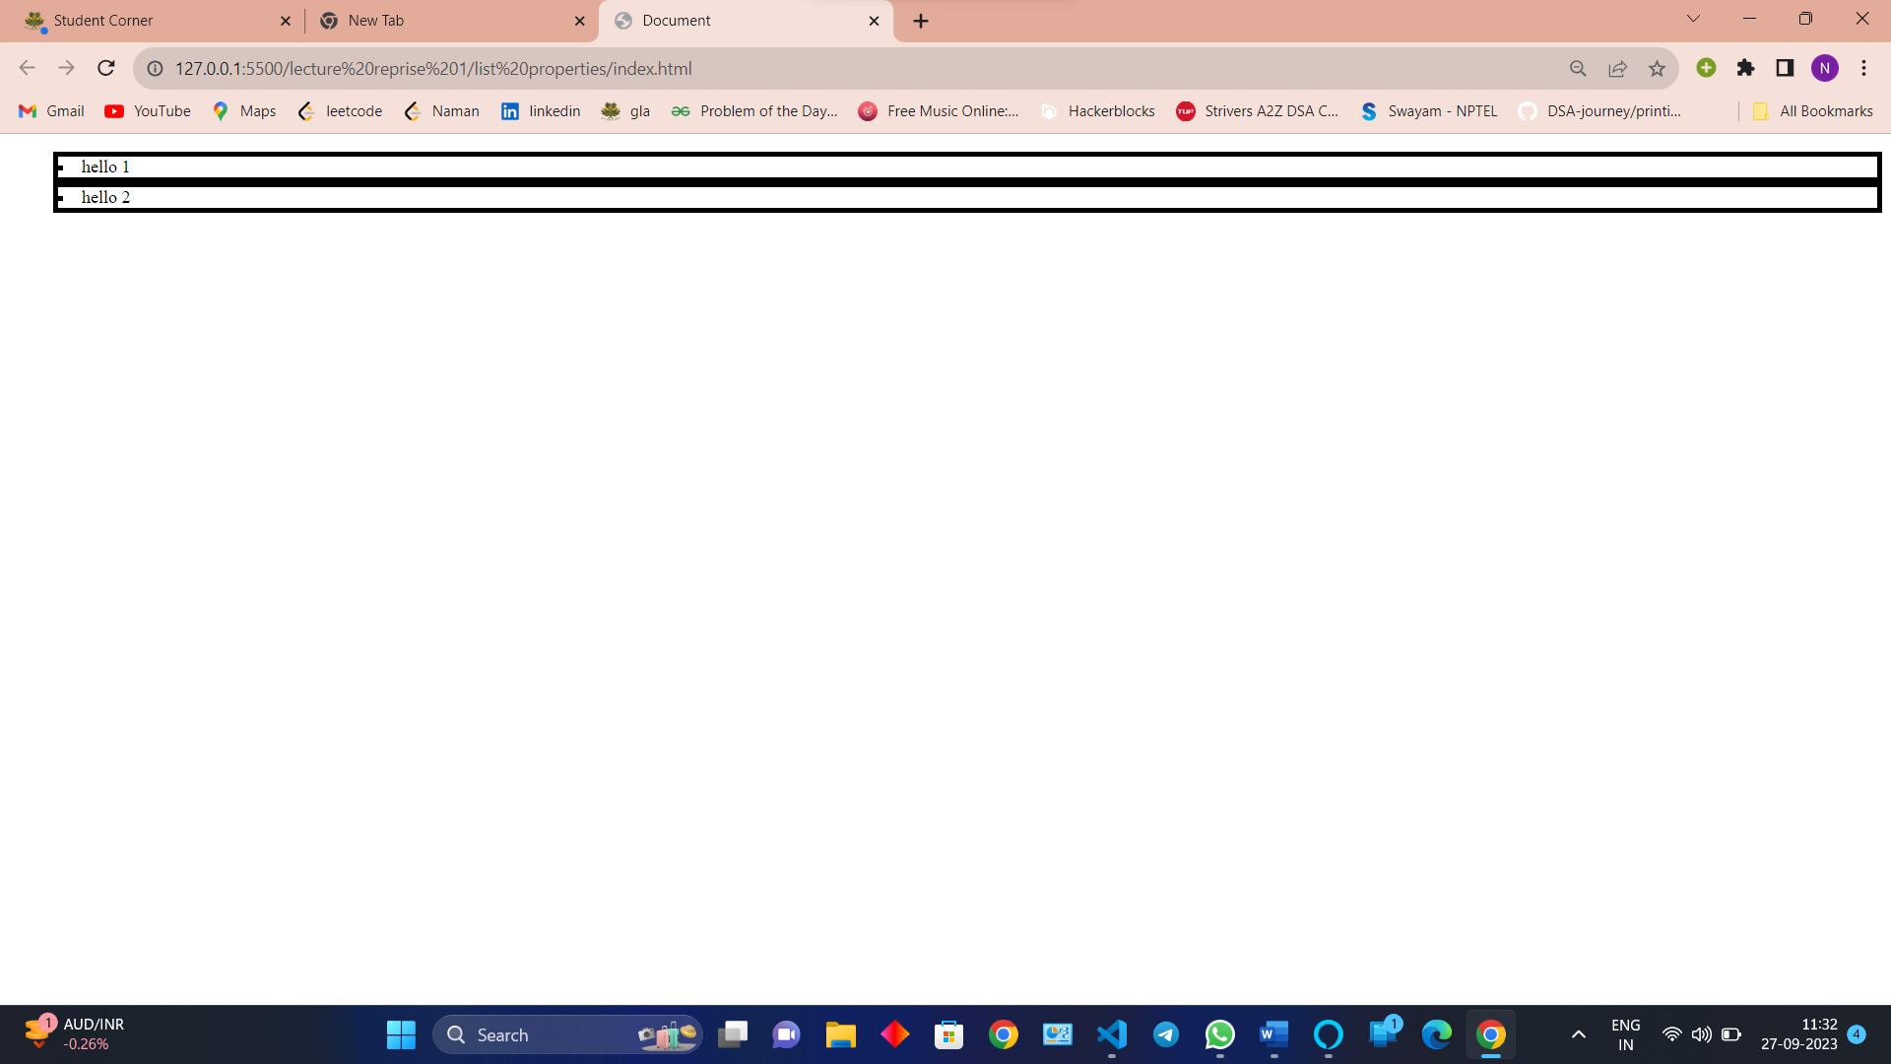

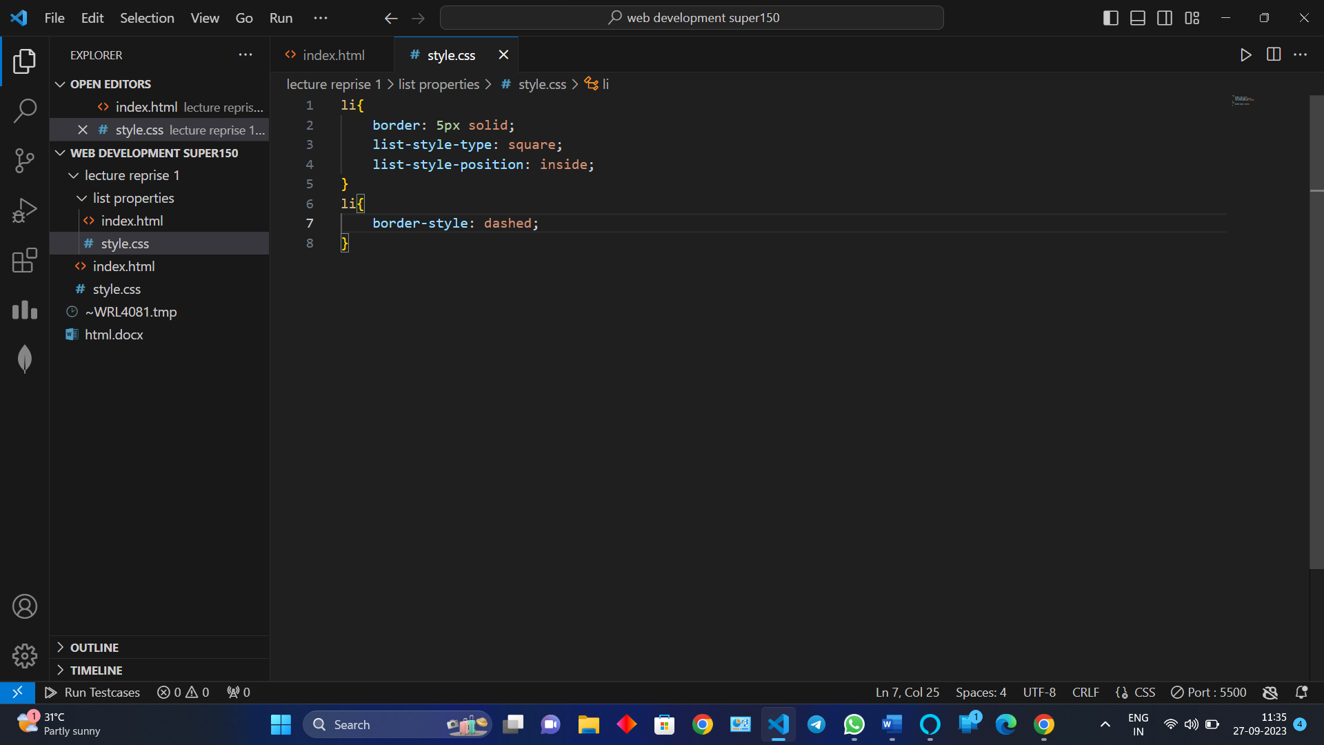

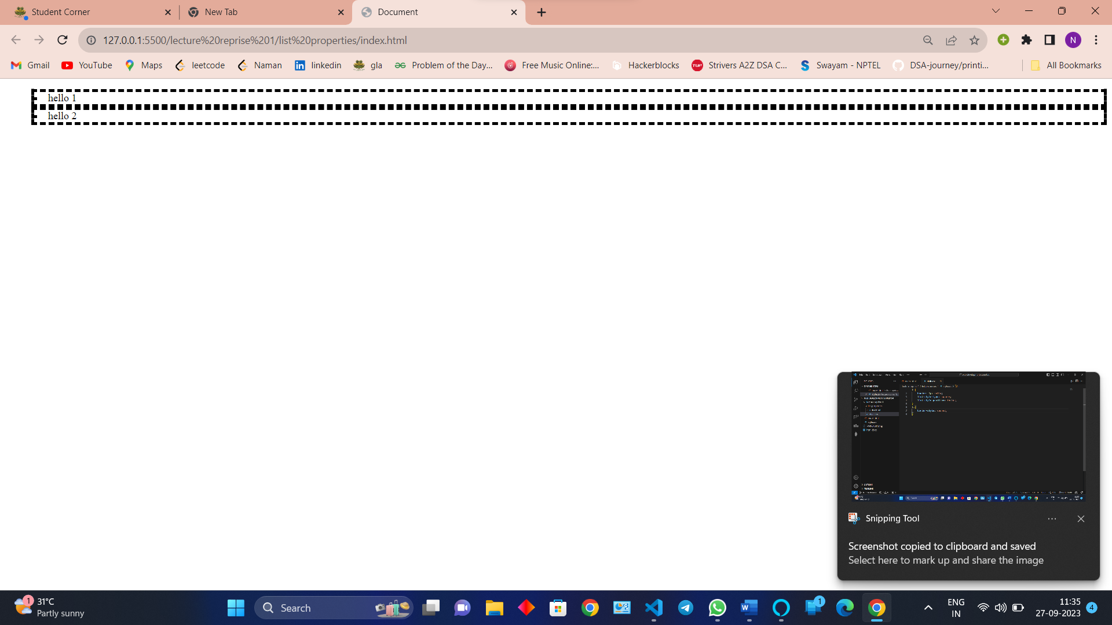

**FLEX BOX (important)**

Purpose – responsivity.

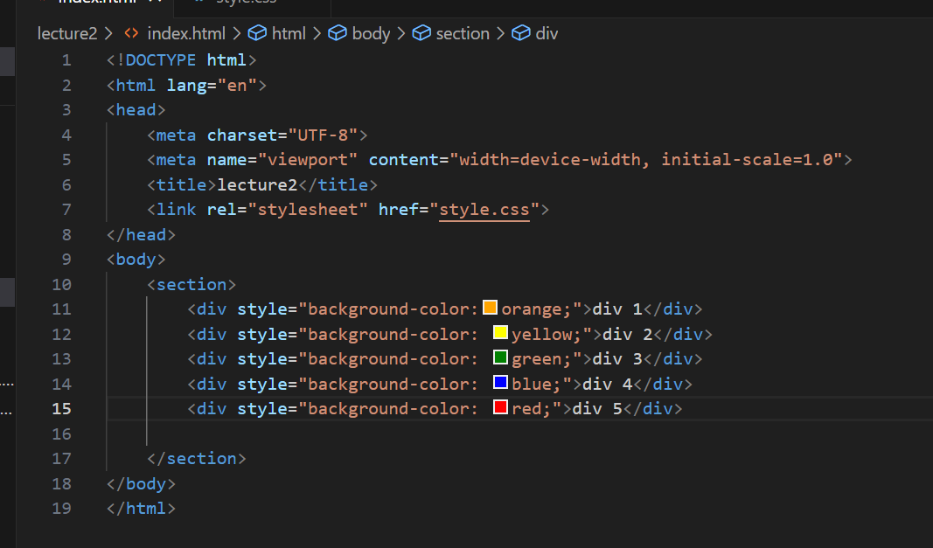

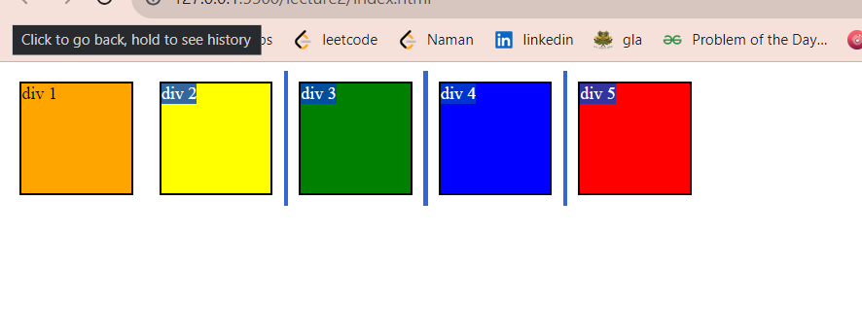

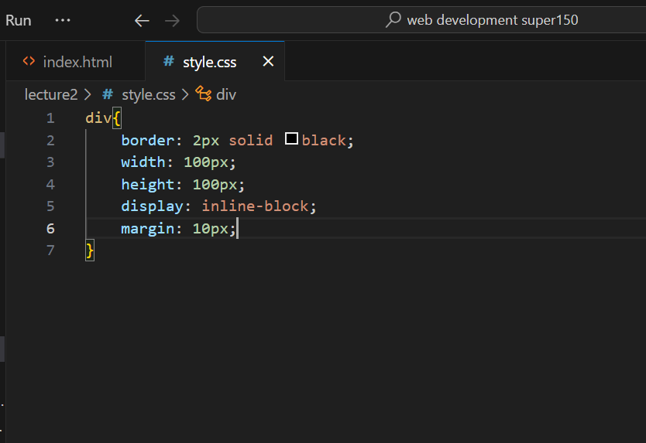

Using display inline block and margin

We put element on child element

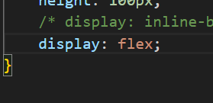

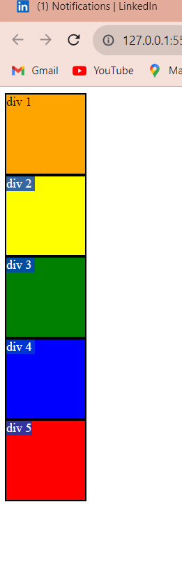

No change

Now using flex box

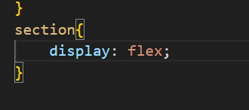

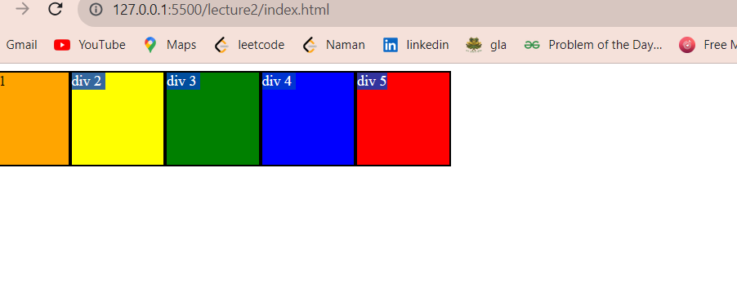

Flex box is a 1d representation at a time there is only one direction either vertical or horizontal

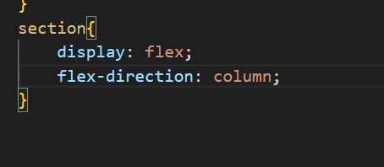

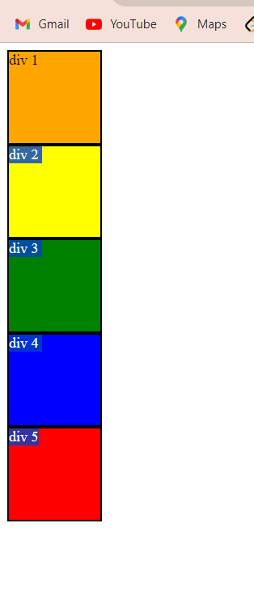

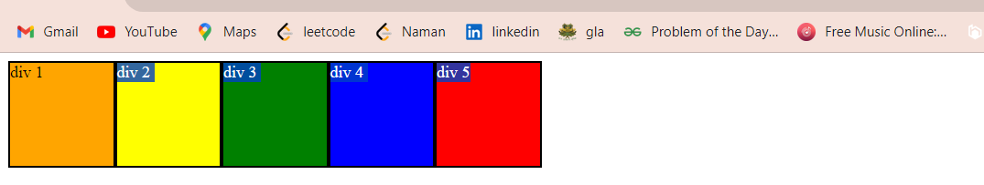

By default our main axis is along row and can be change along column using command flex dirction

Row reverse and column reverse

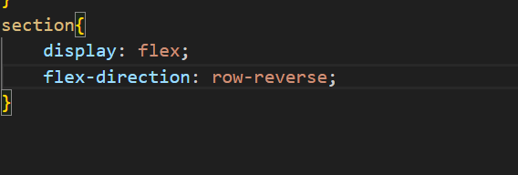

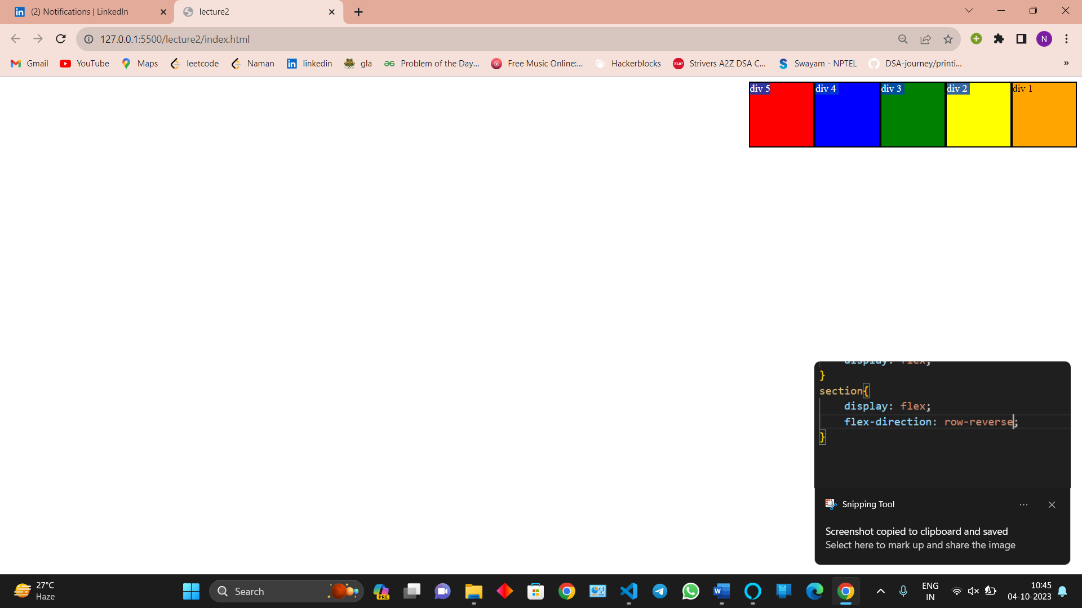

Point to be noted that the div is started from point 5 and go to point 1 means in row reverse also the element sequentialvity be change

Column reverse

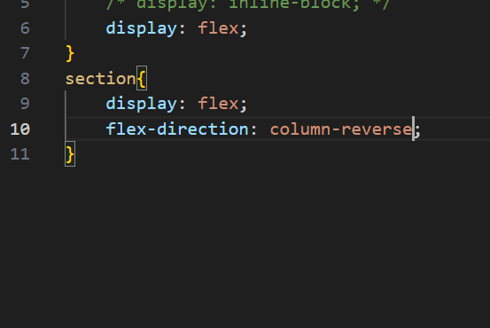

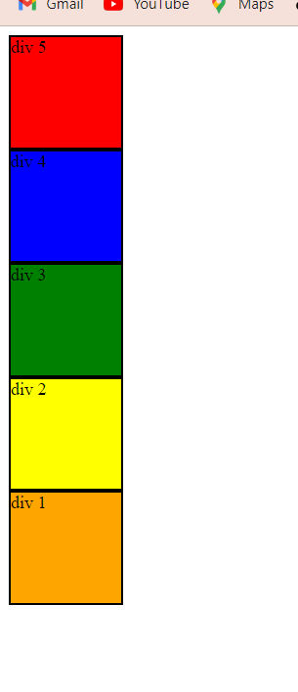

Same as row reverse but column position is not change but there sequence is changed

JUSTIFY CONTENT\

Flex end

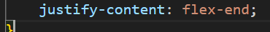

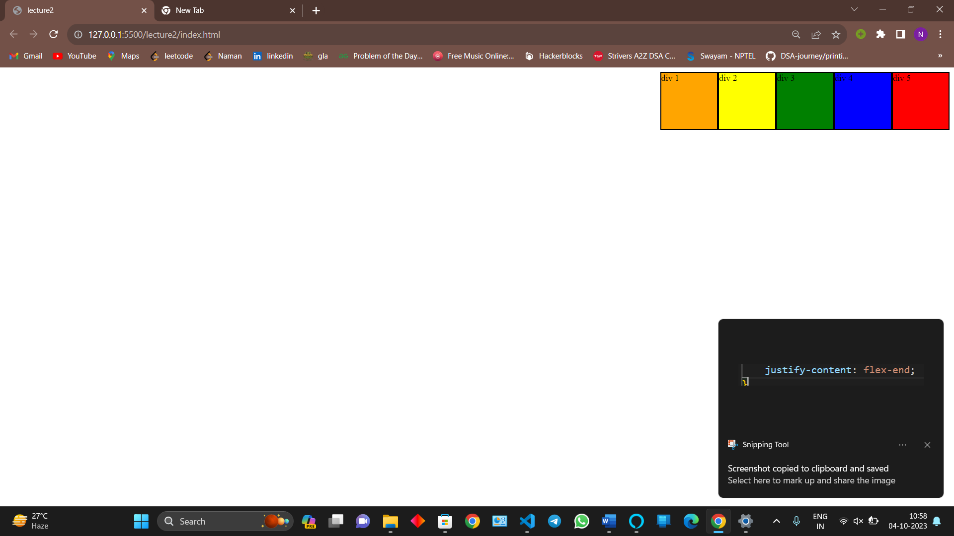

Flex around

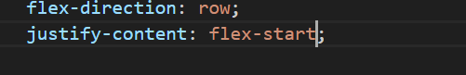

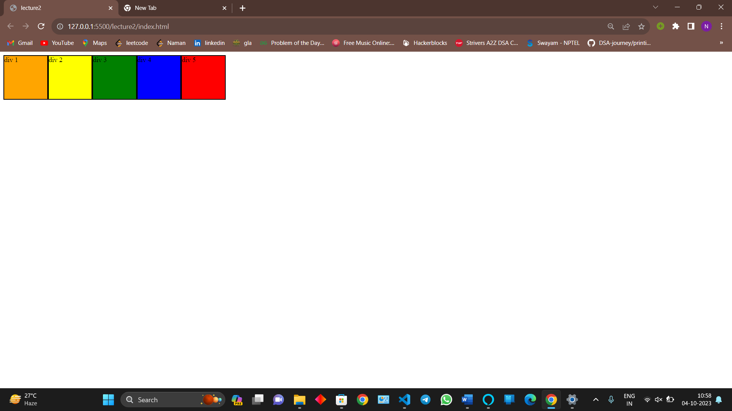

Flex center

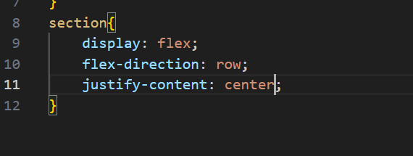

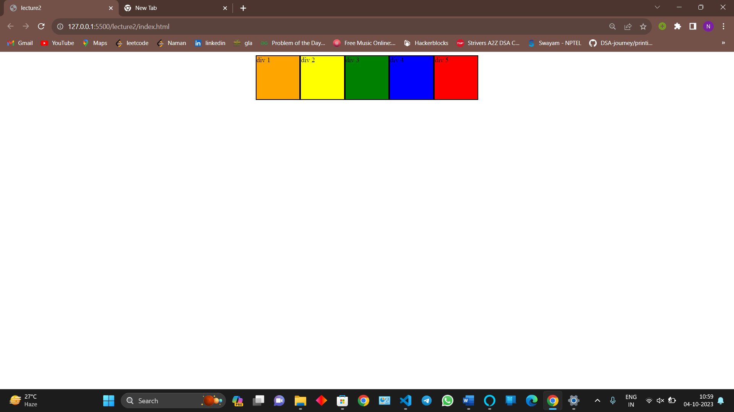

Space evenly

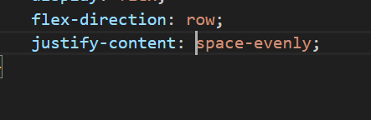

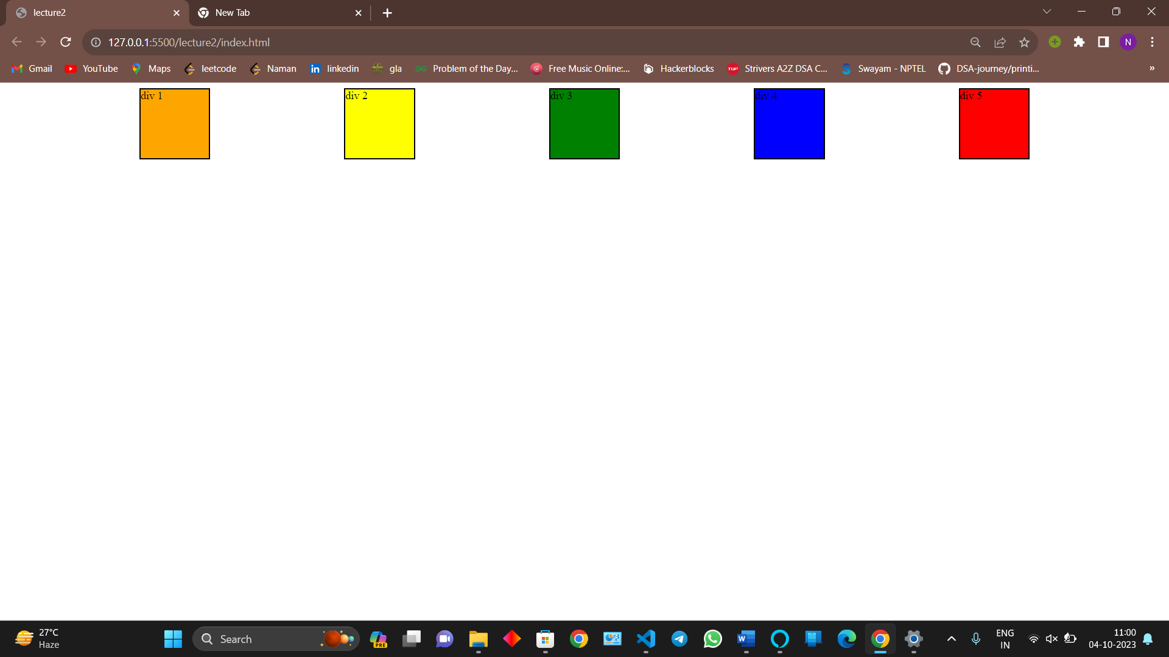

All the space are same

Space around

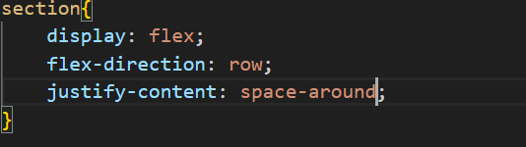

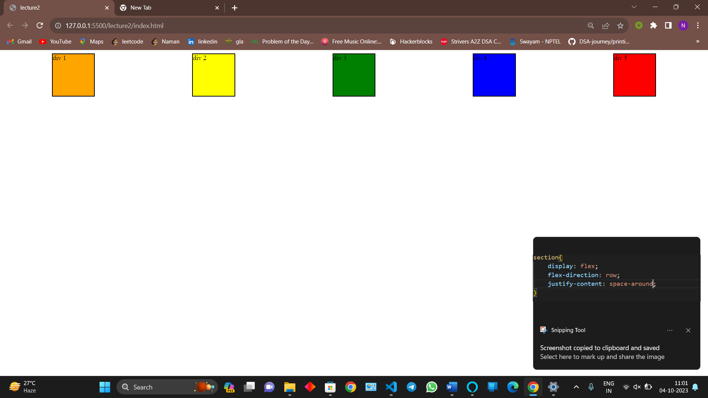

Corners are half of the middle space

SPACE BETWEEN

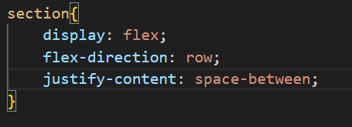

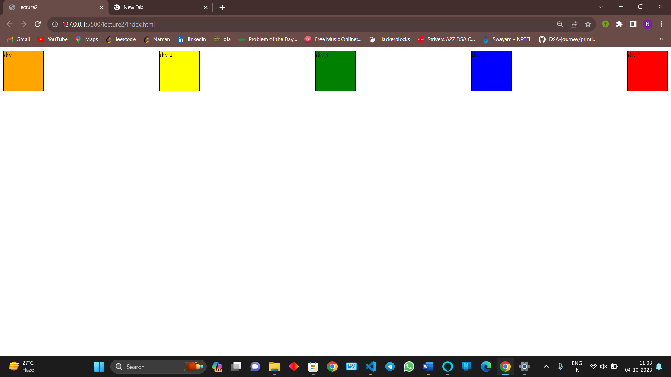

Only space appears between the blocks

NOTE- CROSS AXIS IS THE AXIS WHICH IS 90 TO CURRENT AXIS AND WHEN WE HAV E TO FIX THE ITEMS ALONG CROSS AXIX WE USE ALIGN ITEMS

**ALIGN ITEMS**

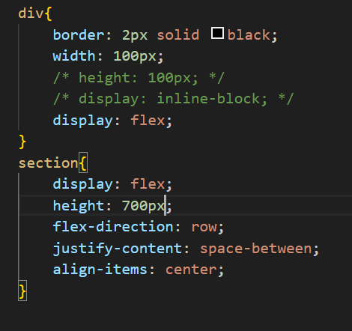

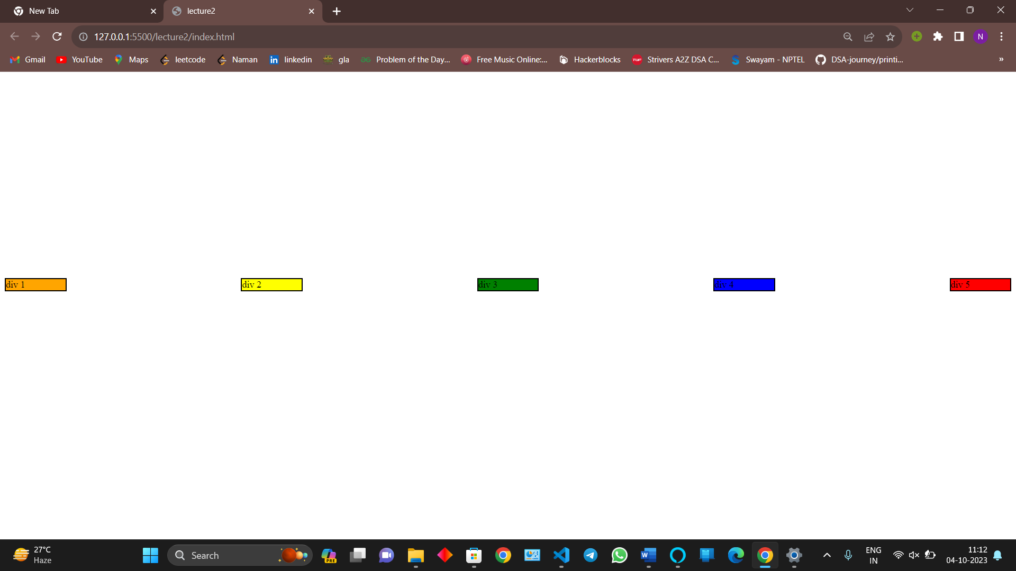

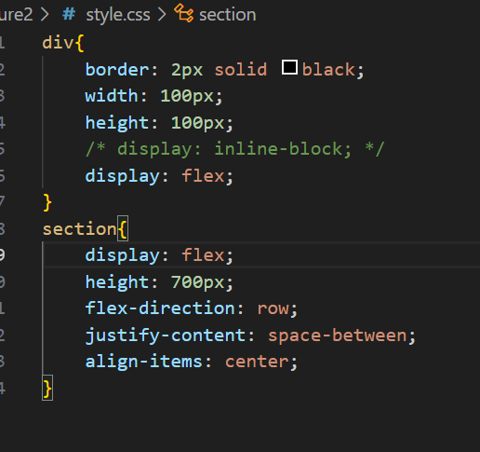

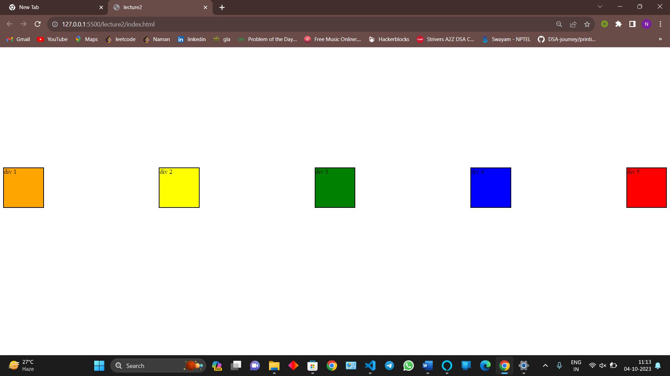

Align center is doing the center of the section

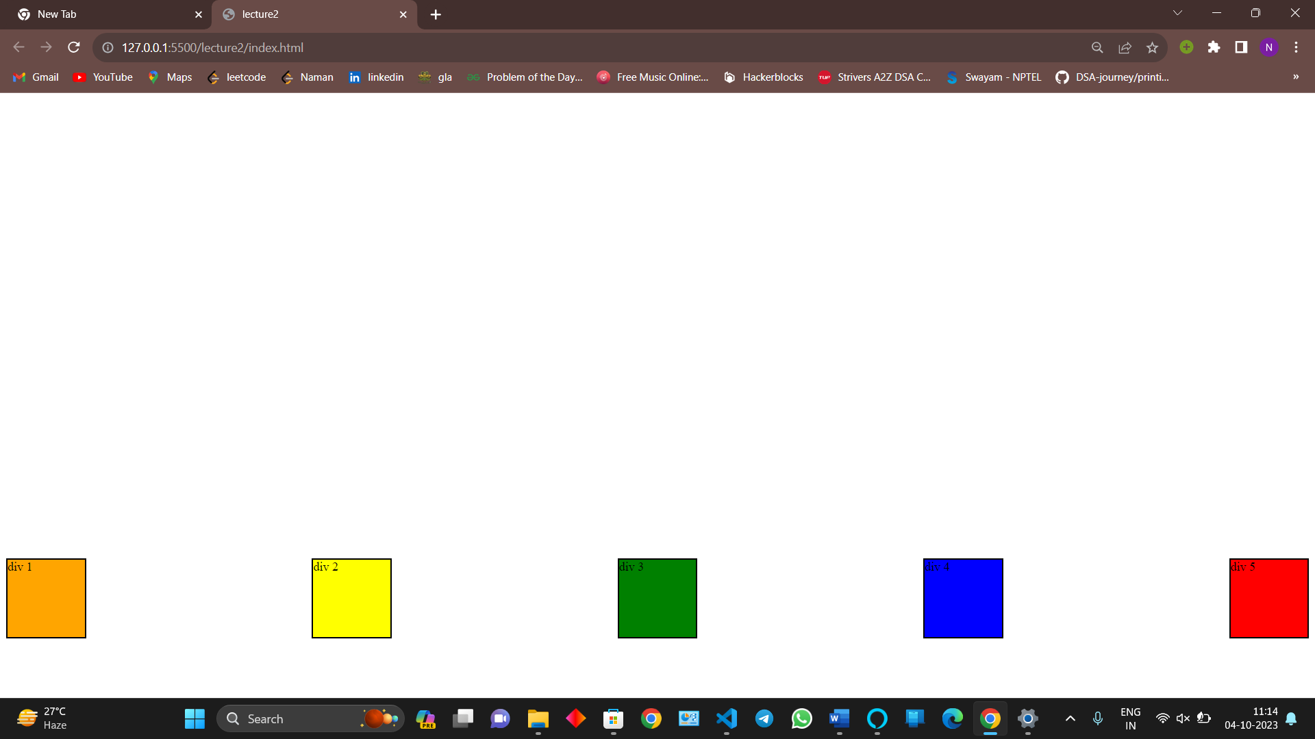

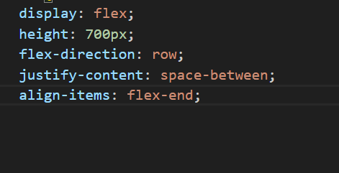

Giving border to section

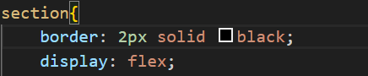

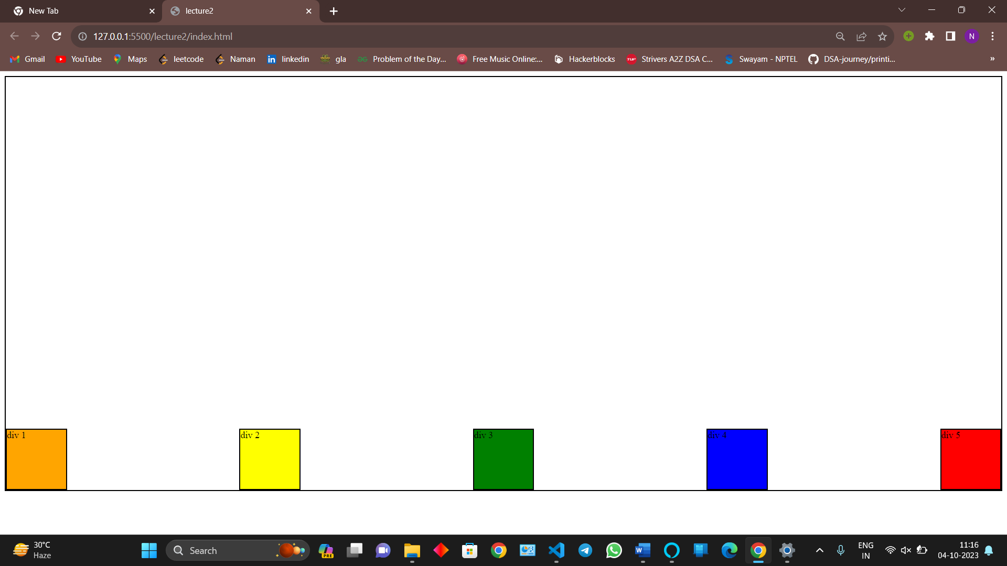

Giving direction column

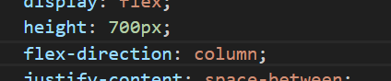

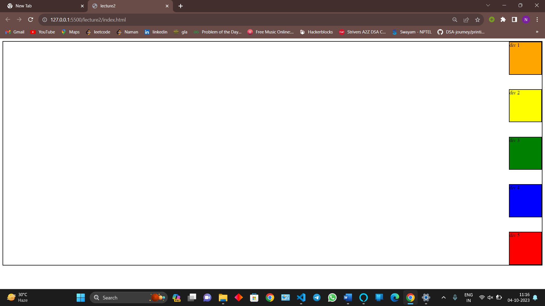

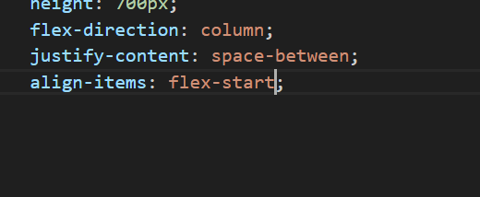

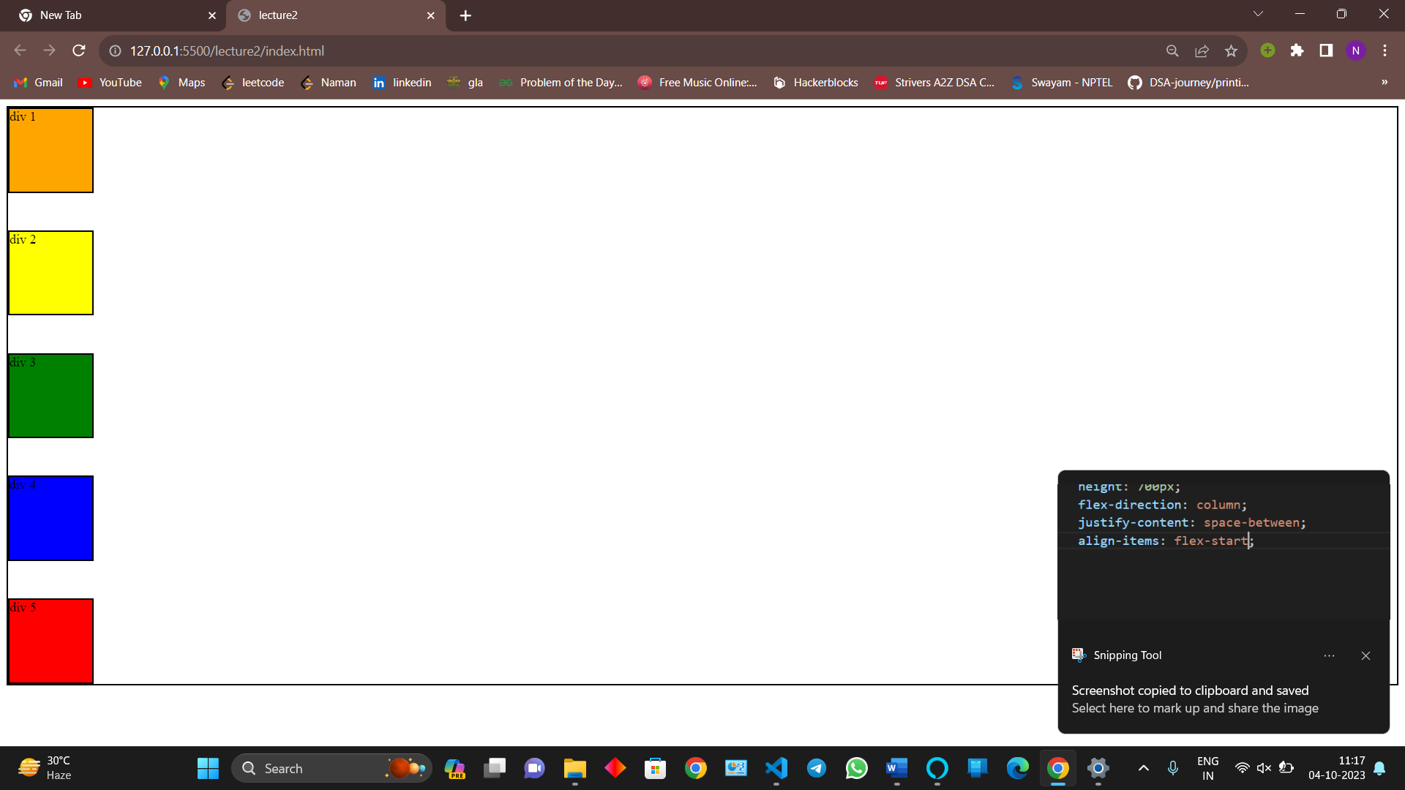

Stretch property – a default property

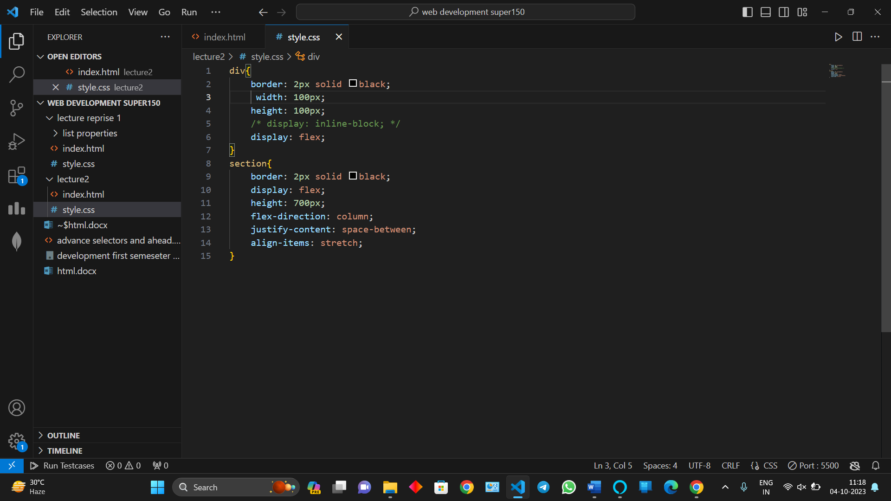

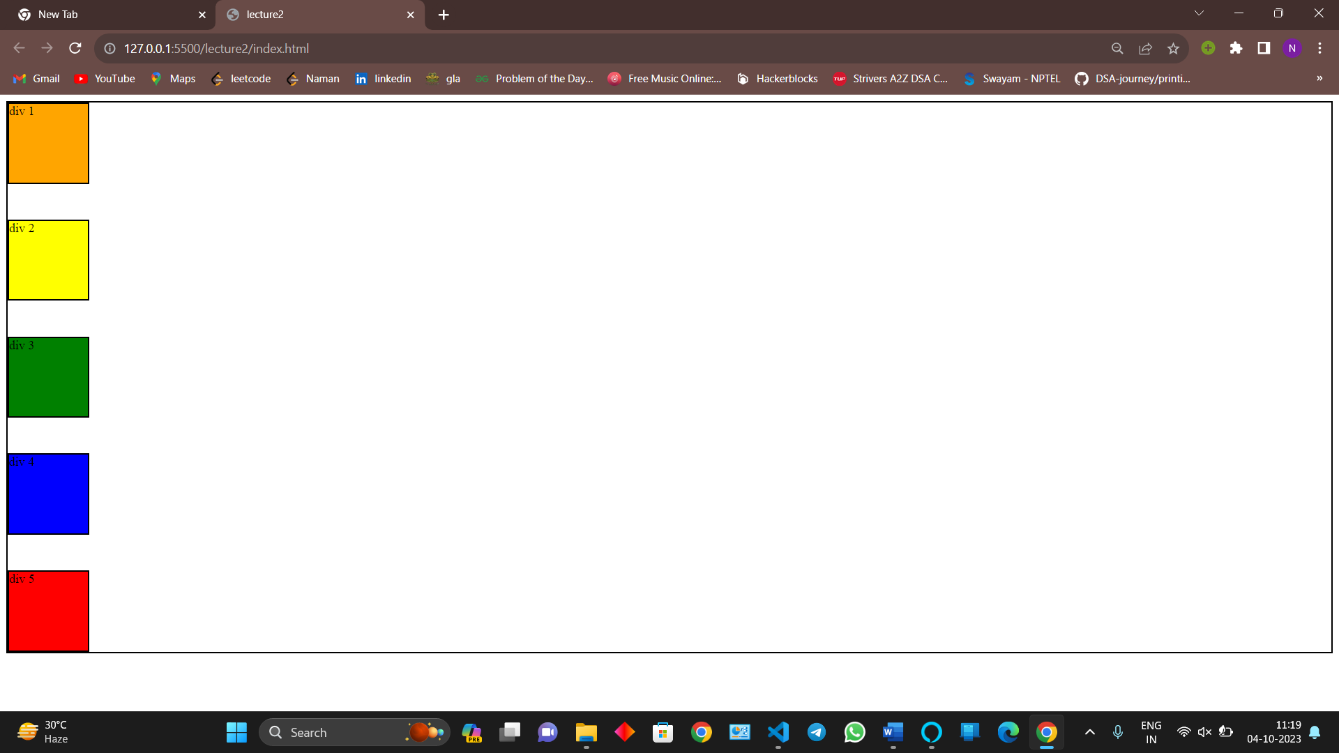

Now stretching

Remove the restricted with in div

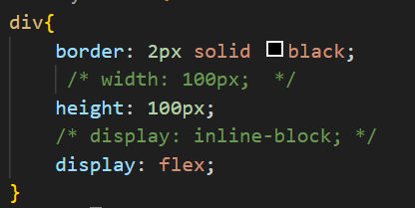

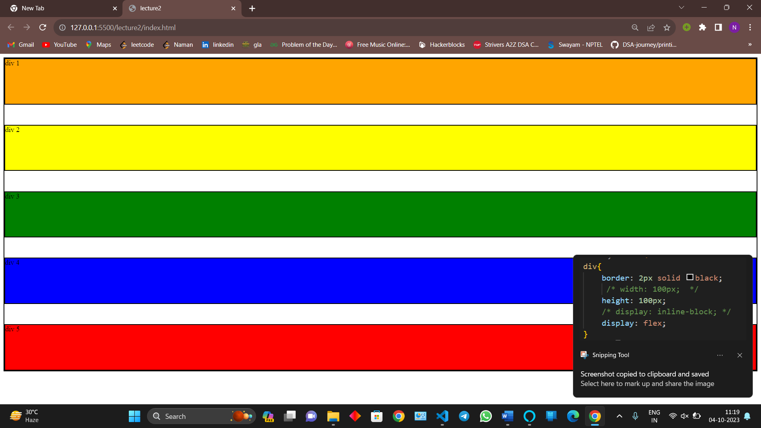

By default if we do not give the align property stretch and width of the box is not fixed all the elements are by default stretched

FLEX WRAP

By default now wrap

After space is over element will srink

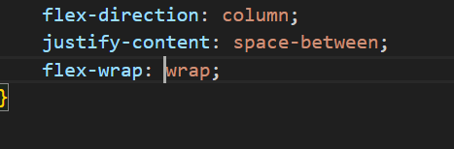

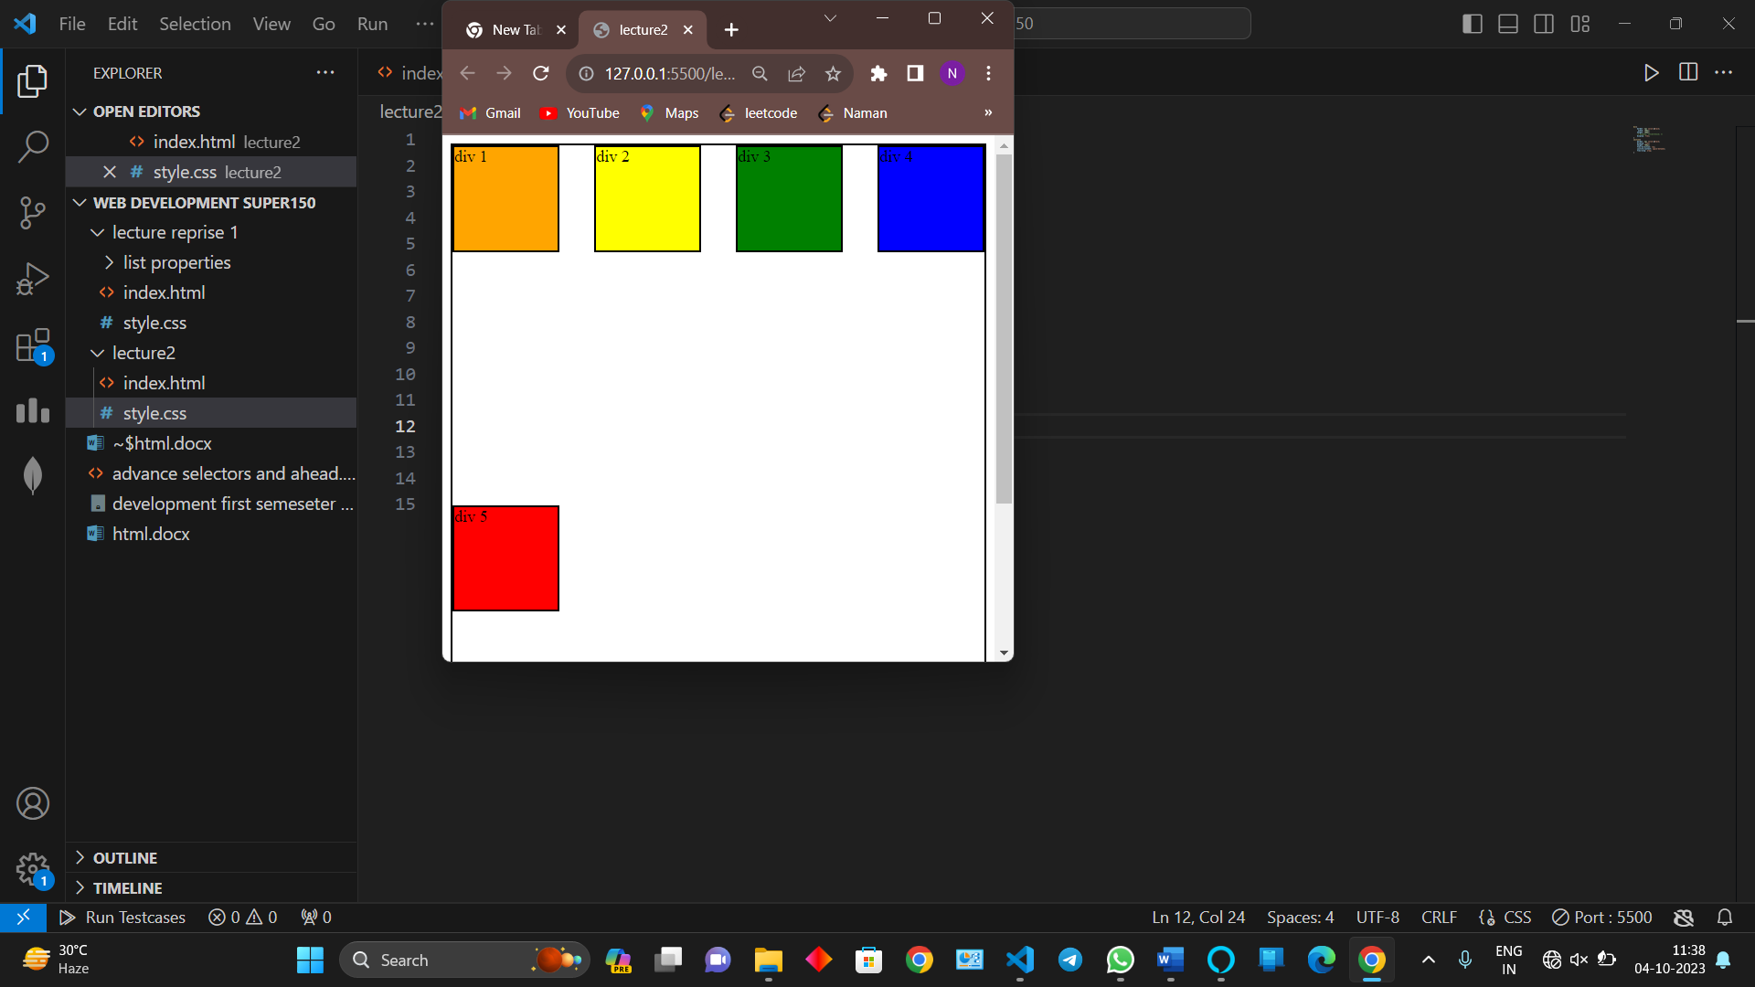

The fifth box gone into second line

All the properties of flex box we have learned till now are parent properties

ALIGN CONTENT

Sees the space between between two rows

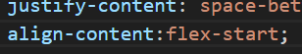

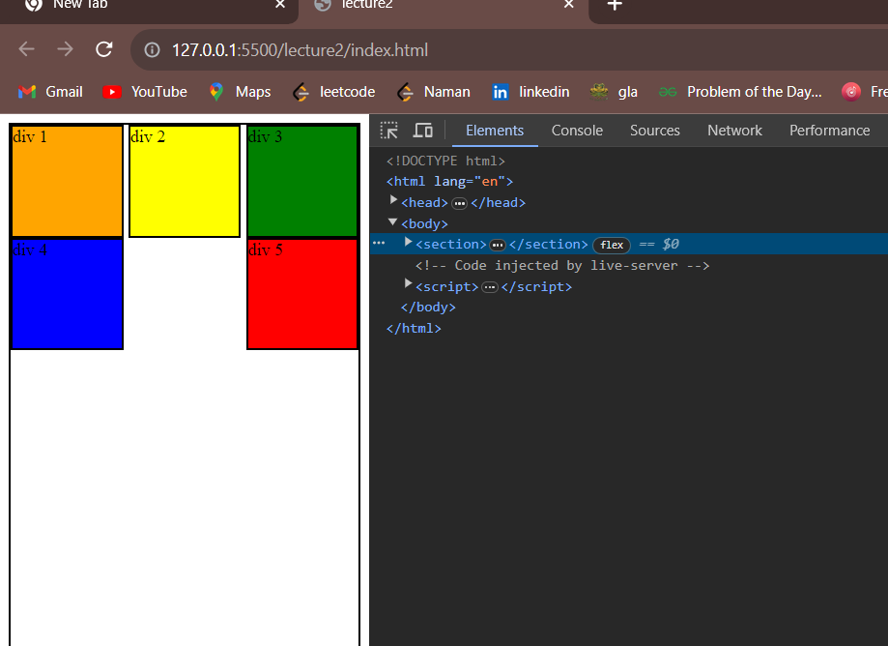

**GAP**

Gap between two columns is called gap

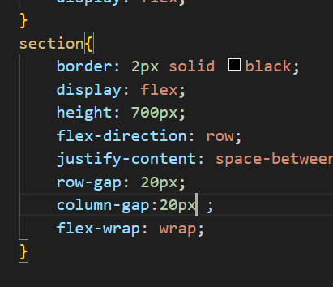

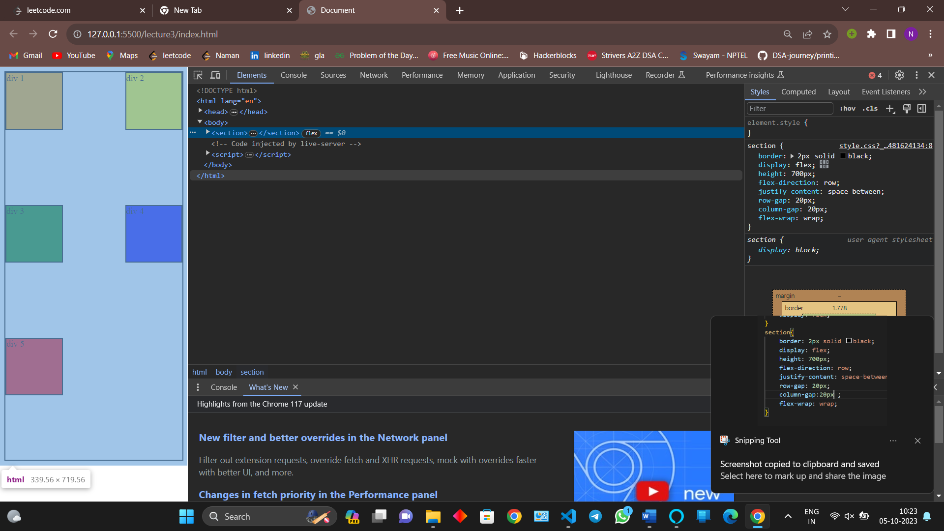

We can use

Gap:; which do atleast the given number of gap or more

Row-fap

Columns gap

**CHILD PROPERTIES**

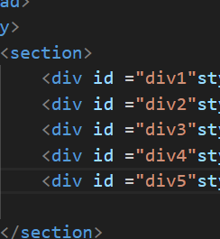

Given id to each and every div

FLEX GROW

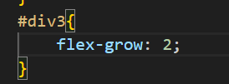

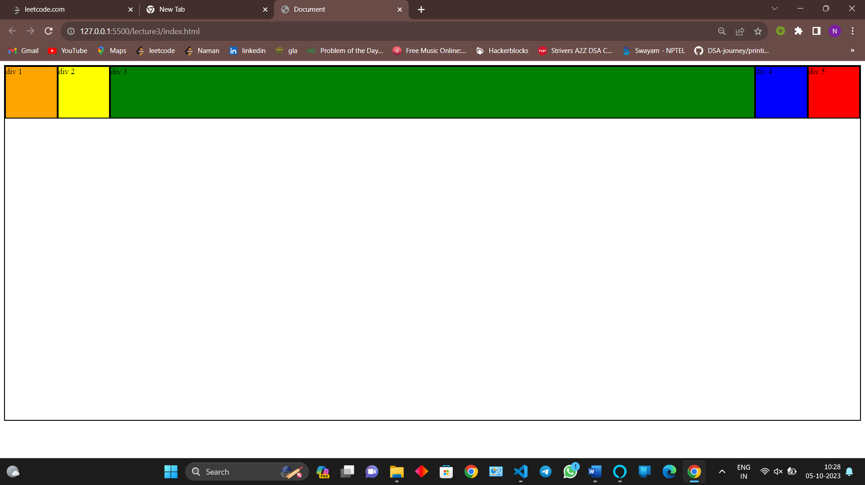

It does effect it while writing 1 ,2 or any number because flex grow is only in one

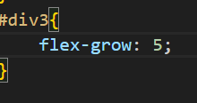

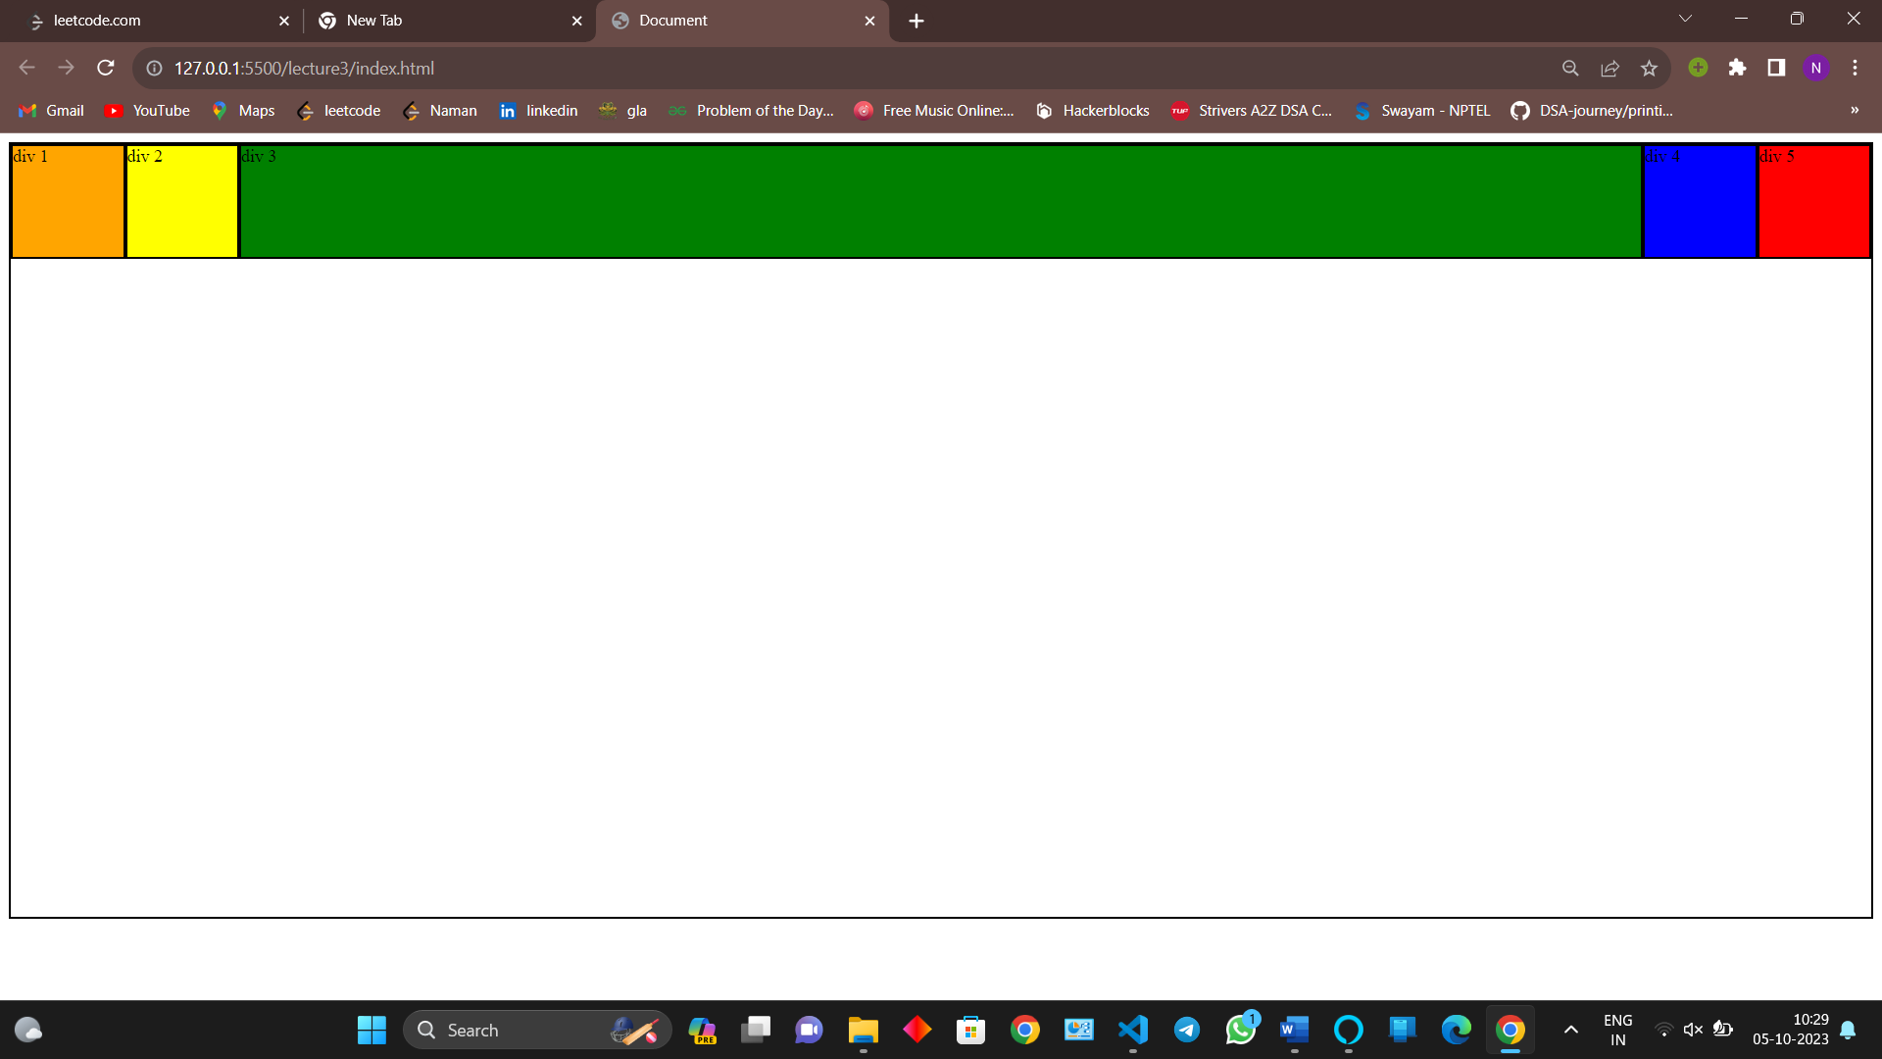flex grow ka simple matlab extra space ko baatna if ek banda hai baatne ko to kitna bhi space kitne bhi ratio likho sab ek pe hi jayege aur ye ek child property hai

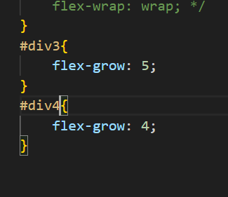

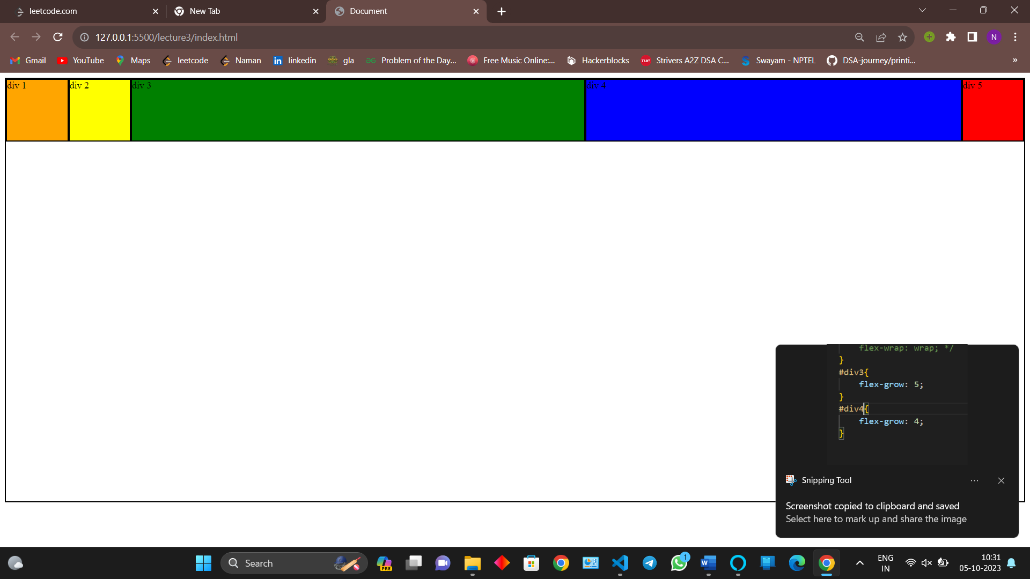

FLEX SHRINK

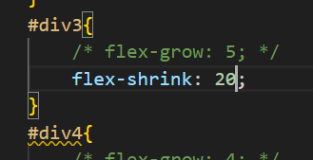

Flex will shrink with different intensity with respect to other by default all shrink normally

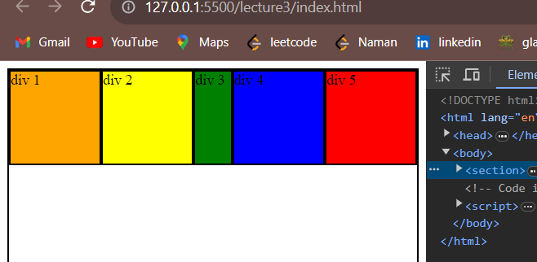

**MEDIA QUERY**

Different sizes for different screen

We basically on production layer work on 4 layers

1200 px

991/992px

767/7678

576

These are called the breakpoints

How to use media query

Syntax

@media{  
 swarg ka Darwaja

}

For printers we use @media print

By default all print screen etc

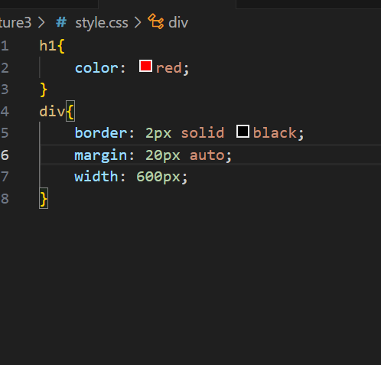

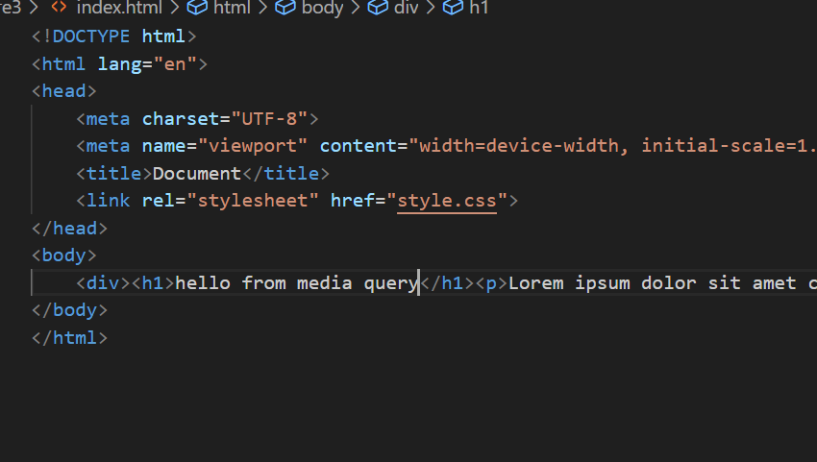

To give margin of left or right to center directly write

Auto only works on left or right margin not works on top and bottom

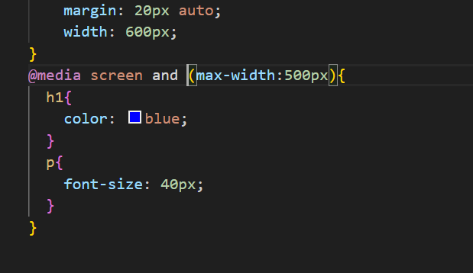

Space after AND is necessary without it not work

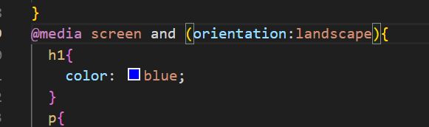

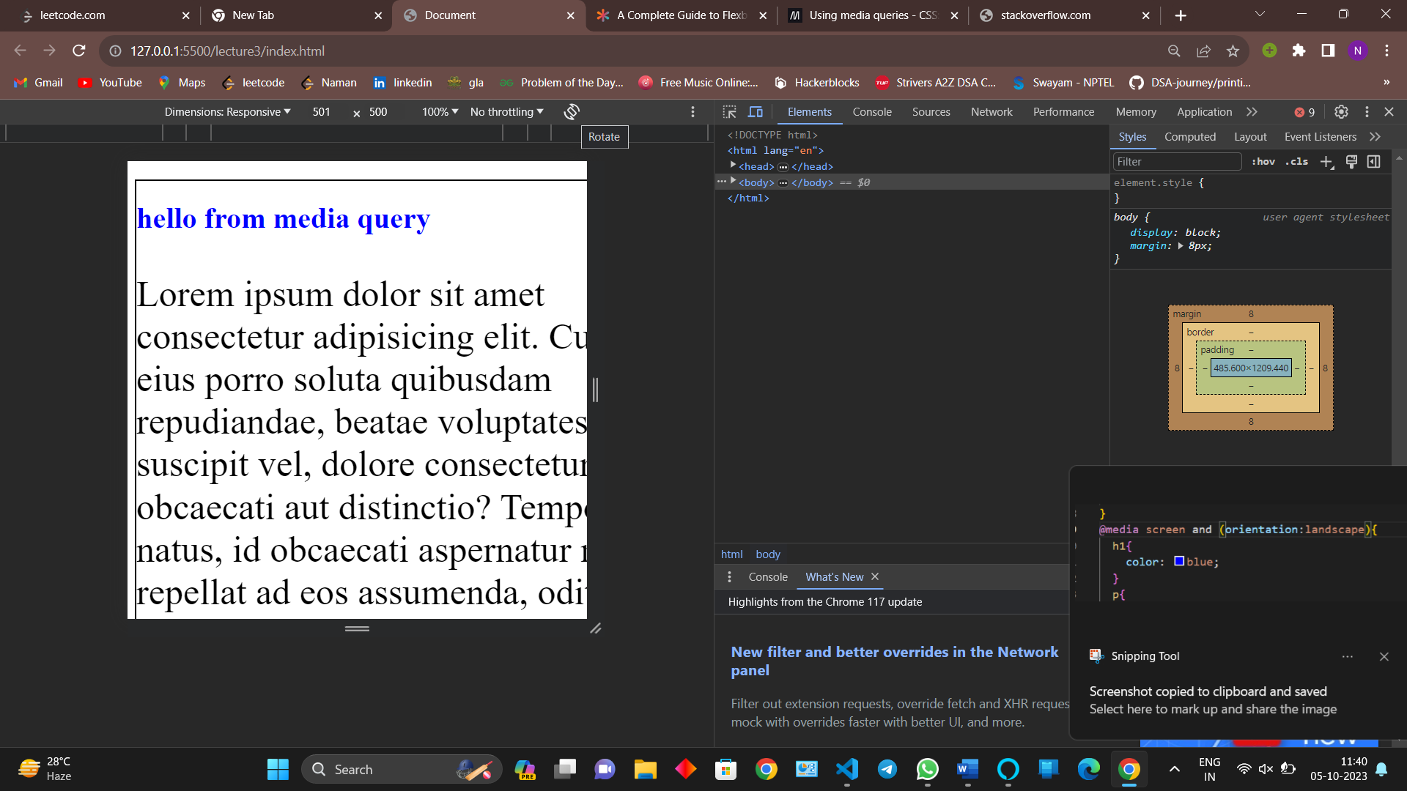

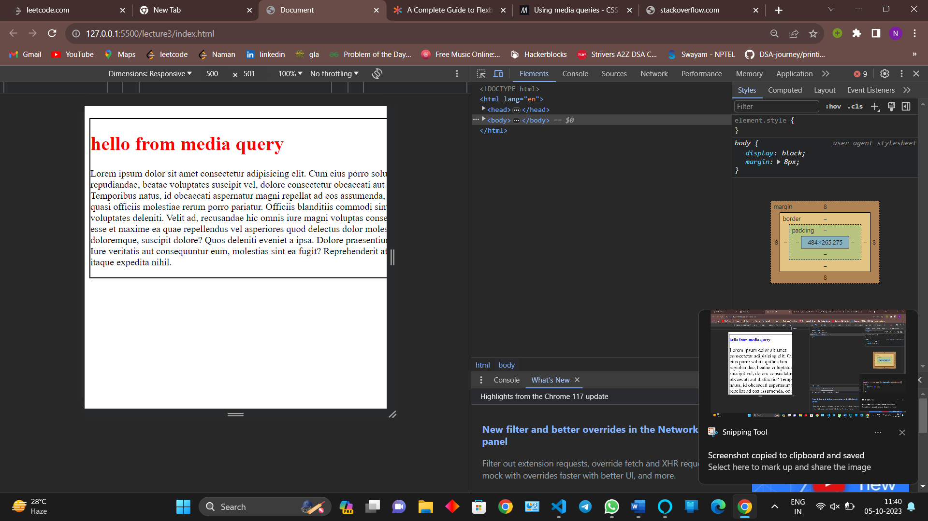

We can give or condition using comma ,

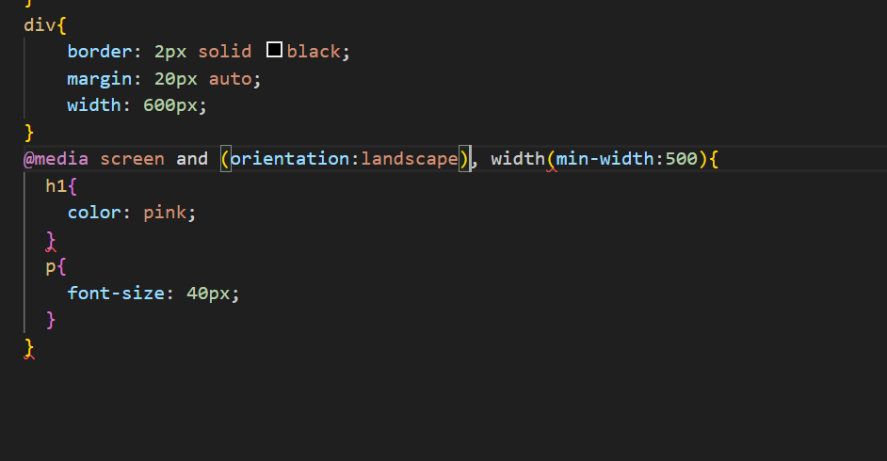

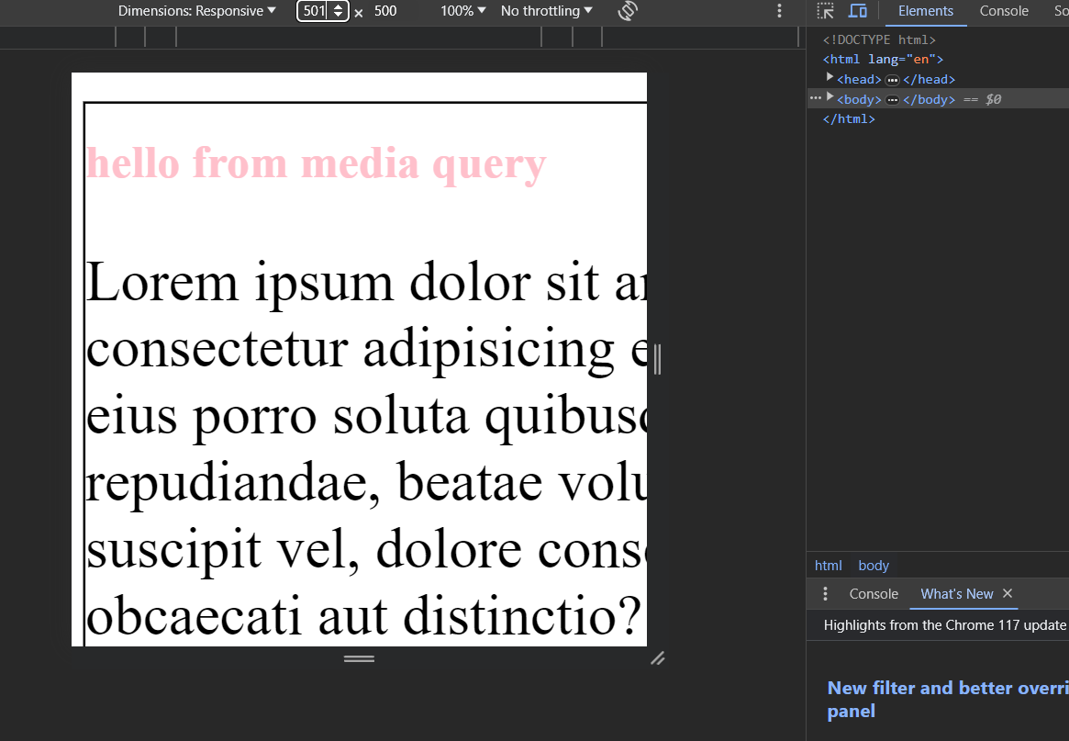

**TRANSITION**

Transition basically from one state to another state by default transition duration is 0 ms

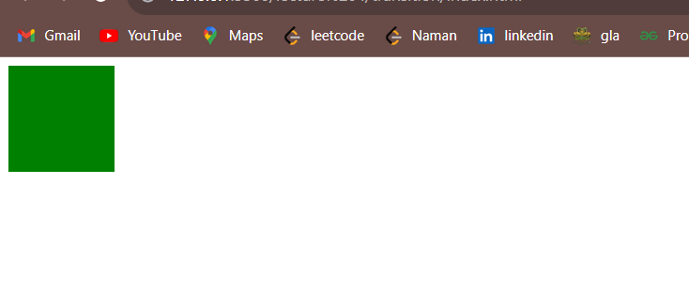

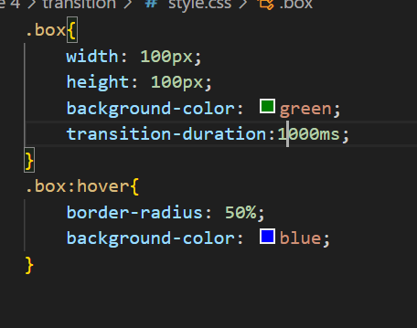

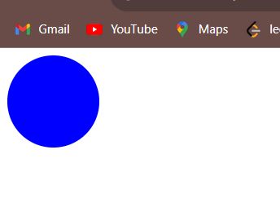

Now it will take 1000ms from transitioning from one state to another state

From above example two things were changing in same time colour and shape now we want to change or give transition duration on a particular property so we use transition property

TRANSITION-PROPERTY

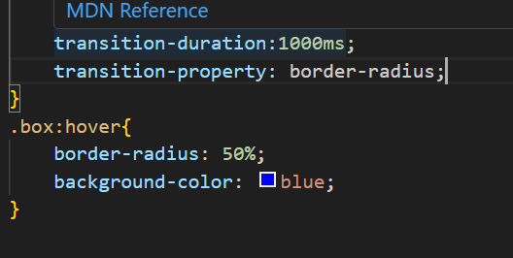4

Now 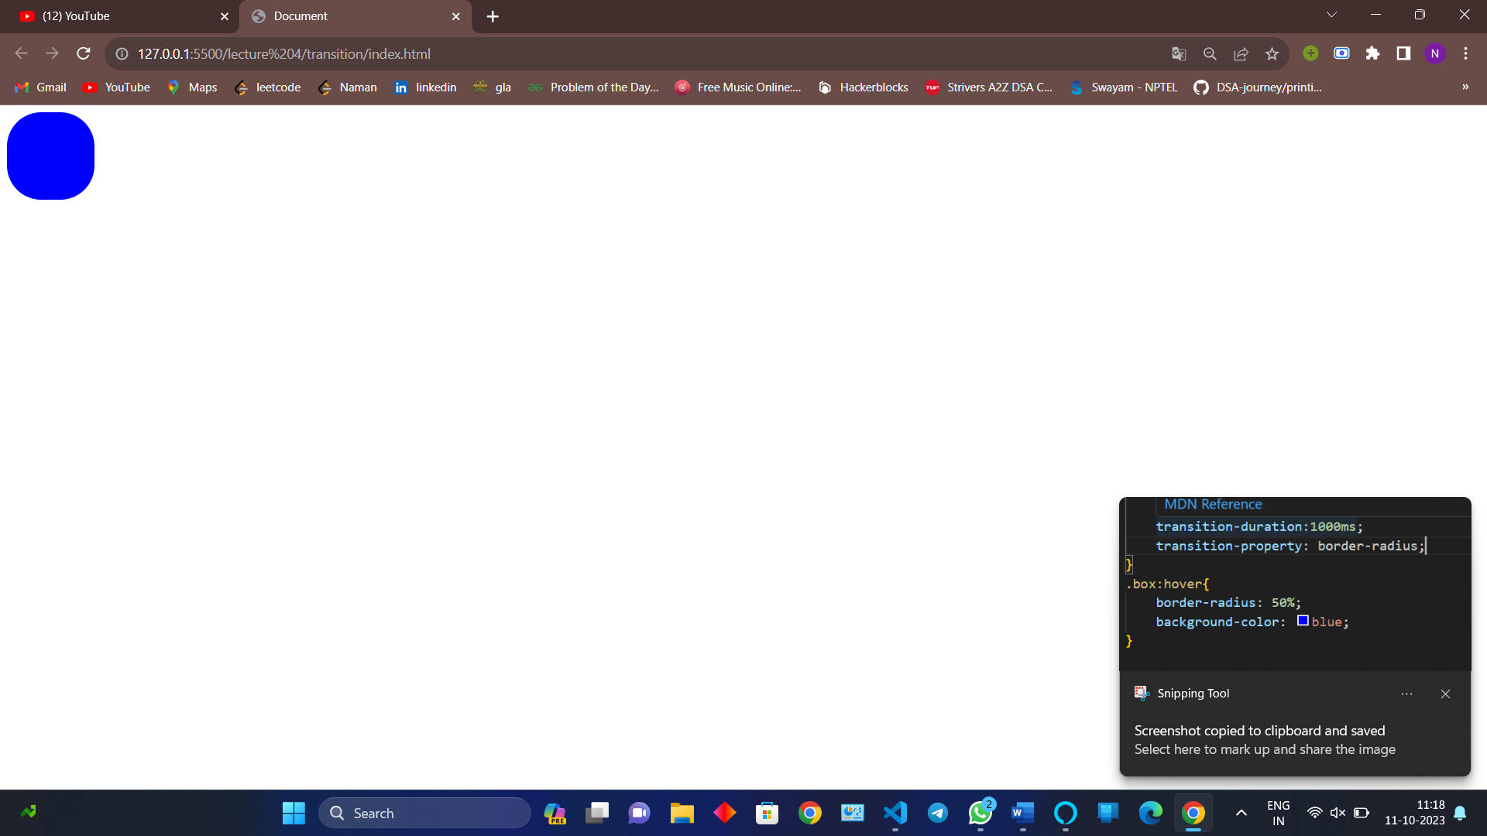

Now the colour will change fast and shape will change slowly



To give multiple property type space separated properties

TRANSITION TIMING FUNCTION

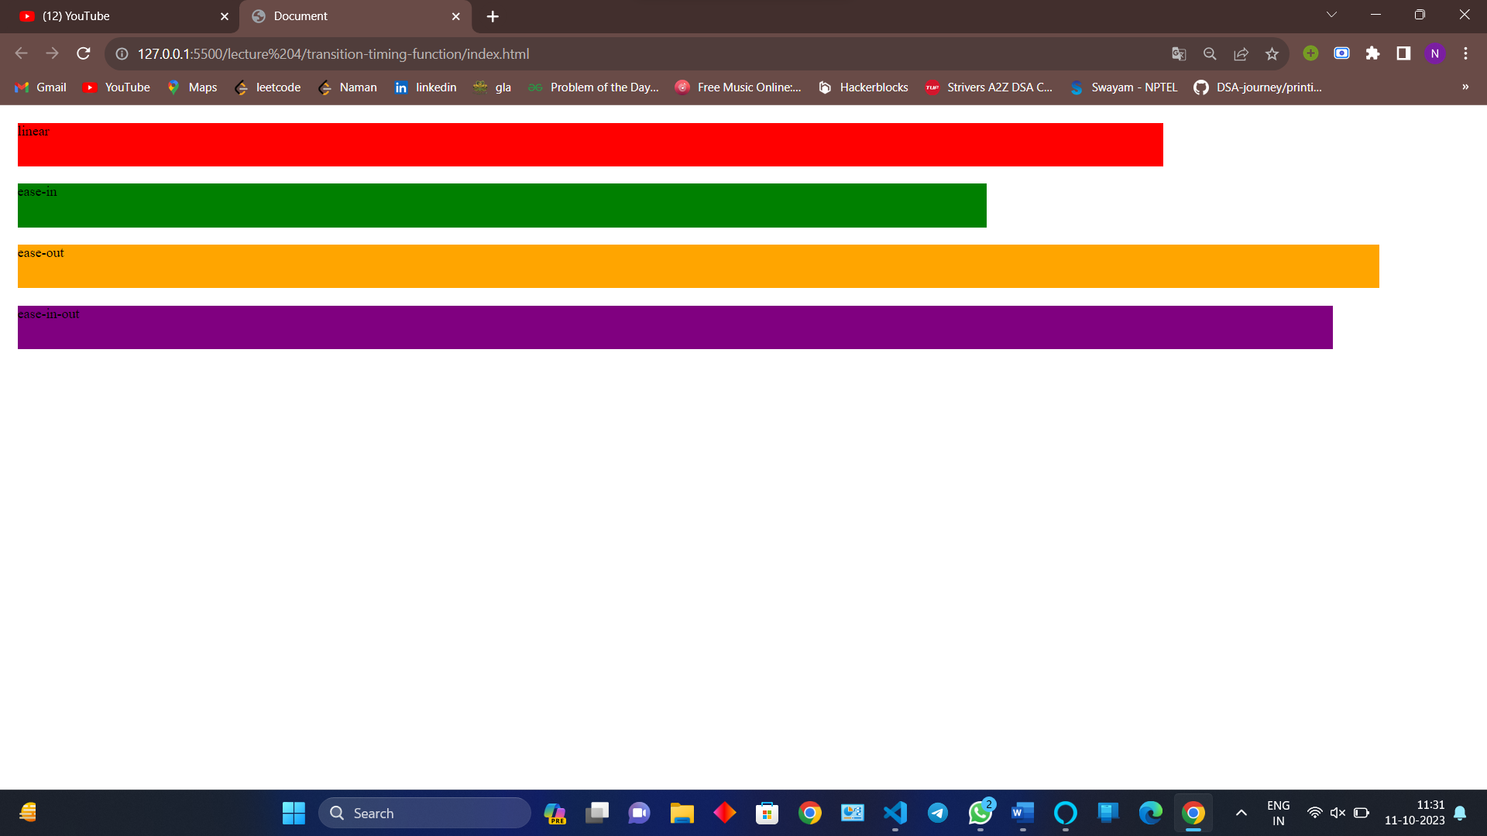

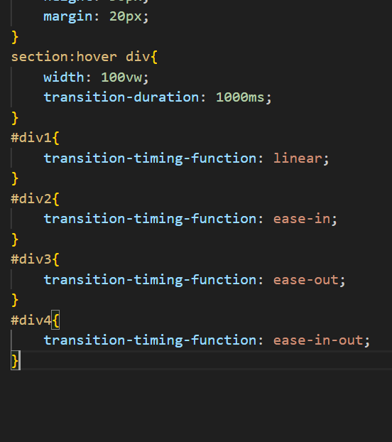

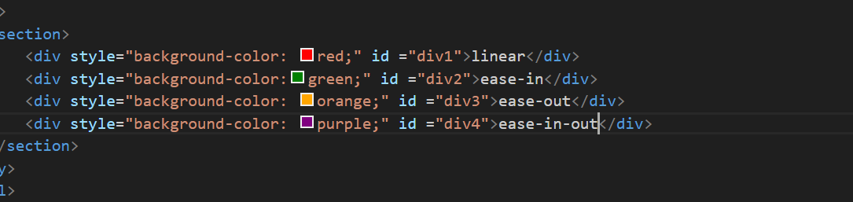

Linear – it will same speed through transition

Ease-in – start slow end fast

Ease -out – start fast end slow

Ease-in-out – start slow middle fast end slow

**TRANSFORM PROPERTY**

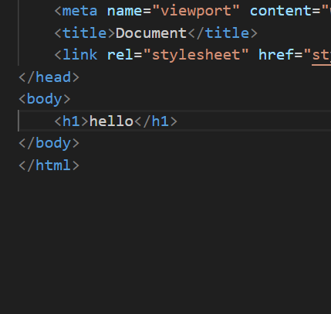

TRANSLATE

Translate means change

TRANSLATEX ( NUMBER )

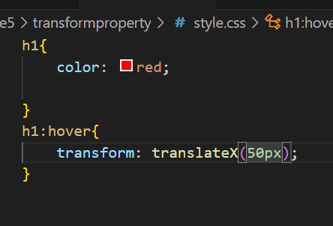

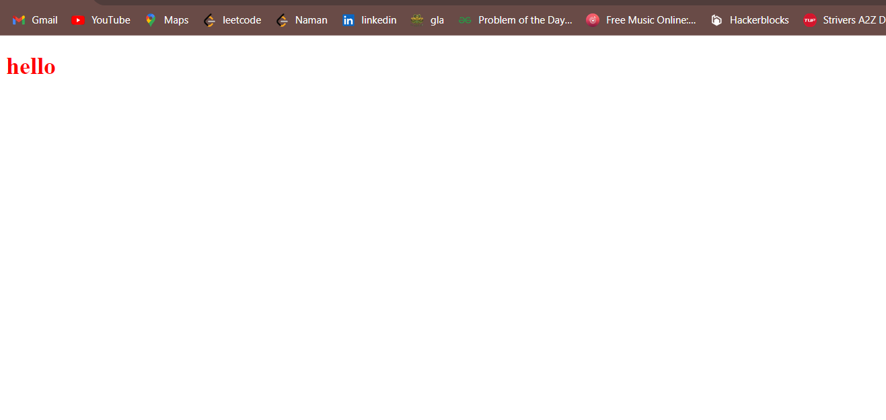

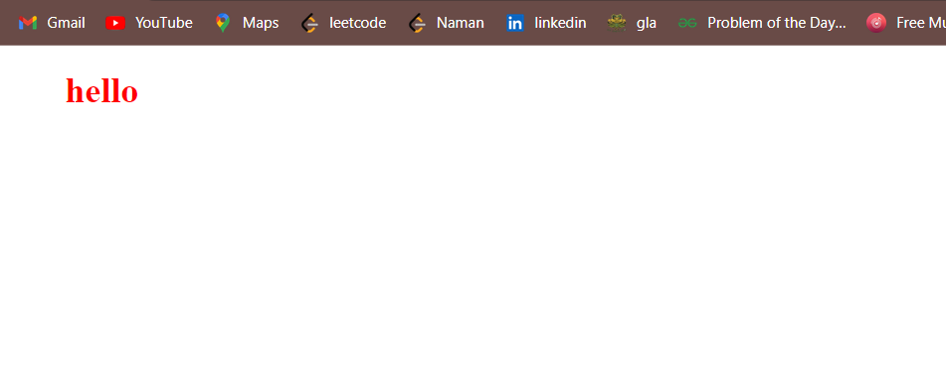

We can not give simultaneously x and y

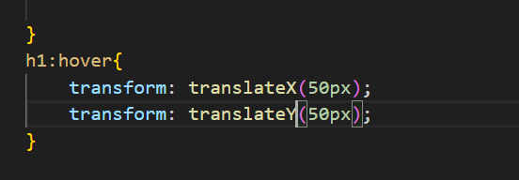

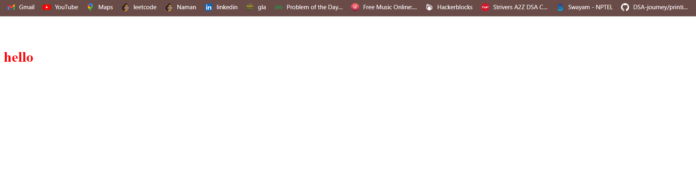

To change two or more translate in one heading we do

Transform translate(px,px);

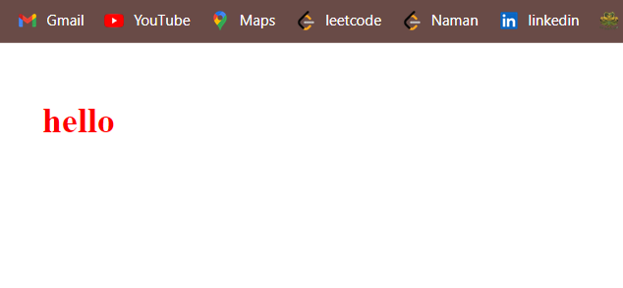

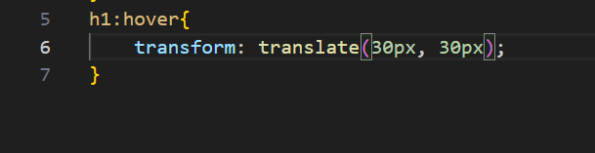

ROTATE

ROTATEX(DEGREE)

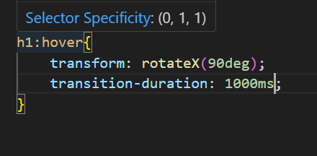

ROTate according to diagram



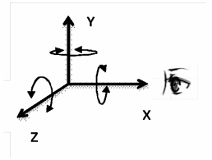

ROTATEY(degree angle)

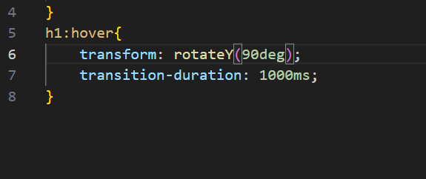

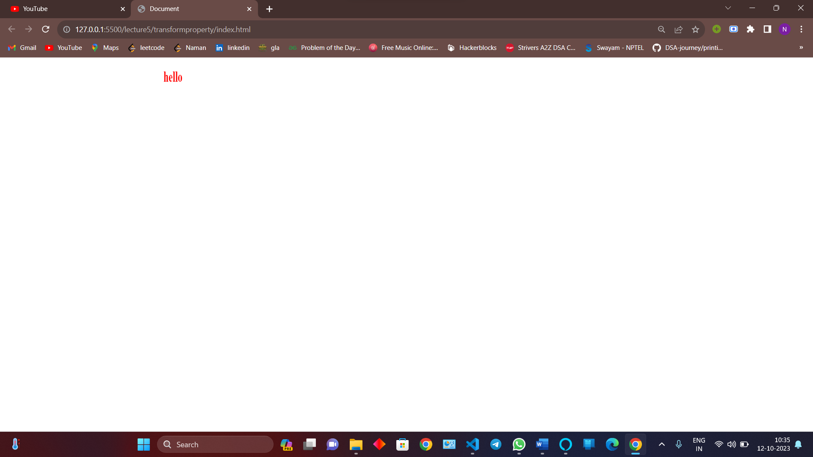

Y taking long turn because the center of h1 ag is in center of the screen

SCALE

SCALEX

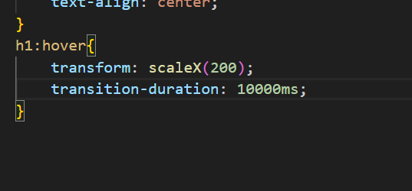

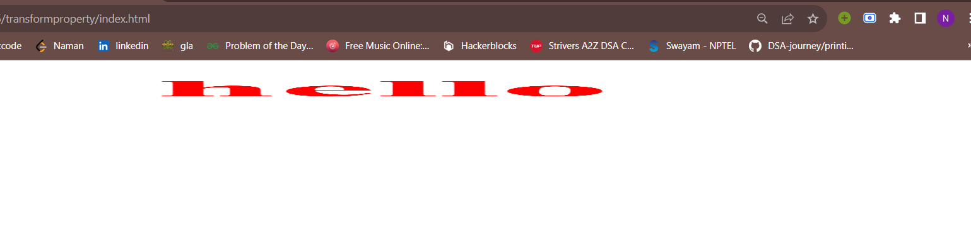

Changing the size 200x with respect to original size

SCALEY

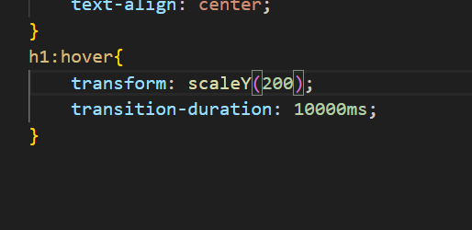

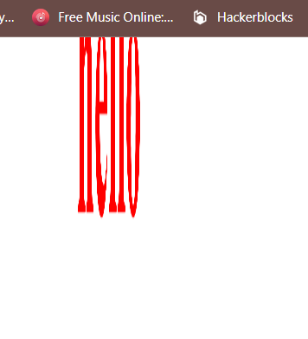

CHAGNES IN Y DIRECTION

Expand in both direction for y negative as well as positive

**ANIMATION**

@keyframes identifier{

}

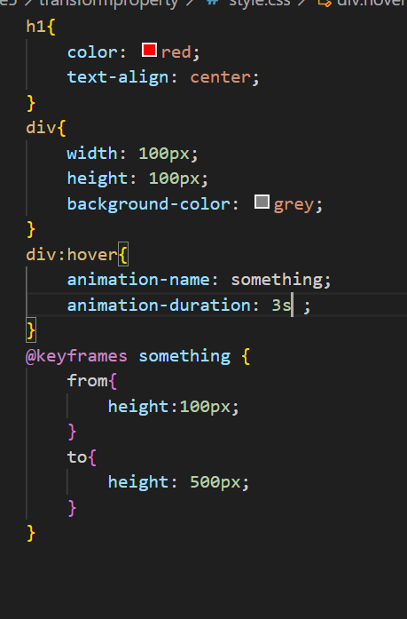

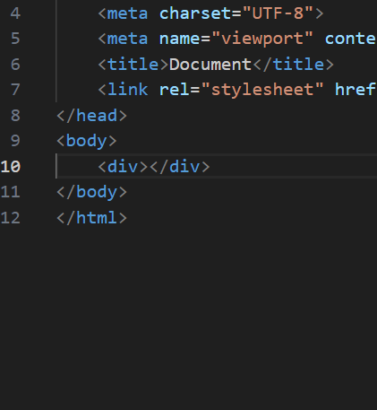

Animation duration is necessary without it you cant see it

Now for middle state

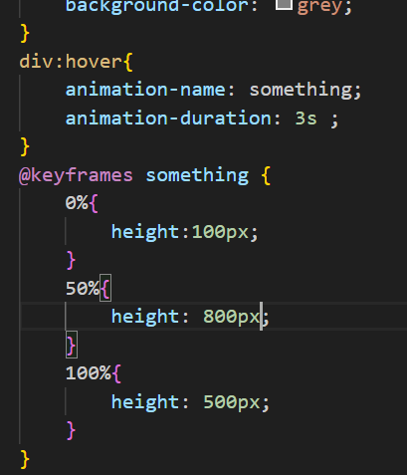



Uptil 50 %



After 50%

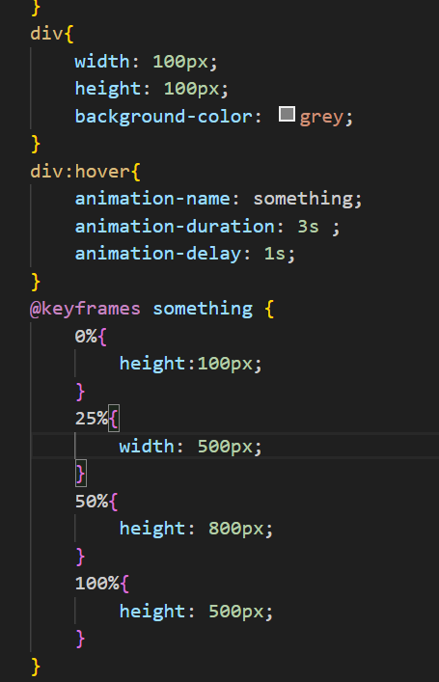

Can also do like this

If we want to run animation numerous time use

Animation -iteration-conut:;

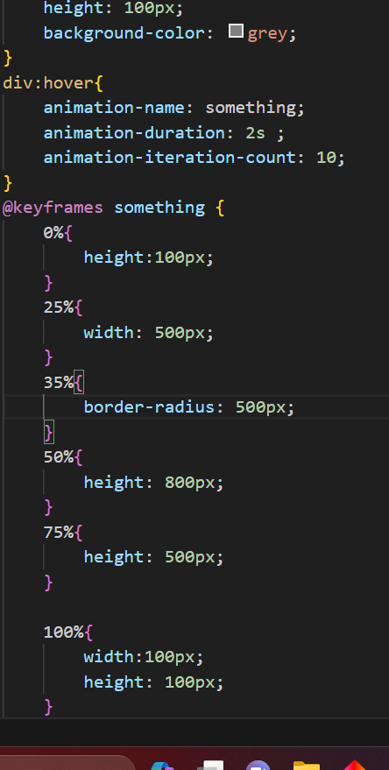

Animation count can be infinite

ANIMATION DIRECTION

CHANGES THE FLOW OF DIRECTION OF ANIMATION

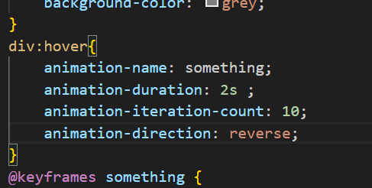

The animation will be alteranate if we write “alternate” in animation-direction

ANIMATION FILL MODE

Means where it should be stop when animation is ended



We can also give backwards

The animation will stop at initial

ANIMATION PLAY STATE

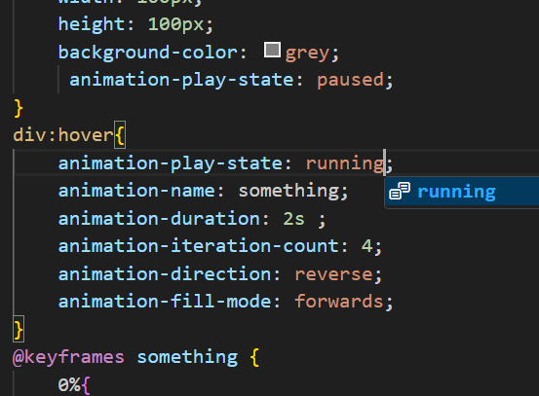

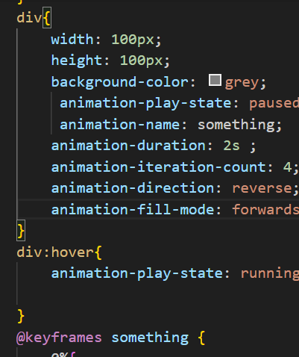

When we remove hover from the object object animation stays where it is and restart form that state only

**BOOTSTRAP**

First we have to include cdn links of css as well as java script

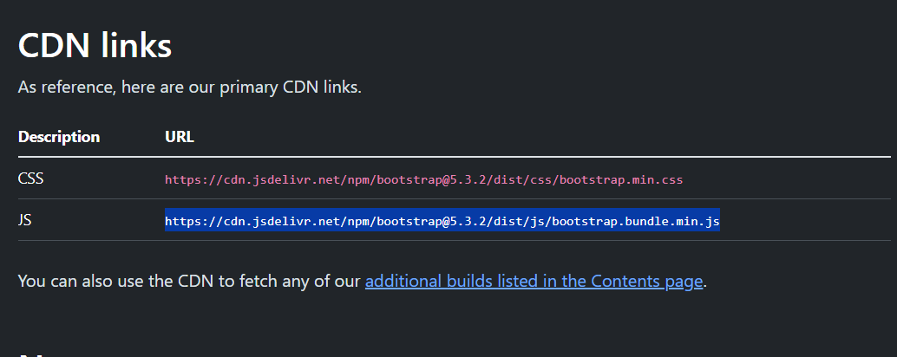

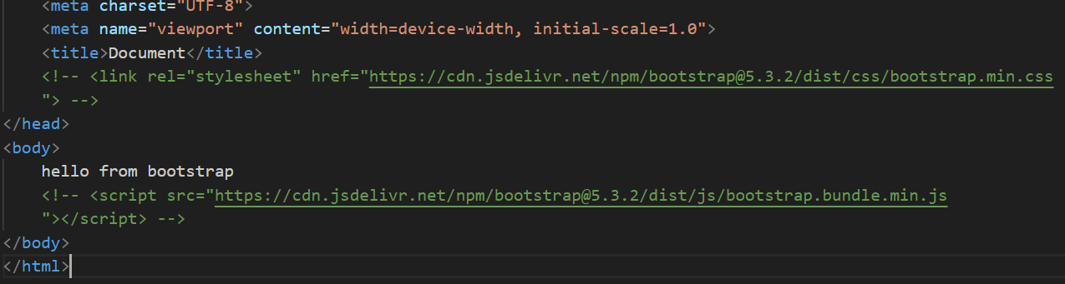

Commented links

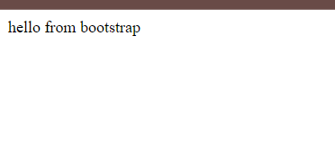



Uncommented link

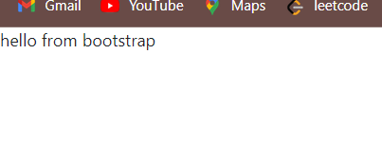

Look how font size and padding changed when we insert css link of cdn for bootstrap



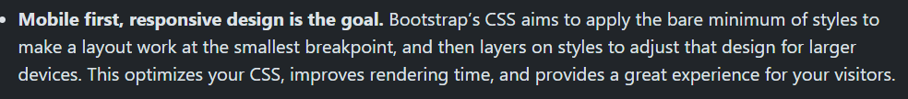

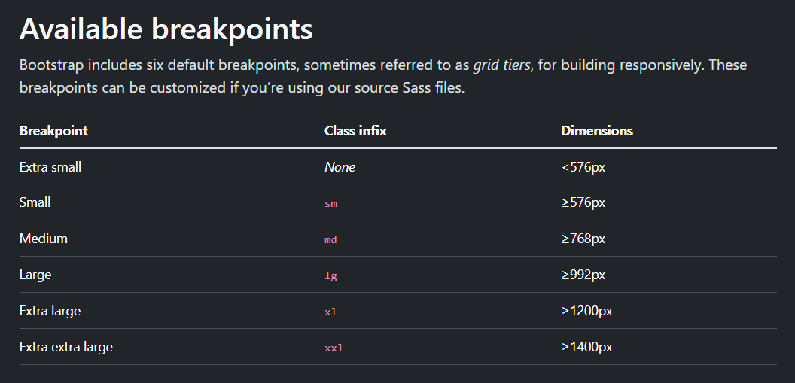

Containers

Bootstrap divide the page into 12 equal columns if you want to fix 13 column thing in this 12 column the bootstrap swap it into next line

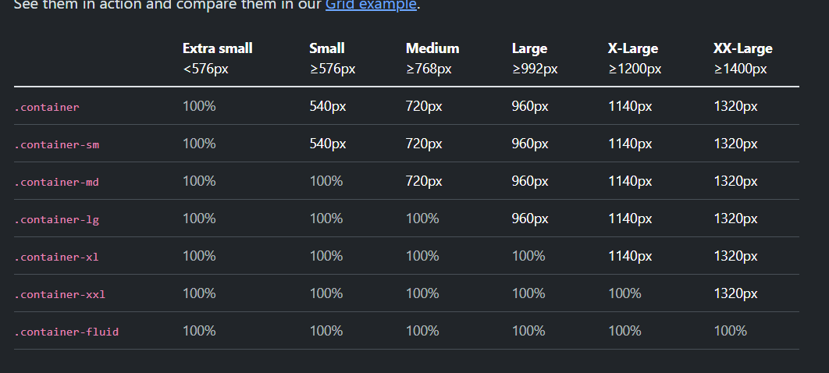

.container – when the size is lower then 576 px it will occupy 100 %

Sm – when size is between 576 and 768 the container will take 540 px

GRID

When you want to specify row give class = row if column class = “column”

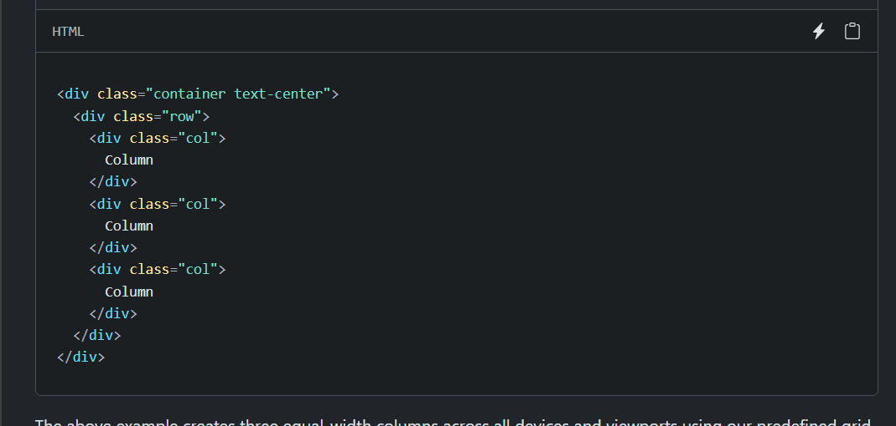

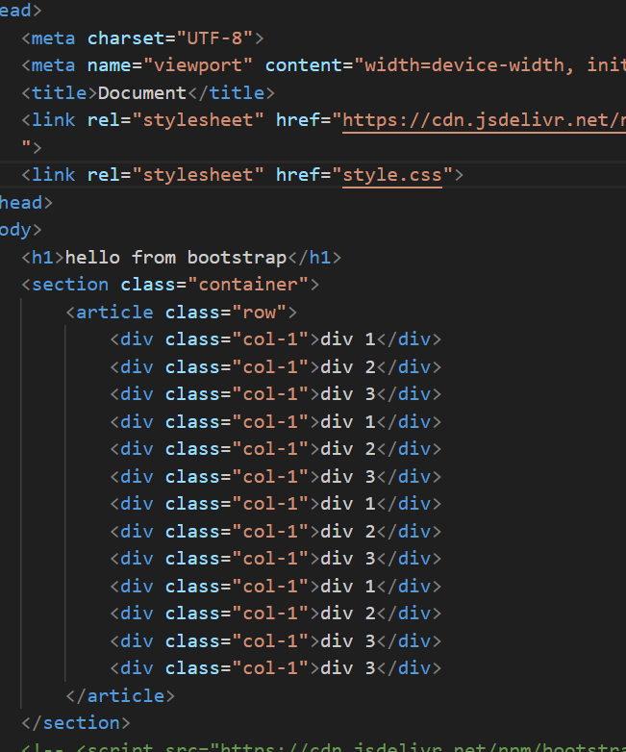

In containter we can divide grid into 12 columns

We define row by class = row

We define column by class = col

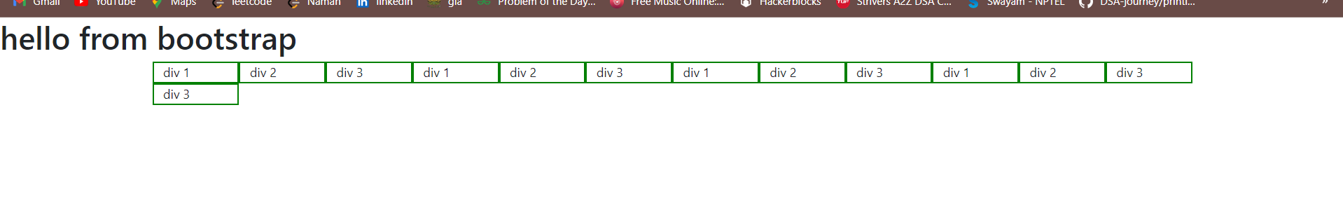

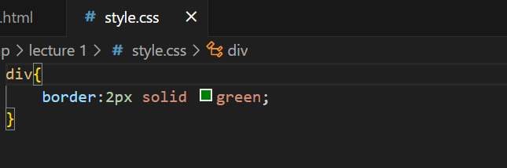

In this case we have speciefied col-1 which means each div or column will take exactly one column of grid and that’s why 13th column is below in the next row

Now without giving unit

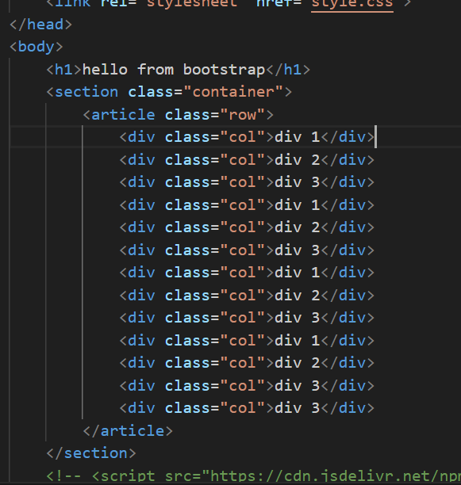



Now if I give 2 unit to a single column

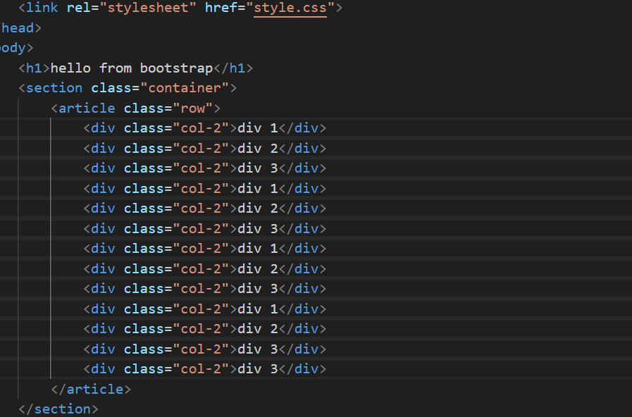

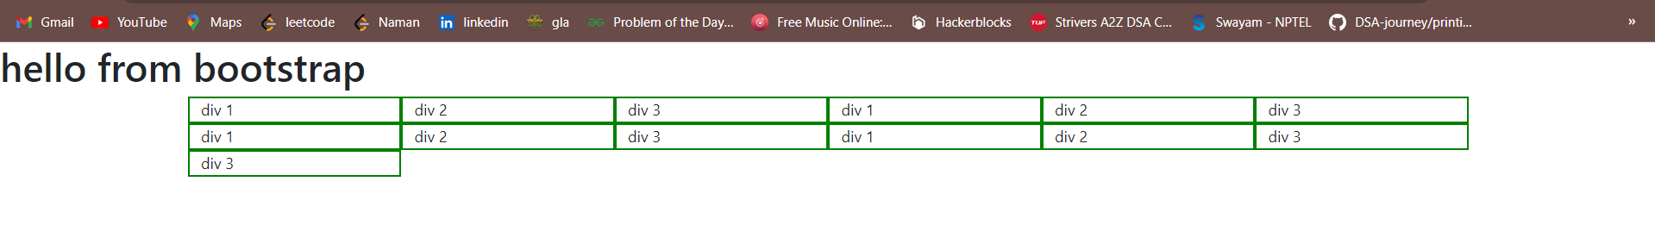

If you give col spam more than 12 than each column will take a whole 12 col

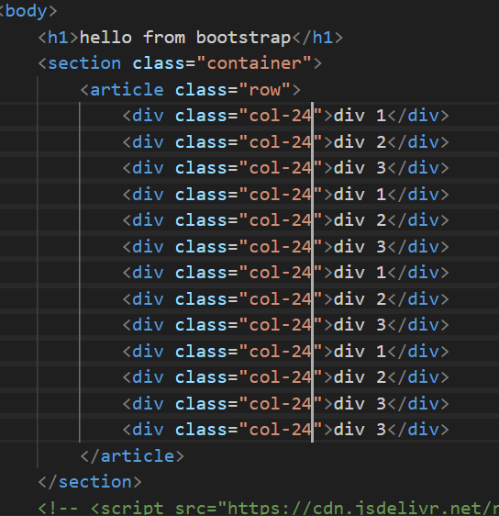

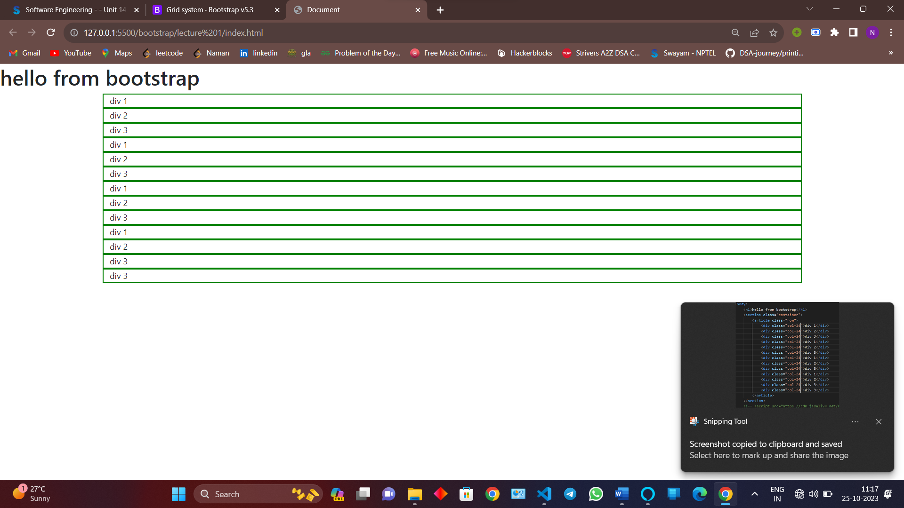

NOTE WE CANT GIVE VALUE IN DECIMAL

WE CAN ALSO GIVE DIFFERENT COLUMN WIDTH TO DIFFERENT COLUMN



            <div class="col">div 3</div>

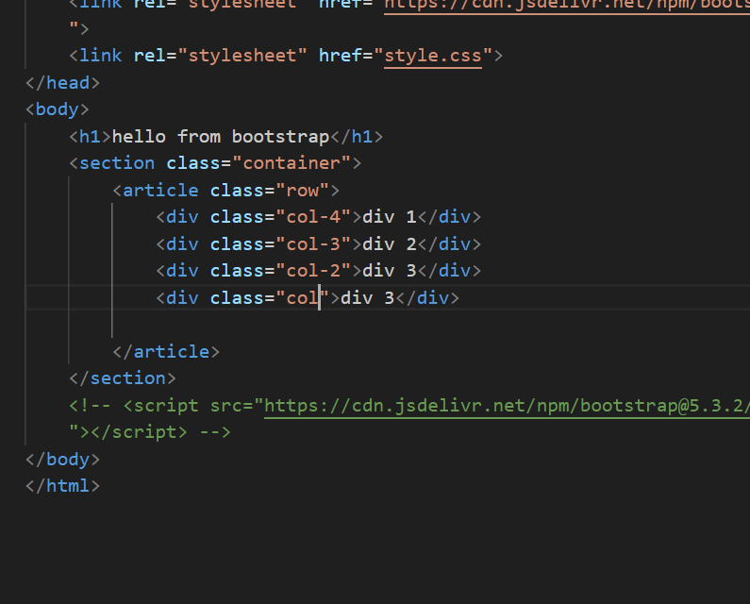

Giving columns for different screen

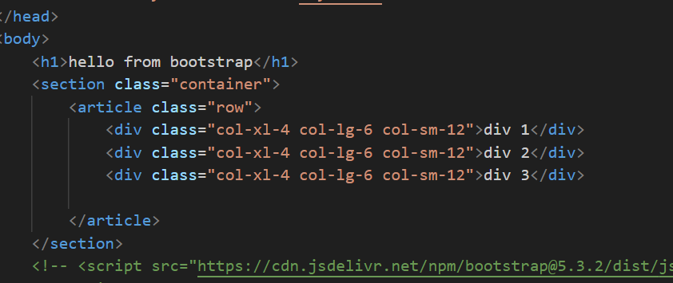

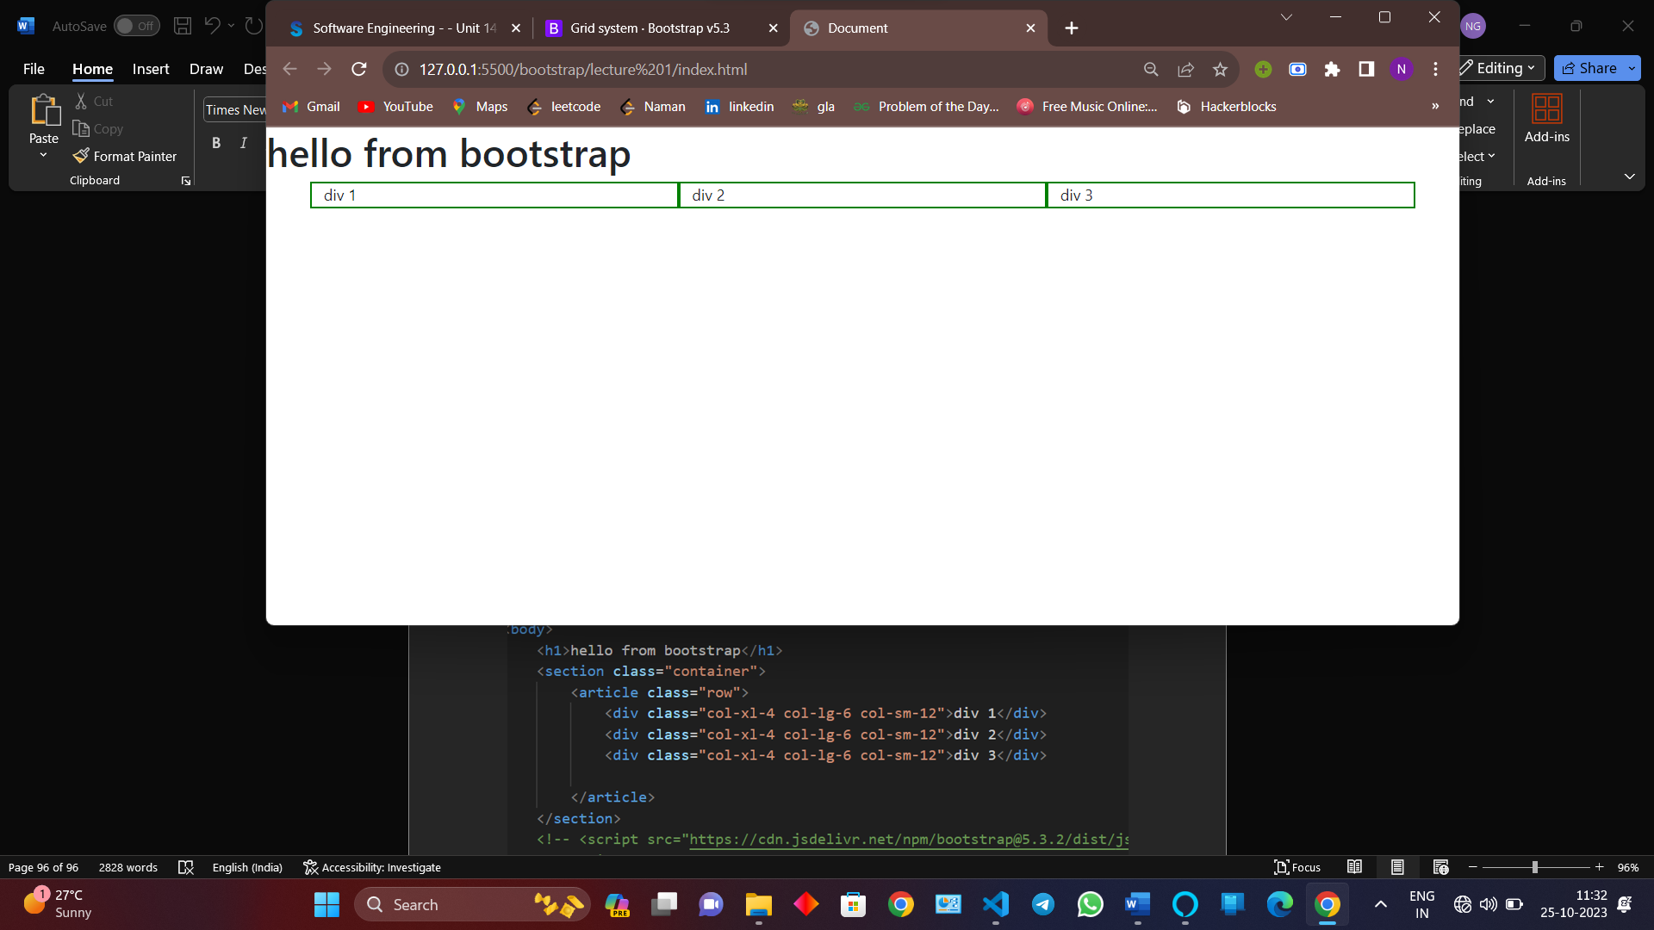

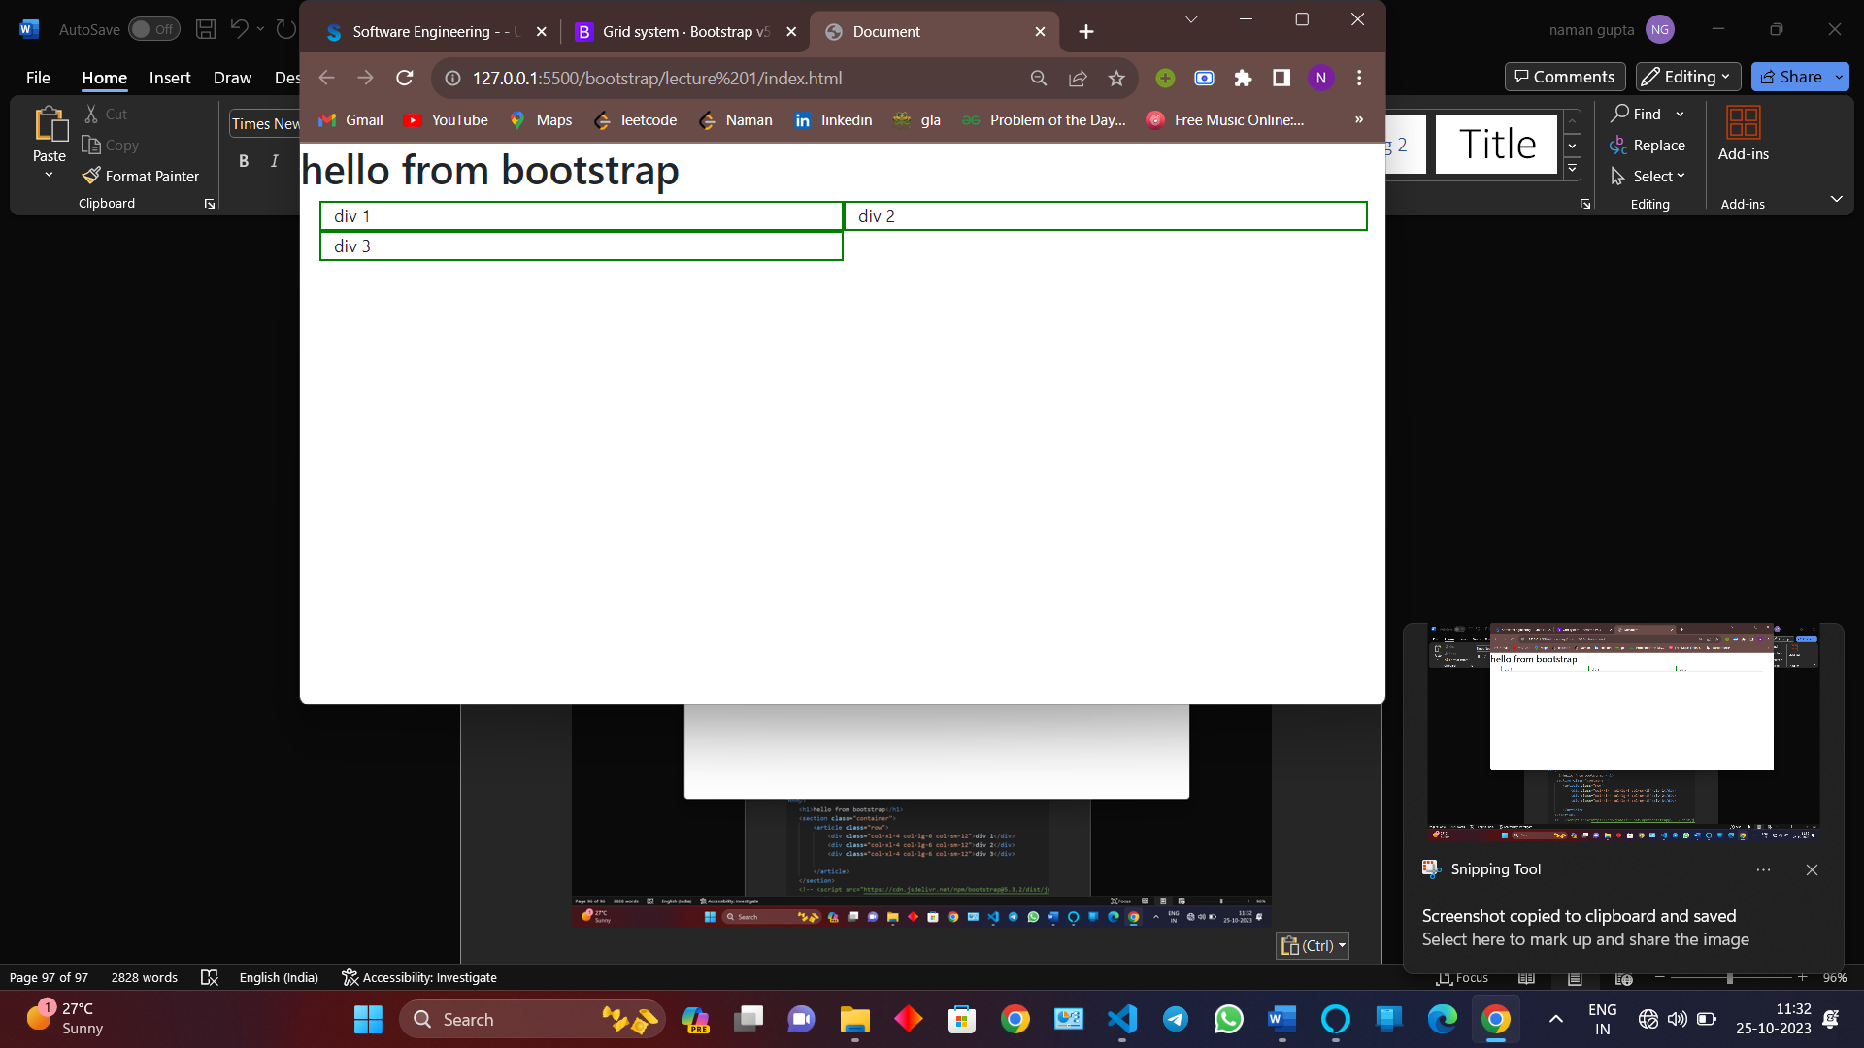

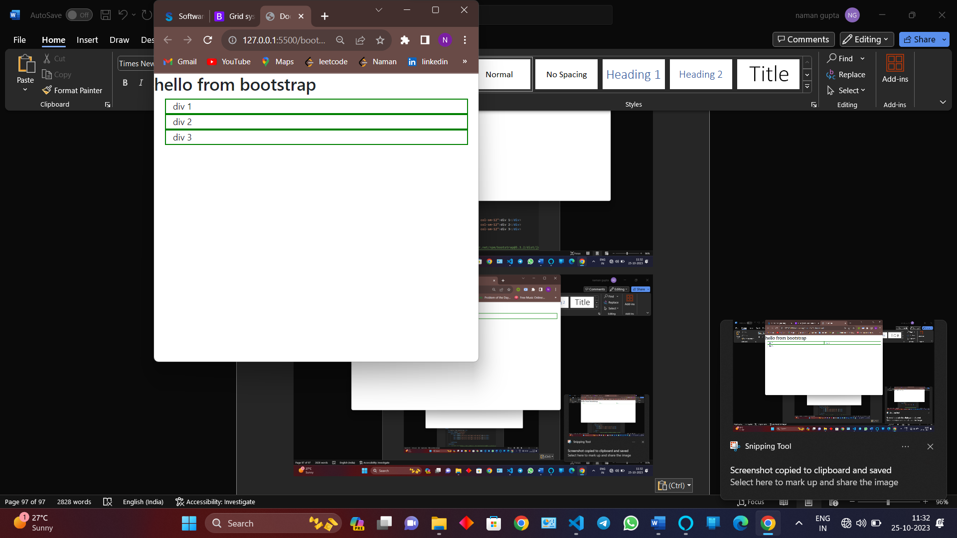

By default it take the first col specification size you have given

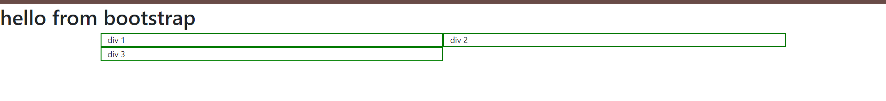

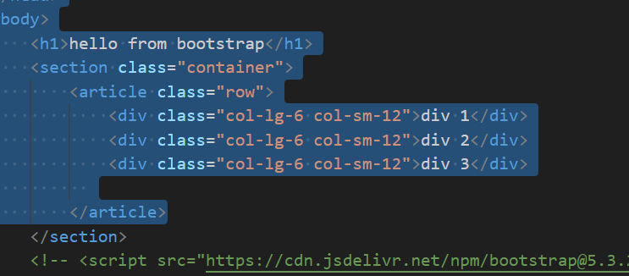

NAVBAR

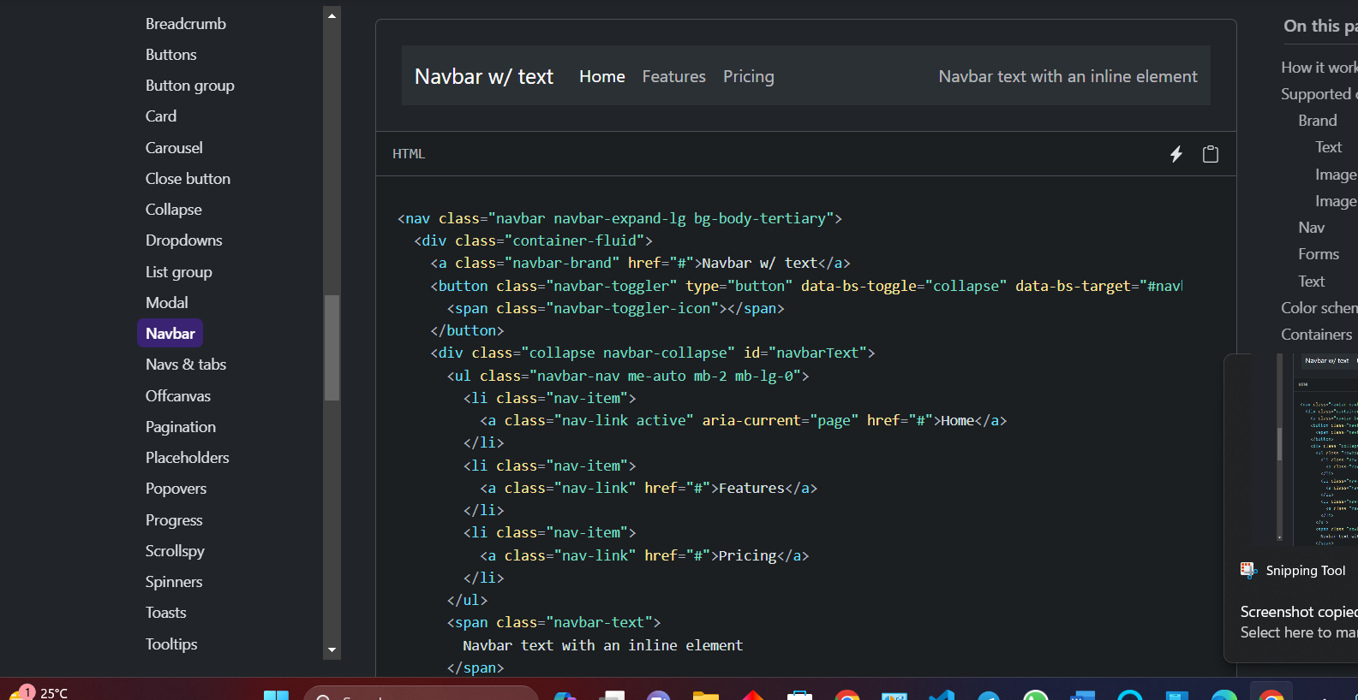

Just copy the code and make changes to it

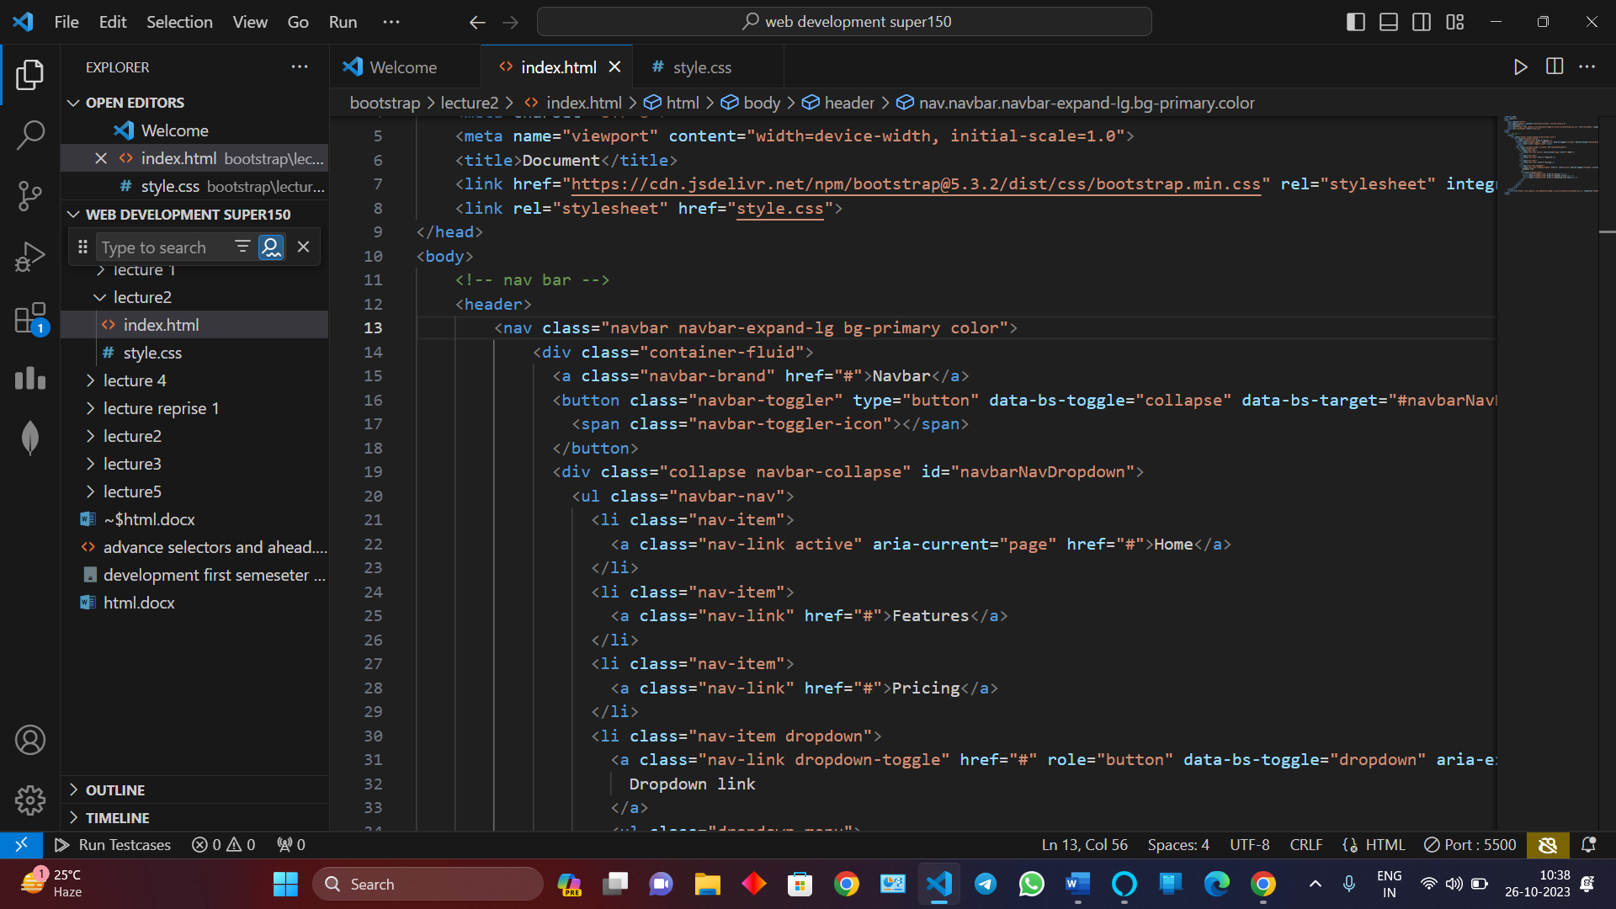

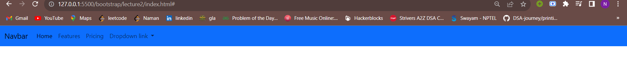

If there is bootstrap class and the same class is made by user than the bootstrap class will dominatinant so to do the user class first remove bootstrap class

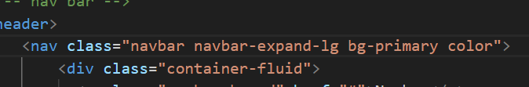

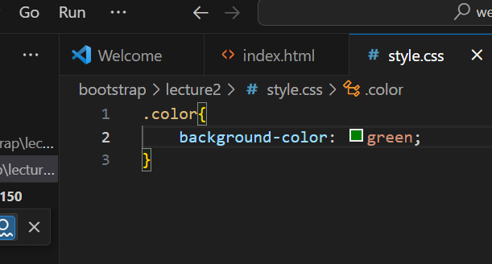

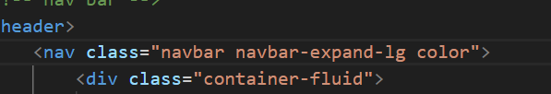

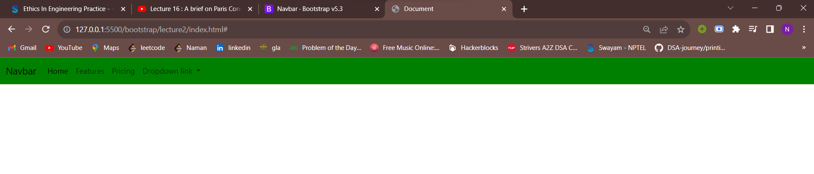

CROUSELS

THE SLIDING WINDOW WIDGETS

